Rescue a Reassortant Human-Bovine Rotavirus and a Recombinant NSP-1-EGFP rotavirus Serotype of G1
Running title
Rescue a Reassortant Human-Bovine Rotavirus
Introduction
Among human viral gastroenteritis, rotaviruses (RVs) are account for main etiologic agents which induce diarrhea in infants and young children under the age of five years. In general, group A rotaviruses are considered as causative pathogen for gastroenteritis in different host species such as mammals and avian [1, 2]. In human, rotaviruses as ubiquitous intestinal pathogens to induce severe acute gastroenteritis in infants and young children are associated with high morbidity and mortality with ~128,500–215,000 deaths annually [3, 4].
RVs are categorized as non-enveloped triple-layered icosahedral viruses which contain 11 segment genome of double-stranded RNA. RVs belong to the Rotavirus genus in the Reoviridae family. In genome coding sequences of rotaviruses, there are 12 proteins expression cassette which include six non-structural proteins (NSP1-NSP6) and six structural proteins (VP1–VP4, VP6, and VP7) [5, 6]. In structural proteins, VP4 and VP7 proteins are embedded in the outer layer of viral capsid and by which rotavirus genotypes/serotypes (the G and P genotypes/serotypes, respectively) can be categorized. Recently, the binary classification of circulating rotaviruses has been demonstrated that there are 36 G and 51 P genotypes/serotypes of rotaviruses [7-9]. However, on the basis of evidented circulating rotaviruses, there is a limited genotype combination of rotaviruses which can be infect humans. For rotaviruses, the phenomenon named host range restriction (HRR) is related to host-restricted capacity of rotaviruses to spread between different host species. By HRR, the ability of infection and replication of a certain rotavirus is limited in a heterologous host [10]. For unknown mechanism of HRR, some researchers considered that mutations in variant genome segments of rotaviruses including VP3, VP4, NSP1, NSP2, NSP3, and NSP4 may be give rise to deficiency for viral pathogenicity in a new host [11-14]. Despite these limitations, rotavirus genotypes including G1-G4, G9, G12, P[8], and P[4] have been accounted for the most common circulating rotaviruses that have been involved 90 percent of human rotavirus infections and, the combined genotypes of rotavirus infections have been defined to be G1P[8], G2P[4], G3P[8], G4P[8], and G9P[8] [15].
Among rotavirus vaccines licensing against human rotavirus which whole of them are live-attenuated commercial vaccines, two vaccines consisting of RotaTeq and RotaSiil are based on bovine rotavirus [16]. RotaTeq and RotaSiil vaccines are pentavalent in which have included different genotypes of human rotavirus for VP4 and VP7 capsid antigens. RotaTeq vaccine has five G and P genotypes of human rotavirus strains containing G1, G2, G3, G4, and P[8] covering the most common circulating human rotaviruses. In contrast to RotaTeq, RotaSiil vaccine has only G genotypes of human rotavirus including five reassortant human-bovine rotavirus strains, G1, G2, G3, G4, and G9. This India rotavirus vaccine was produced in 2017 and received WHO prequalification in September 2018. In addition to the above mentioned two pentavalent vaccines, the manufactures have introduced four human rotavirus vaccines in form of monovalent (Rotarix, Rotavac, Rotavin, Lanzhou) which are commercially used against human rotavirus infections [17, 18].
In production of a rotavirus vaccine, attainment for increasing efficacy and potency of vaccine has been excluded by the traditional methods problems such as virus serial passage in cell culture or by detection of a reassorted rotavirus strain after reassortment between human and animal rotavirus to reach considered vaccine [17, 19]. Recently, a new method which is available to prevail the difficulties is named reverse genetics to rescue of genetically manipulated rotavirus. This method can play a role in new generation candidate rotavirus vaccines [17]. At the first time, rotavirus rescue system was indicated by Komoto and et al. in 2006 that explained the rescue of human rotavirus VP4 genomic RNA can be done by using vaccinia virus (VV) expressing T7 RNA polymerase [20]. After then, in 2017 kanai and et al. accomplished a quite edited method of reverse genetics system for rescue of the simian SA11 rotavirus strain which was only based on plasmid [21]. Up to now, several researches have been documented the rescue of different rotavirus strains which have been led to recovery the rotaviruses including monoreassotant or double reassortant rotaviruses with a genetic base of simian rotavirus [21-26].
Here, we demonstrate that reassortant G1 serotype (Wa strain) RV can be rescue by following transfection of baby hamster kidney cells constitutively expressing T7pol (BHK-T7) with 11 RV cDNA plasmids including one plasmid expressing VP7 gene of human rotavirus Wa strain along with other rotavirus plasmids from bovine rotavirus as a genetic backbone. The helping plasmids consist of expression plasmids encoding VV capping enzyme subunits. Also for efficient rotavirus rescue, a coding T7 RNA polymerase plasmid was co-transfected into BHK-T7 cells. Finally, in this research the EGFP expression as a foreign gene sequence included in the NSP-3 segment of the human-bovine reassortant rotavirus was successful.

Materials and Methods
Construction of rotavirus genes
The 11 segments of rotavirus cDNA genome along with accessory elements consisting of T7 promoter before the first nucleotide of each gene, ribozyme delta and T7 terminator at the end of genes were synthesized. The cDNA of rotavirus genes was cloned into the pUC57 plasmid (Genscript Company, Hong Kong). Among 11 synthesized genes, 10 genes were related to bovine rotavirus genes (WC-3 strain) and one gene was corresponding gene sequence of VP7 outer capsid antigen which was adopted from human rotavirus (strain of Wa, G1 genotype).

Cell lines
Baby hamster kidney cell line (BHK-T7) and MA104 cells were grown in high glucose Dulbecco’s Modified Eagle’s Minimal medium (DMEM) (Gibco) containing 10% fetal bovine serum (FBS) (Gibco), the antibiotics penicillin (100 U.ml -1) and streptomycin (0.1 mg.ml -1).

Transfection and virus rescue
After six-well plate monolayers preparation of BHK-T7 cells (5 × 10⁵ cells/well), transfection of 11 rotavirus plasmids and VV capping enzyme subunits which synthesized by Shingen company (Hong Kong) was done using 10 μL of Lipofectamine transfection reagent, as follows: in one methods, plasmid concentrations were 0.7 µg of each WC-3 and Wa rescue plasmid pWC-VP1, pWC-VP2, pWC-VP3, pWC-VP4, pWC-VP6, pSC-VP7, pWC-NSP1, pWC-NSP2, pWC-NSP2, pWC-NSP3, pWC-NSP4, and pWC-NSP5, and other was the same method which was conducted by Kanai and et al [21]. Also, 0.7 µg of each capping subunit enzyme expression plasmids (pVV-CapS and pVV-CapL) were used. Additionally, in one of the rotavirus rescue methods, the effect of a plasmid with T7 RNA polymerase gene activity to rotavirus rescue efficiency was tested. (Fig. 1) Also, the pFT7A plasmid as previously described in our report [27] was co-transfected to assay T7 RNA polymerase activity in BHK-T7 cells. To generate recombinant rotavirus with additional coding sequence for EGFP gene (pWC-NSP3.eGFP plasmid), the plasmid encoding NSP3 sequence was edited to include EGFP sequence between nucleotides 967 and 968 under control of internal ribosomal entry site element of FMD (IRES) for reinitiate the translation of downstream sequence of EGFP. Both transfected BHK-T7 cells maintained for 48 h in DMEM medium without FBS. Finally, MA104 cells along with trypsin (0.3 µg/ml medium) were added onto transfected BHK-T7 cells and virus replication were assessed until observation of cytopathic effect after co-culture.

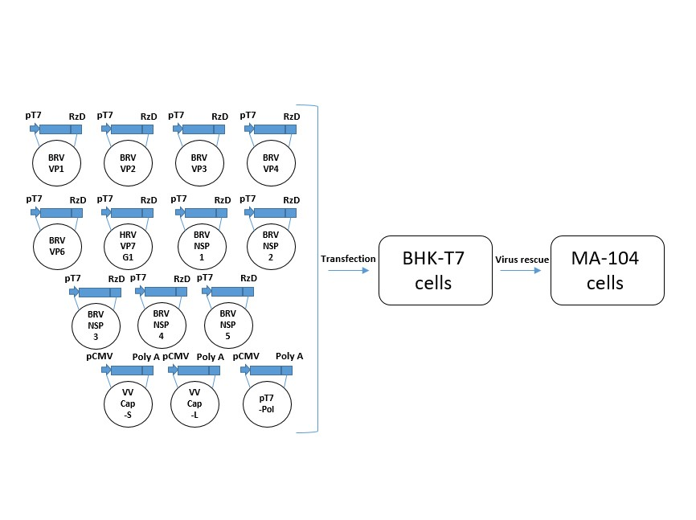
Fig. 1. Schematic presentation for rotavirus reverse genetics by a 13-plasmid RG to produce a reassortant human-bovin rotavirus. The 11 T7 plasmids are accounted for the full-length segments of 11 individual genes of rotavirus flanking by the T7 promoter (pT7) and the HDV ribozyme (RzD), and two CMV plasmids are related to capping enzyme subunits of VV. A plasmid related to T7 RNA polymerase enzyme (pT7-Pol) was used in one of the transfections. To generate reassortant human-bovine rotavirus, BHK-T7 cells were co-transfected with the 13 or 13+1 T7 and CMV plasmids.

Assessment of rescued reassortant rotavirus
In order to analyze reassortant rotavirus which were rescued by reverse genetics, the MA 104 cells were used for propagation of rescued rotavirus in DMEM medium containing 0.3 µg/ml trypsin. Rotavirus isolation was done by plaque purification, and virus titers were accomplished on MA 104 cells. To assess viral genome, viral RNA genomes were extracted from infected-cell lysates by TRIzol solution. To determine presence of human rotavirus VP7 gene in the rescued rotaviruses, RT-PCR assays were carried out by specific primers. Briefly, 6-μL of extracted RNA was added in RT mixtures (containing specific primers and dNTPs) and incubated at 90°C for 10 minutes and then placed on ice for 2 minutes. Then, the second reaction buffer (containing 10X reverse transcription buffer, RTase enzyme, RNase inhibitor, and DEPC treated water) was added to the previous mixture and incubated at 50 °C for 60 minutes. Finally, the RT reaction mixture was incubated at 85 °C for 5 minutes to inactivate the enzyme. After that, PCR amplification was performed for each sample of rotavirus isolation. The PCR reactions were in a 50-μL volume containing 8 µL synthesized cDNA, 25 µL of 2X PCR master mix, and 10 mM of each primer (forward primer: 5'-ACG GGA TCA CTA GAC GCT GTA-3', and reverse primer: 5'-ATC CGT TCC CAT TGA GAT CCA TT-3'). The PCR amplification was done under the following condition: Primary denaturation at 95°C for 6 min, followed by 30 amplification cycles consisting of denaturation at 95°C for 50 s, annealing at 57°C for 35 s, and extension at 72°C for 55 s, and a final extension step for 8 min. In order to detection of EGFP sequence in the recombinant rescued rotavirus, PCR amplification by using set primers including 5'-ATG GTG AGC AAG GGC GAG GAG-3', and 5'-TTA CTT GTA CAG CTC GTC CAT G-3' as forward and reverse primers was done. The PCR cycles condition was performed under the following condition: Primary denaturation at 95°C for 6 min, followed by 35 amplification cycles consisting of denaturation at 95°C for 50 s, annealing at 58°C for 35 s, and extension at 72°C for 90 s, and a final extension step for 6 min.

Results
Reassortant rotavirus release
Based on previous reports for rescue of different rotaviruses, to establish a reverse genetics system for rescue a reassortant human-bovine rotavirus, the VP7 gene sequence of human rotavirus was adopted from Wa strain (G1 genotype) and remaining 10 gene sequences of bovine rotavirus from WC-3 strain were selected from NCBI. The flanking necessary sequence elements for rescue of rotavirus containing T7 promoter sequence before first nucleotide of rotavirus genes and hepatitis delta virus (HDV) ribozyme (Rib) sequences as well as T7 terminator in the end of each rotavirus gene sequences were added. To aim for rotavirus rescue, the 11 different rotavirus plasmids were transfected into BHK-T7 cells by two methods consisting of transfection with the equivalent concentrations and another transfection method which was published by Kanai and et al [21]. After 48h post of transfection, MA-104 cell line to increase rotavirus replication was added. Five days after plasmids transfection into BHK-T7 cells, with observation of cell degradation, the cells were subjected to two cycles of freezing and thawing and cell lysates were inoculated to MA-104 cells. Start of virus cytopathic effects (CPE) were formed after one day of virus adsorption and complete CPEs were observed in the third days of virus passage in MA-104 cells in each of the methods and there was no significant difference between two methods. However, our results indicated that there was different between transfection of only rotavirus plasmids with transfection of rotavirus plasmids along with expression plasmid of T7 RNA polymerase to promote transcription of rotavirus genomic RNA because in latter method the cell lysis and virus rescue was occurred around forth days after transfection.

Rescue of recombinant rotavirus containing EGFP
To assess the recombinant rotavirus harboring an EGFP sequence in backbone of NSP3 gene sequence, FMD IRES sequence was used to translate the EGFP gene by reinitiating mechanism. Our results showed that a recombinant reassortant human-bovine rotavirus can be efficiently rescued and EGFP was expressed under control of IRES sequence. (Fig. 2B) To compare parental rescued reassortant human-bovine rotavirus with the recombinant rescued rotavirus for the replication kinetics, we tested replication cycles of two viruses. After MA104 cell infection at a multiplicity of infection (MOI) of 0.1, the curves of multiple step growth were assigned for reassortant human-bovine rotavirus, and recombinant rRV-NSP3-IRES-eGFP. Our results showed that both rotaviruses are the same characteristics of the replication. (Fig. 3) In order to assess the stability of inserted foreign genes located at the NSP-3 genome segment of bovine rotavirus, the serial passage of rotavirus was carried out. Results of stability of the EGFP inserted gene determined that foreign genes in the NSP-3 sequence of rotavirus genome can maintain at least for 9 cycles of rotavirus replication.

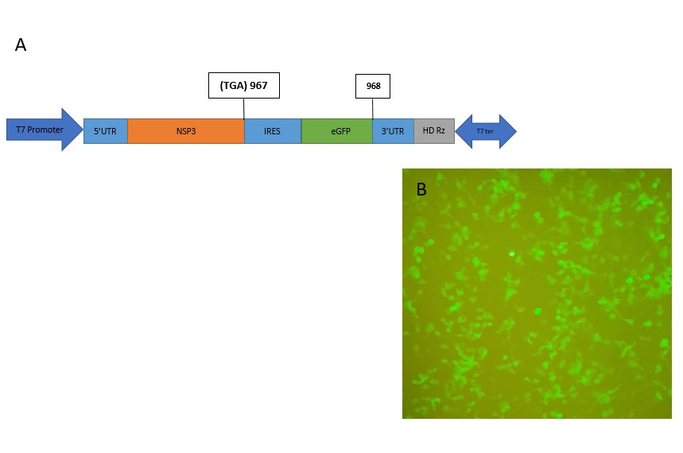
Fig. 2. (A) Schematic representation of the recombinant rotavirus that encode the NSP3-IRES-eGFP sequence (rRV-NSP3-IRES-eGFP). (B) Fluorescent expression of rRV-NSP3-IRES-eGFP after 24 h of MA104 cell infection with the recombinant rotavirus. The MA104 cells were infected with rRV-NSP3-IRES-eGFP at a MOI of 1.

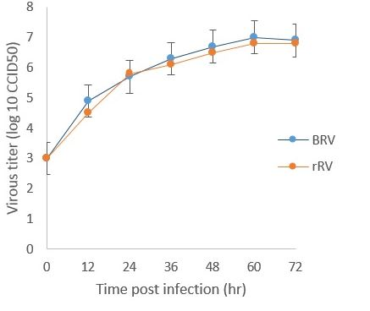
Fig. 3. The replication kinetics of bovine rotavirus (BRV) and rRV-NSP1-IRES-eGFP (rRV). The MA-104 cells infection were done for BRV and rRV at a multiplicity of infection (MOI) of 0.01. The virus titers (CCID₅₀) were calculated for frozen cells collections at one to five days post-infection. Data were shown as a mean and standard deviation (SD) of duplicate samples.

Genomic analysis
In order to confirm the human rotavirus VP7 sequence in backbone of bovine rotavirus as a reassortant rotavirus, we accomplished a RT-PCR assay for detection of G1 rotavirus serotype in the rescued rotavirus. The results of RT-PCR for detection of VP7 sequence of human G1 serotype showed that the VP7 segment of related G1 rotavirus was included in the genome backbone of bovine rotavirus. (Fig. 4A) Finally, the sequencing results were also positive for confirmation of human rotavirus VP7 gene in the rescued rotavirus. The RT-PCR result for conformation of eGFP sequence in the rescued rRV-NSP1-IRES-eGFP for the ninth passage of this virus was also positive. (Fig. 4 B)
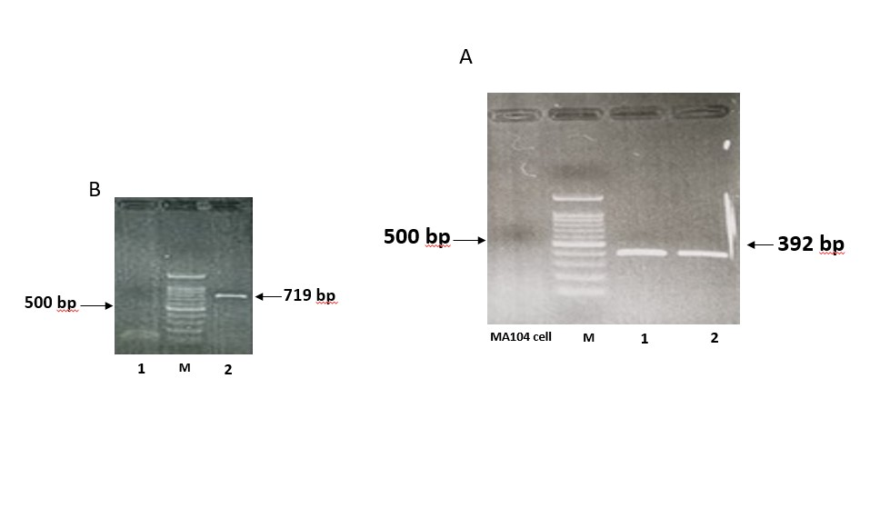
Fig. 4. (A) VP7 PCR product for MA104 cell as a control, and lines of 1 and 2 for positive control and rescued reassortant rotavirus with 392 bp in length. (B) The PCR amplification for EGFP gene inserted in NSP3 segment of rRV-NSP3-IRES-eGFP with 719 bp bond in length.

Discussion
The rescue of reassortant and non-reassortant rotavirus from variant genotypes have been accomplished including simian rotavirus SA11, human rotaviruses, murine-Like rotaviruses, and recently bovine rotaviruses. These investigations have been indicated that there were an efficient and successful reverse genetic system for rescue of rotaviruses. On the other hand, different recombinant rotaviruses with foreign gene sequences have also been rescued by reverse genetics. However, an efficient reverse genetic system for rescue of reassortant human-bovine rotavirus has not reported. Hence, in this research for rescue of a reassortant human-bovine rotavirus we documented a suitable reverse genetic system. In the rescued reassortant rotavirus, the VP7 gene sequence of human rotavirus Wa strain was included in the genetic backbone of bovine rotavirus WC-3 strain. Also, by our research an efficient reverse genetic system was showed that to be able for rescue of a recombinant human-bovine rotavirus with an included EGFP full gene sequence as foreign gene. In similar to documentations which used helping expression plasmids for efficient improvement of reverse genetic systems for rescue of rotavirus, we also used two subunits of VV capping expression plasmids for capping of nascent viral genomic RNA transcripts. However, the FAST expression plasmid which was documented to be efficient for rescue of rotavirus, in our research was not used. In contrast to some recently research which have been showed use of the high concentration for NSP-2 and NSP-5 can be lead to better rescue of rotavirus without using helping expression plasmids such as VV capping expression plasmids, and FAST expression plasmid, we documented that use of the same plasmids concentration is suitable for transfection and rescue of rotavirus. At the same of a before report for increasing efficacy of rotavirus rescue with additional expression of the amount of T7 RNA polymerase [28], an expression T7 RNA polymerase plasmid was co-transfected separately into BHK-T7 cells. In alignment with Qin and et al. [28], our results indicated that highly rate of T7 RNA polymerase expression can be important for rescue of rotavirus.
Given that variations in genome size of different genomic segments for isolated rotaviruses are demonstrated, several research for the insertion or replacement of foreign nucleotide sequences have been accomplished to add different foreign genes into genomic segments of rotaviruses such as NSP1 and NSP3 [6, 21, 28-32]. Based on the observations, in our attempts an EGFP sequence as foreign gene was inserted into the NSP3 segment of our rescued reassortant human-bovine rotavirus. For expression of foreign gene sequence which inserted into genomic segments of rotaviruses, different methods have been applied including deletion in rotavirus genome sequence, stop codon usage, and use of virus peptidase [32]. In order to expression of a downstream sequence, we involved the FMD IRES sequence. With the advent of EGFP fluorescent, our results indicated that expression of EGFP embedded in NSP3 and under control of internal ribosomal entry site sequence of FMD can be efficient. Although the recent attentions for use of rotavirus as viral vector have been increasing, there are challenges for maintenance of foreign gene sequences in the genome of rotavirus [28]. Hence, to sustain stable expression of foreign gene during serial passage of rotavirus as an important goal has been noticed. Here, we sustain the fluorescence of EGFP for 6 cycles of rotavirus replication. However, complete loss of EGFP fluorescence occurred in form of stepwise from cycle 7 to 9. In this research, we accomplished the rescue a reassortant human-bovine rotavirus with VP7 gene sequence from human rotavirus strain of Wa. Finally, use of a rotavirus resemble to RotaTeq vaccine with documented safety as viral vector for new generations of vaccines can open the appointment to access an efficient immunity for other viral antigens.

Declarations
Ethics approval and consent to participate
Not applicable
Consent for publication
Not applicable
Availability of data and materials
Not applicable
Competing Interests
Not applicable
Funding
Not applicable
Authors' contributions
Mona Aminipour: Ph.D. student who has performed as his Ph.D. research project, Mostafa Ghaderi: Design and Management of project, and all the other authors have been involved in experiments, technical support, and writing the manuscript.
Acknowledgements
Not applicable

References
1. Parashar, U.D., et al., Global illness and deaths caused by rotavirus disease in children. 2003. 9(5): p. 565.
2. Kanai, Y. and T.J.V.R. Kobayashi, Rotavirus reverse genetics systems: Development and application. 2021. 295: p. 198296.
3. Troeger, C., et al., Rotavirus vaccination and the global burden of rotavirus diarrhea among children younger than 5 years. 2018. 172(10): p. 958-965.
4. Kanai, Y., et al., Rapid production of recombinant rotaviruses by overexpression of NSP2 and NSP5 genes with modified nucleotide sequences. 2024. 98(12): p. e00996-24.
5. Fukuda, S., et al., Generation of recombinant authentic live attenuated human rotavirus vaccine strain RIX4414 (Rotarix®) from cloned cDNAs using reverse genetics. 2024. 16(8): p. 1198.
6. Wei, J., et al., A novel rotavirus reverse genetics platform supports flexible insertion of exogenous genes and enables rapid development of a high-throughput neutralization assay. 2023. 15(10): p. 2034.
7. Yuzhakov, A., et al., Prevalence and genetic diversity of group A rotavirus genotypes in Moscow (2019–2020). 2021. 10(6): p. 674.
8. Komoto, S., et al., Reverse genetics system for human rotaviruses. 2020. 64(6): p. 401-406.
9. Santos, N. and Y.J.R.i.m.v. Hoshino, Global distribution of rotavirus serotypes/genotypes and its implication for the development and implementation of an effective rotavirus vaccine. 2005. 15(1): p. 29-56.
10. Kawagishi, T., et al., Reverse genetics of murine rotavirus: a comparative analysis of the wild-type and cell-culture-adapted murine rotavirus VP4 in replication and virulence in neonatal mice. 2024. 16(5): p. 767.
11. Feng, N., et al., Roles of VP4 and NSP1 in determining the distinctive replication capacities of simian rotavirus RRV and bovine rotavirus UK in the mouse biliary tract. 2011. 85(6): p. 2686-2694.
12. Ciarlet, M., et al., Analysis of host range restriction determinants in the rabbit model: comparison of homologous and heterologous rotavirus infections. 1998. 72(3): p. 2341-2351.
13. Hoshino, Y., et al., Identification of group A rotavirus genes associated with virulence of a porcine rotavirus and host range restriction of a human rotavirus in the gnotobiotic piglet model. 1995. 209(1): p. 274-280.
14. Sánchez-Tacuba, L., et al., The role of the VP4 attachment protein in rotavirus host range restriction in an in vivo suckling mouse model. 2022. 96(15): p. e00550-22.
15. Wahyuni, R.M., et al., Prevalence and distribution of rotavirus genotypes among children with acute gastroenteritis in areas other than Java Island, Indonesia, 2016–2018. 2021. 12: p. 672837.
16. Kulkarni, P.S., et al., A randomized Phase III clinical trial to assess the efficacy of a bovine-human reassortant pentavalent rotavirus vaccine in Indian infants. 2017. 35(45): p. 6228-6237.
17. Uprety, T., D. Wang, and F.J.A.o.v. Li, Recent advances in rotavirus reverse genetics and its utilization in basic research and vaccine development. 2021. 166(9): p. 2369-2386.
18. Soares‐Weiser, K., et al., Vaccines for preventing rotavirus diarrhoea: vaccines in use. 2019(10).
19. Velasquez, D.E., U. Parashar, and B.J.E.r.o.v. Jiang, Decreased performance of live attenuated, oral rotavirus vaccines in low-income settings: causes and contributing factors. 2018. 17(2): p. 145-161.
20. Komoto, S., J. Sasaki, and K.J.P.o.t.N.A.o.S. Taniguchi, Reverse genetics system for introduction of site-specific mutations into the double-stranded RNA genome of infectious rotavirus. 2006. 103(12): p. 4646-4651.
21. Kanai, Y., et al., Entirely plasmid-based reverse genetics system for rotaviruses. 2017. 114(9): p. 2349-2354.
22. Falkenhagen, A., et al., Generation of simian rotavirus reassortants with diverse VP4 genes using reverse genetics. 2019. 100(12): p. 1595-1604.
23. Falkenhagen, A., et al., Generation of simian rotavirus reassortants with VP4-and VP7-encoding genome segments from human strains circulating in Africa using reverse genetics. 2020. 12(2): p. 201.
24. Komoto, S., et al., Modification of the trypsin cleavage site of rotavirus VP4 to a furin-sensitive form does not enhance replication efficiency. 2011. 92(12): p. 2914-2921.
25. Mingo, R., et al., Genetic determinants restricting the reassortment of heterologous NSP2 genes into the simian rotavirus SA11 genome. 2017. 7(1): p. 9301.
26. Fukuda, S., et al., Rapid generation of rotavirus single-gene reassortants by means of eleven plasmid-only based reverse genetics. 2020. 101(8): p. 806-815.
27. Ghaderi, M., et al., Construction of an eGFP expression plasmid under control of T7 promoter and IRES sequence for assay of T7 RNA polymerase activity in mammalian cell lines. 2014. 7(3): p. 137.
28. Qin, S.-K., et al., Efficient and robust reverse genetics system for bovine rotavirus generation and its application for antiviral screening. 2024. 39(6): p. 917-928.
29. Arnold, M.M., et al., Rotavirus variant replicates efficiently although encoding an aberrant NSP3 that fails to induce nuclear localization of poly (A)-binding protein. 2012. 93(7): p. 1483-1494.
30. Patton, J.T., et al., Effect of intragenic rearrangement and changes in the 3′ consensus sequence on NSP1 expression and rotavirus replication. 2001. 75(5): p. 2076-2086.
31. Zhu, Y., et al., A recombinant murine-like rotavirus with Nano-Luciferase expression reveals tissue tropism, replication dynamics, and virus transmission. 2022. 13: p. 911024.
32. Papa, G. and O.R.J.V.R. Burrone, Rotavirus reverse genetics: a tool for understanding virus biology. 2021. 305: p. 198576.

