Bioprocess optimization strategies for enhanced antimicrobial peptide expression in Pichia pastoris: An in-depth review

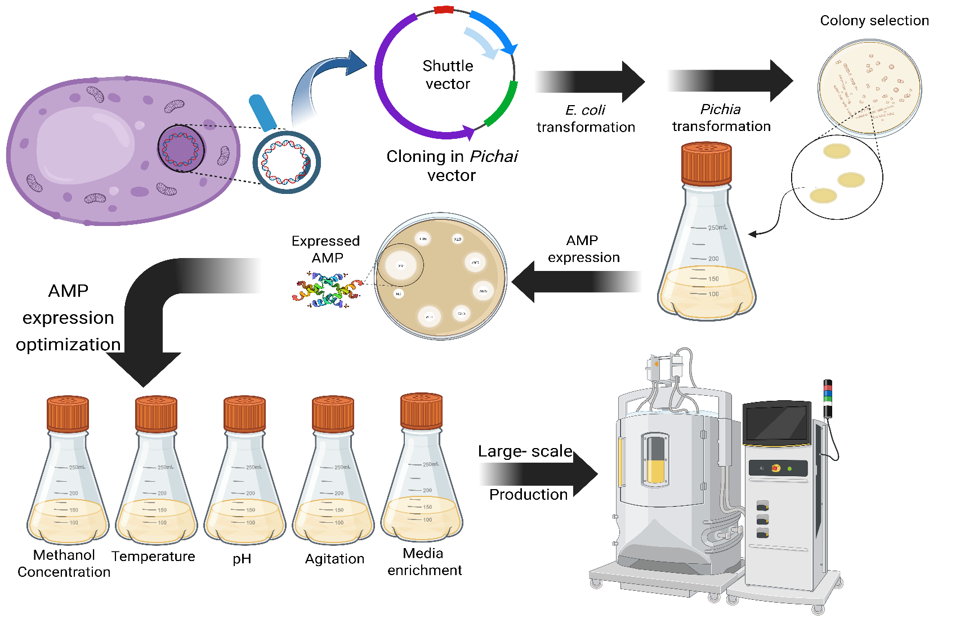
Graphical Abstract

Abstract
Antimicrobial peptides (AMPs) have emerged as promising agents for combating antibiotic-resistant infections and modulating immune responses in inflammatory diseases. Producing these peptides efficiently and cost-effectively remains a major challenge for their clinical and industrial use. Among various expression systems, Pichia pastoris stands out as a versatile eukaryotic host capable of performing essential post-translational modifications, enabling high-level expression, and facilitating the secretion of biologically active AMPs. This review highlights key factors affecting recombinant AMP production in P. pastoris, including strain selection, pre-culture conditions, methanol- and co-substrate-based induction strategies, and the optimization of culture parameters such as pH, temperature, and incubation time. We also discuss challenges such as protease activity, oxidative stress-induced mutations, and media formulation issues that affect yield and AMP stability. Combining these insights offers a comprehensive framework for optimizing AMP expression in P. pastoris, thereby strengthening its potential as a therapeutic agent for addressing infectious diseases.
Keywords: Antimicrobial peptides, Pichia pastoris, Recombinant protein expression, Methanol induction, Bioprocess optimization

Introduction
The rising prevalence of microbial resistance to conventional antibiotics has emerged as a critical threat to global public health [1]. Understanding the mechanisms of bacterial resistance, such as antibiotic efflux pumps, antibiotic inactivation, and biofilm formation, will help address the global problem of antibiotic resistance worldwide .[2]
Accordingly, a variety of new strategies are being adopted to address this problem, such as the use of newly formulated antibiotic compounds, antibiotics combined with natural sources, and AMPs [3]. In the design and use of various drugs, it is important to note that resistance mechanisms in bacteria may develop after exposure to both old and new drugs, so research into discovering drugs that elicit less resistance in bacteria seems essential. One of these research areas is AMPs [2].
According to the World Health Organization (WHO), it is projected that by 2050, AMPs, which are naturally produced by a wide range of prokaryotic and eukaryotic organisms as part of their innate defense mechanisms. These peptides are typically small in size and possess broad-spectrum antimicrobial activity, targeting bacteria, viruses, fungi, and certain parasites. AMPs exert their effects through various mechanisms, such as disrupting microbial membranes, modulating host immune responses, interfering with quorum sensing, and inhibiting biofilm formation. Due to their relatively simple structures, AMPs can be synthesized via chemical, biological, or recombinant methods [4, 5]. Among these, biological production offers several advantages over traditional chemical synthesis, especially at the industrial scale. These advantages include lower production costs, enhanced biocompatibility, and the capacity to undergo essential post-translational modifications, such as disulfide bond formation and glycosylation, processes often challenging to achieve with chemical synthesis, which is typically expensive, time-consuming, and limited to shorter peptide sequences [6].
Various expression systems have been employed for the recombinant production of AMPs, including Escherichia coli, mammalian cells, insect cells, Saccharomyces cerevisiae, and P.pastoris. Among these, P. pastoris stands out as a valuable host due to its rapid growth rate, ability to perform eukaryote-like post-translational modifications, and unique ability to utilize methanol as the sole carbon source to induce AMP expression under the control of the AOX1 promoter [7].
However, large-scale production of AMPs using recombinant systems is not without challenges. One of the most critical factors is optimizing expression conditions to achieve high yield and target peptide activity. In P. pastoris, parameters such as methanol concentration, induction temperature, aeration rate, and culture pH significantly impact peptide expression levels and quality.
Beyond expression, the downstream processing and purification of recombinant AMPs are crucial for maintaining their structural integrity and biological activity. It is essential to minimize denaturation during purification to ensure the final product's functionality.
In this study, we investigated the expression of several AMPs—potentially for the first time at a large scale—using the P. pastoris system. We evaluated the impact of key factors, including methanol concentration and induction temperature, on expression efficiency. Furthermore, we present optimized strategies for peptide purification and recovery, aiming to obtain a final product with high purity and retained biological activity [8].

Antimicrobial Peptides
AMPs have emerged as promising alternatives in the fight against antibiotic-resistant infections. These small peptides, typically 10–50 amino acids long, exhibit potent and broad-spectrum antimicrobial activity against bacteria, fungi, and viruses, including multidrug-resistant strains [9]. Beyond direct killing, AMPs act as key immunomodulators that regulate inflammation and promote wound healing, underscoring their therapeutic potential in infectious and inflammatory diseases. As vital components of the innate immune system across nearly all life forms, AMPs form a first line of defense against invading pathogens. Their mechanisms—primarily targeting microbial membranes and multiple cellular processes—differ fundamentally from those of traditional antibiotics, which act on single, mutable targets such as ribosomes or enzymes. Consequently, AMPs act quickly and are less likely to induce bacterial resistance. Their broad activity, low cytotoxicity, and unique modes of action make them attractive candidates for next-generation therapeutics [10]. The discovery of AMPs dates back to 1939, when Dubois first isolated peptide compounds from Bacillus species in soil. Since then, numerous Bacillus strains have been identified as prolific producers of bioactive peptides, including bacteriocins, lipopeptides, glycopeptides, and non-ribosomally synthesized cyclic peptides [11-13]. These molecules exhibit strong antimicrobial and surface-active properties, enabling them to disrupt microbial membranes effectively [14]. These peptides have demonstrated activity against pathogens such as Salmonella, Shigella, and Staphylococcus aureus, underscoring their clinical relevance. Amphibians, especially frogs, also produce diverse AMPs—over 300 types identified from frog skin—serving as part of their innate defense. Similarly, marine organisms, inhabiting the planet's most biodiverse ecosystems, represent a vast untapped reservoir of AMPs with potential biomedical applications [15].
In humans, AMPs are continuously synthesized by the innate immune system. For example, intestinal microbiota produce peptides that inhibit the colonization of pathogenic bacteria, thereby maintaining gut homeostasis. Disruptions in AMP production can contribute to diseases such as inflammatory bowel disease, also known as colitis [16]. Key human AMPs include defensins, cathelicidins, lectins, and lactoferrin, each playing crucial roles in defense and immune modulation. Defensins exhibit both antimicrobial and anti-inflammatory activities [17, 18], while cathelicidins, particularly LL-37, display broad-spectrum activity, disrupt biofilms, and promote tissue repair. Lectins are being explored for their potential antiviral effects, and lactoferrin exhibits antimicrobial and immunoregulatory properties through its iron-binding capacity. Despite their promise, several challenges hinder the clinical translation of AMPs. These include instability due to enzymatic degradation, high production costs, and formulation difficulties. Advances in peptide engineering, synthetic biology, and nanotechnology are addressing these limitations by enhancing peptide stability, improving bioavailability, and reducing cost-effectiveness [19-21].
Given the complexities of large-scale recombinant production, efficient AMPs synthesis relies heavily on selecting an appropriate expression system. An ideal system must ensure high yield, correct folding, and essential post-translational modifications to preserve the peptides' structural integrity, stability, and biological activity, which are necessary for therapeutic success. Therefore, the following section aims to discuss the various expression platforms used for AMP production and to provide a comparative evaluation of their efficiency, advantages, and limitations.

Expression Systems
A variety of biological systems are currently employed for the expression of recombinant AMP, each offering unique advantages and facing specific limitations. In this section, we present a critical comparison of P. pastoris with other commonly used expression platforms, including E. coli, mammalian cell lines, and alternative yeast species, highlighting the relative strengths and drawbacks of each system for AMP production [22, 23]. Figure 1 represents the most important host cells for AMP expression.

Microbial host
Escherichia coli remains the most commonly used microbial host for recombinant AMP production because of its rapid growth, low cultivation costs, and well-established genetic manipulation techniques. These qualities make it a popular choice for high-throughput expression of simple AMPs and peptides. However, despite its widespread use, E. coli has several significant limitations that limit its effectiveness in producing complex or therapeutically important AMPs. A major problem is its inability to perform essential post-translational modifications (PTMs). As a prokaryote, E. coli lacks the enzymatic machinery necessary for key modifications such as glycosylation, disulfide bond formation, and precise proteolytic processing. These PTMs are vital for the proper folding, stability, and biological activity of many eukaryotic AMPs. Consequently, peptides produced in E. coli often fail to attain their native conformation, leading to decreased activity or complete loss of function[24].
Additionally, the intracellular environment of E. coli is highly reducing, leading to misfolding of complex or disulfide-rich peptides. This misfolding often leads to the formation of insoluble inclusion bodies in recombinant peptides. Extracting functional AMPs from these aggregates requires complex denaturation and refolding processes that are typically labor-intensive, inefficient, and can substantially reduce both yield and biological activity [25, 26]. Another significant limitation of E. coli expression systems is their limited ability to secrete compounds outside the cell. Native strains usually accumulate recombinant AMPs inside the cytoplasm, complicating downstream processing and purification. The necessity for cell disruption and additional purification steps not only increases production complexity but also adds to costs and time [9].
Collectively, these challenges emphasize the inherent limitations of E. coli as a host for producing structurally complex or therapeutically important AMPs, especially those that require eukaryotic-like modifications for proper function.

Mammalian cell lines
Mammalian expression systems, especially Chinese hamster ovary (CHO) and human embryonic kidney (HEK293) cells, are widely recognized as the gold standard for producing recombinant AMPs that require complex post-translational modifications. These systems uniquely perform authentic eukaryotic modifications, including precise glycosylation, disulfide bond formation, and accurate proteolytic processing. These capabilities ensure proper peptide folding, enhanced structural stability, and optimal biological activity, making mammalian hosts particularly suitable for manufacturing therapeutically important AMPs and antibody-based molecules [25]. A key advantage of mammalian systems is their ability to produce recombinant peptides with human-like glycosylation patterns and folding mechanisms that closely mimic native cellular processes. This helps preserve the peptides' bioactivity and reduces the risk of immunogenic reactions, both of which are essential for clinical applications. However, despite these benefits, several challenges limit their widespread use. Mammalian cell lines typically grow slowly and require tightly controlled culture conditions, resulting in longer production times. Additionally, the use of specialized, nutrient-rich media and strict bioreactor standards results in significantly higher operational costs compared to microbial or yeast-based systems [26].
Therefore, although mammalian expression systems are essential for producing high-quality, therapeutically active AMPs, their scalability and cost-effectiveness remain significant challenges for large-scale industrial use [27].

Insect cells
The baculovirus–insect cell expression system, which typically utilizes cell lines such as Spodoptera frugiperda (Sf9) and Sf21, has gained significant recognition as a dependable platform for producing structurally complex recombinant AMPs. This eukaryotic expression system offers notable advantages, including its capacity to generate large, multifunctional peptides and enable specific post-translational modifications (PTMs), such as phosphorylation and limited glycosylation. These modifications are often essential for proper folding, stability, and bioactivity of AMPs, thereby improving their therapeutic potential [28].
Despite these advantages, the insect cell system also has several inherent limitations. The process of generating recombinant baculoviruses is labor-intensive and time-consuming, involving multiple steps of cloning, transfection, and amplification before achieving optimal expression levels. Additionally, the glycosylation patterns produced by insect cells differ significantly from those in mammalian systems, often resulting in simpler, non-human-like glycan structures. These differences can negatively impact the biological effectiveness, immunogenic profile, and therapeutic potential of the expressed AMPs [25].
Overall, while baculovirus–insect cell systems serve as a valuable intermediate between microbial and mammalian platforms, offering the capability for complex peptide expression with moderate fidelity of PTMs, their limitations in scalability and glycosylation fidelity necessitate careful consideration for clinical-grade AMP production.

Saccharomyces cerevisiae
Saccharomyces cerevisiae, a well-established eukaryotic host, is widely used to produce AMPs via recombinant techniques. Recognized as Generally Regarded As Safe (GRAS) by regulatory agencies, S. cerevisiae has a long history of safe use in biotechnology and the food industry, highlighting its industrial significance and safety credentials. Its well-understood genetics, ease of cultivation, and suitability for large-scale fermentation make it an appealing platform for the production of recombinant biomolecules. One major advantage is its rapid growth and inherent ability to secrete heterologous proteins, including AMPs, directly into the medium, which simplifies downstream purification and reduces both production time and costs. Additionally, the yeast supports vital post-translational modifications, such as disulfide bonds and N-linked glycosylation, which are essential for the correct folding and functional stability of recombinant peptides. However, S. cerevisiae has limitations. A key issue is its tendency to hyperglycosylate recombinant peptides by attaching high-mannose oligosaccharides. These non-human glycosylation patterns can negatively affect the biological activity, structural stability, and immunogenicity of AMPs, especially those designed for therapeutic use. Therefore, while S. cerevisiae remains a valuable and safe platform for AMP production, its glycosylation heterogeneity poses a challenge for applications requiring human-like protein processing [29].

Pichia pastoris
The methylotrophic yeast P. pastoris has become an increasingly popular host for producing AMPs due to its ability to combine high expression levels with eukaryotic protein processing capabilities. As a GRAS organism, P. pastoris supports high-cell-density fermentation, enabling the secretion of recombinant peptides into the extracellular medium, thereby simplifying downstream purification. Importantly, it carries out essential post-translational modifications (PTMs), such as disulfide bond formation and glycosylation, which are vital for maintaining peptide stability and bioactivity. These features make P. pastoris a robust system for both research and large-scale industrial production of AMPs.

Advantages
P. pastoris has gained considerable recognition as a versatile and efficient eukaryotic host for the recombinant production of AMPs. This methylotrophic yeast uniquely bridges the gap between prokaryotic and higher eukaryotic expression systems, combining high expression efficiency with the ability to perform complex post-translational modifications (PTMs) essential for peptide bioactivity and stability.
The organism was originally identified for its distinctive ability to utilize methanol as its sole carbon and energy source, a trait enabled by alcohol oxidase (AOX) enzymes encoded by the AOX1 and AOX2 genes. In the early 1980s, P. pastoris was developed as a genetic platform for recombinant protein production by researchers at Phillips Petroleum Company. Its methylotrophic nature facilitated the use of the AOX1 promoter. This strong and tightly regulated element remains repressed in the presence of glucose or glycerol but is robustly induced by methanol. This feature enables precise control of expression levels, making P. pastoris an ideal system for the inducible production of AMP. Subsequent taxonomic revisions in 1995 reclassified P. pastoris, with commonly used laboratory strains now recognized as Kamagataella phaffii. Nevertheless, the historical designation P. pastoris remains widely accepted within the scientific community [26, 27].
Over the past several decades, P. pastoris has become one of the most widely used eukaryotic hosts for the expression of recombinant proteins, including biopharmaceuticals, industrial enzymes, and vaccine candidates. Its capacity to reach exceptionally high cell densities, perform essential PTMs, and efficiently secrete recombinant peptides makes it an attractive alternative to both bacterial and mammalian expression systems. Notably, AMPs expressed in P. pastoris often exhibit greater antimicrobial potency than chemically synthesized peptides, which are typically produced through cost-intensive, less scalable methods [9].
One of the principal advantages of P. pastoris lies in its ability to perform critical post-translational modifications required for the biological activity of complex peptides. Although its glycosylation patterns differ slightly from those of mammalian cells—typically producing shorter, high-mannose glycans—the yeast effectively executes key modifications such as disulfide bond formation, proteolytic processing, and limited glycosylation. These processes collectively contribute to the structural integrity, stability, and functionality of recombinant AMPs [30, 31].
Another major strength of P. pastoris is its highly efficient secretion system. Recombinant peptides are readily secreted into the extracellular medium, greatly simplifying downstream purification and reducing the need for cell disruption steps. The system is also amenable to cultivation in cost-effective, chemically defined media and typically does not require serum supplementation. This not only minimizes the risk of contamination but also reduces production costs, making P. pastoris particularly well-suited for industrial-scale AMP manufacturing [6].
Furthermore, P. pastoris exhibits rapid growth kinetics and the ability to achieve high biomass concentrations within relatively short cultivation periods. These characteristics significantly reduce production timelines and improve scalability, thereby enhancing the economic feasibility of large-scale AMP production compared to slower-growing mammalian systems.
From a biosafety perspective, P. pastoris offers an additional advantage as a eukaryotic host free of endotoxin contamination—a limitation commonly associated with Gram-negative bacterial hosts such as E. coli. This feature enhances the safety and regulatory compliance of AMPs and other therapeutic proteins expressed in P. pastoris, reinforcing its suitability for pharmaceutical and clinical applications [32].

Disadvantages
Despite its many advantages, P. pastoris is not without limitations, and several factors may limit its efficiency and broader applicability for the production of recombinant AMPs.
One of the primary challenges in P. pastoris expression systems is proteolytic activity in the culture medium. Proteases originating from contaminating microorganisms, such as bacteria or fungi, can cause cell lysis, inhibit yeast proliferation, and degrade target recombinant peptides. Although P. pastoris naturally secretes only minimal amounts of endogenous proteases, their activity can increase under stress conditions or during prolonged fermentation, leading to partial degradation of AMPs. Proteolytic degradation negatively affects product yield, stability, and bioactivity. Therefore, maintaining strict aseptic conditions, optimizing cultivation parameters, and employing protease inhibitors are critical to preserving AMP integrity throughout production and downstream processing [33-35].
Another major limitation of P. pastoris is its reliance on methanol for inducing gene expression under the AOX1 promoter. Although this system provides tight regulatory control and high expression levels, methanol handling poses notable safety and operational challenges due to its flammability and toxicity. Moreover, methanol metabolism imposes metabolic stress on the cells, often leading to reduced folding efficiency and productivity during large-scale fermentations [36, 37].
Glycosylation in P. pastoris, although more controlled than in Saccharomyces cerevisiae, still differs significantly from that in mammalian systems. The yeast predominantly produces high-mannose glycans rather than complex, human-like structures, which can affect AMP stability, activity, and pharmacokinetic behavior. While glycoengineered P. pastoris strains capable of humanized glycosylation have been developed, these modifications increase system complexity and production costs [38].
Secretion efficiency represents another constraint of the P. pastoris system. The extent of AMP secretion depends on various factors, including the design of the signal sequence, peptide characteristics, and culture conditions. Inefficient secretion can result in intracellular accumulation, misfolding, or proteolytic degradation of AMPs, ultimately reducing yield and complicating purification processes [39].
Additionally, large-scale fermentation can be limited by oxygen depletion and heat accumulation, which induce physiological stress and compromise protein quality. Optimal control of aeration, pH, and temperature is therefore crucial for maintaining stable and efficient AMP expression.
In summary, while P. pastoris remains a robust and widely adopted eukaryotic platform for recombinant AMP production; however, challenges related to methanol induction, non-human glycosylation, secretion inefficiency, and process stress must be carefully managed. Continued advances in strain engineering, promoter design, and bioprocess optimization are expected to enhance the industrial potential of AMP biosynthesis on a large scale [40]. Suitable expression systems are summarized in Table 1, reflecting the various factors.

Optimization of AMP production conditions
Researchers in the laboratory have developed biological processes to enhance AMP expression, including increased biomass growth and higher product yield, by adjusting factors such as pH, temperature, oxygen levels, and nutrient supply. Figure 2 illustrates the most critical parameters for optimizing AMP production conditions in P. pastoris.

Appropriate strain selection
P. pastoris is a genetically engineered methylotrophic yeast renowned for its ability to utilize methanol as its sole source of carbon and energy [42]. Optimizing culture conditions and nutrient composition is crucial for achieving efficient recombinant protein production in this system. Expression outcomes vary depending on whether the methanol-inducible AOX1 promoter controls genes—commonly used in Mut⁺ or Mutˢ phenotypes—or the constitutive GAP promoter, which drives continuous expression independent of methanol induction [43].
Several P. pastoris strains are routinely employed for recombinant AMP production, including X-33, GS115, KM71, SMD1163, and MC100-3. Among these, GS115 and KM71 contain both AOX1 and AOX2 genes and exhibit the Mut⁺ phenotype, enabling rapid methanol metabolism and high expression efficiency. In contrast, KM71 and MC100-3 exhibit the Mut⁻ phenotype, characterized by slower methanol utilization and reduced oxygen demand—features advantageous for methanol-free or glycerol-based expression systems[44].
A notable challenge associated with AOX1-driven expression is the system's dependence on methanol, which serves as both the inducer and primary carbon source. While methanol induction enables tight regulation and high-level expression, it also introduces operational complexity and potential stress on host cells. Therefore, alternative promoters, such as GAP or hybrid systems, are increasingly being explored to mitigate methanol-related limitations.
The SMD1163 strain, engineered to delete pep4 and prb1, exhibits reduced vacuolar protease activity, making it particularly suitable for the expression of protease-sensitive AMPs. Comparative studies have shown that GS115 consistently demonstrates higher transformation efficiency and recombinant AMP yield than other strains, including X-33 [45]. This superior performance, combined with its genetic stability, tightly regulated expression system, and reduced susceptibility to proteolytic degradation, positions GS115 as one of the most promising P. pastoris strains for large-scale AMP production [46].

Pre-culture preparation
In heterologous expression of AMPs using the P. pastoris system, the formulation and optimization of the pre-culture medium are critical for ensuring optimal cell growth, metabolic readiness, and physiological robustness before induction. This preparatory phase is crucial when producing biologically active peptides such as AMPs, which can exert cytotoxic or stress-inducing effects on the host cells. Establishing favorable pre-induction conditions promotes cellular health and enhances the system's capacity to manage the metabolic burden associated with recombinant AMP synthesis.
Typically, the selected P. pastoris strain—such as GS115 harboring the recombinant plasmid—is first streaked onto YPD agar plates containing 1% yeast extract, 2% peptone, 2% dextrose, and 2% agar. The plates are incubated at 30 °C for approximately 48 hours to allow colony development. A single well-isolated colony is then transferred into 25–50 mL of liquid YPD medium (identical composition but without agar) in 250 mL baffled Erlenmeyer flasks. The culture is incubated at 30 °C with agitation at 200 rpm for 18–24 hours to promote vigorous cell growth and activation of primary metabolic pathways. This pre-culture stage ensures the physiological competence of the yeast cells, supporting their readiness for subsequent induction and efficient recombinant protein expression [47].
Following this stage, the pre-culture is transferred to buffered glycerol-complex medium (BMGY), containing 1% yeast extract, 2% peptone, 100 mM potassium phosphate buffer (pH 6.0), 1.34% yeast nitrogen base without amino acids, 0.00004% biotin, and 1% glycerol as the primary carbon source. Glycerol facilitates rapid biomass accumulation while maintaining repression of the AOX1 promoter, enabling cells to reach high density before methanol induction. This transitional step ensures that the culture enters the induction phase in an optimal physiological state, minimizing stress and maximizing yield.
Beyond simple biomass generation, pre-culture optimization also helps regulate intracellular cofactor balance, enhance methanol-metabolizing enzyme expression—particularly alcohol oxidase—and strengthen cellular defenses against stresses associated with bioactive peptide synthesis. Proper pre-culture adaptation mitigates the cytotoxic effects that can arise during AMP expression, improves overall process stability, and enhances downstream purification efficiency by reducing cell lysis and product degradation [48].

Effect of methanol on AMP expression media
Methanol serves as the primary carbon and energy source in P. pastoris, playing a pivotal role in recombinant protein expression systems regulated by the AOX1 promoter. Its use is central to achieving efficient, tightly controlled induction of AMP production, as methanol both sustains cellular metabolism and activates the promoter driving gene expression.

Activation of the AOX1 promoter
Methanol uniquely and strongly induces the AOX1 promoter, which remains repressed in the presence of alternative carbon sources such as glycerol or glucose. When the target AMP gene is placed under AOX1 control, methanol acts as a potent inducer, initiating high-level transcription and translation upon its introduction into the culture medium. This property allows for precise regulation of expression timing and intensity.

Optimization of induction timing
During the initial growth phase, P. pastoris cells are typically cultivated using glycerol as the carbon source to promote rapid biomass accumulation. Once glycerol is depleted, methanol is introduced to initiate the induction phase. The timing of this transition is critical, as premature methanol addition can inhibit cell growth, while delayed induction may reduce overall productivity[49] [45].

Effect of methanol concentration
The concentration of methanol significantly influences both the yield and bioactivity of recombinant AMPs. Controlled feeding strategies are therefore essential to balance induction efficiency and cellular health. Studies have demonstrated that methanol concentrations ranging from 0.5% to 3% can effectively induce AMP expression, with the optimal range generally between 0.5% and 1% [45]. Research conducted by the Microbiology Department of Mashhad University of Medical Sciences further confirmed that AMP production peaks at approximately 1% methanol concentration. However, excessive methanol levels—particularly above 5%—are highly toxic to cells, leading to growth inhibition and cell death due to metabolic stress [11, 50]. According to Table 2, Mild methanol induction, typically achieved by supplementing 0.5–1% methanol every 24 hours, has been shown to promote proper protein folding and enhance the biological activity of the expressed AMPs. This controlled induction regime minimizes cellular stress and supports the production of correctly folded, functional peptides. Regular sampling during the induction phase is recommended to monitor expression levels, optimize methanol feed rates, and ensure consistent product quality [6].

Effect of sorbitol and temperature
In P. pastoris expression systems, alternative carbon sources, such as sorbitol, are frequently co-utilized with methanol to enhance AMP production. Although sorbitol alone does not induce the AOX1 promoter, it functions as a non-repressive carbon source that supports cellular metabolism without interfering with promoter regulation. The inclusion of sorbitol in the culture medium helps alleviate metabolic stress associated with methanol utilization, thereby improving cell viability and stability during extended induction periods.
The co-feeding strategy involving both methanol and sorbitol offers a balanced approach to maintaining metabolic activity and induction efficiency. While methanol acts as an inducer of AOX1-driven gene expression, sorbitol supports energy metabolism and promotes steady biomass accumulation. This synergy minimizes methanol's cytotoxic effects while maintaining high levels of recombinant peptide expression. Previous studies have demonstrated that supplementation with 2.5% methanol and 1% sorbitol yields significantly higher AMP production than methanol-only induction [51, 52].
Temperature also plays a crucial role in optimizing AMP expression in P. pastoris. The optimal temperature range for yeast growth and induction generally lies between 28 °C and 30 °C. Temperatures above 32 °C are detrimental to both cell viability and induction efficiency, often leading to reduced productivity or cell death. Conversely, lowering the cultivation temperature from 30 °C to 20 °C has been shown to improve AMP yield, primarily by enhancing protein folding, reducing cellular stress, and decreasing proteolytic degradation of the target peptide [53].
Collectively, the strategic use of co-substrates, such as sorbitol, in conjunction with controlled temperature modulation represents an effective approach to improving AMP expression efficiency, maintaining cell health, and ensuring the structural and functional integrity of recombinant peptides in P. pastoris systems.

Effect of incubation time
Incubation time is a critical parameter for determining the efficiency of AMP expression in P. pastoris systems. The duration of induction directly affects peptide yield, folding efficiency, and overall cell viability, making it a key factor in process optimization. Generally, P. pastoris requires relatively long cultivation periods to achieve maximum recombinant protein production compared to bacterial expression systems.
Experimental data indicate a strong correlation between incubation time, methanol concentration, and AMP expression levels. As summarized in Table 2, the highest expression yield was observed at a methanol concentration of 2.5% with an induction period of 48 hours [53]. Extending incubation beyond 48 hours resulted in a gradual decline in AMP production, likely due to the accumulation of toxic metabolites, increased protease activity, or nutrient depletion leading to cellular stress.
Furthermore, consistent with previous findings, excessive methanol concentrations are detrimental to yeast cells. Concentrations exceeding the optimal range not only compromise cell membrane integrity but also reduce metabolic activity and, consequently, the efficiency of AMP expression [50]. Therefore, maintaining an appropriate balance between induction duration and methanol concentration is essential to ensure sustained cell viability and achieve optimal yields of correctly folded, biologically active AMPs in P. pastoris cultures.

Effect of pH
The regulation of AMPs expression in P. pastoris is highly dependent on both pH and temperature, as these parameters directly affect promoter activity, protein folding, secretion efficiency, and overall cell physiology. Expression systems driven by the AOX1 promoter require methanol induction; however, promoter activity is markedly influenced by the culture medium's pH. Several studies have demonstrated that AOX1 promoter activity declines sharply under acidic conditions, leading to reduced AMP expression. Optimal promoter activity is generally observed within a pH range of 6.0 to 6.5. For instance, in a study investigating Thaumatin II expression in P. pastoris, the highest peptide yield was obtained in BMGY medium maintained at pH 6. Interestingly, the difference in secretion levels between 48 and 72 hours across various pH conditions was minimal compared to the maximum yield achieved. This indicates that pH primarily determines the maximum attainable AMP concentration rather than the expression rate [57].
Temperature also plays a critical role in influencing AMP productivity and cellular stress response in P. pastoris. While most cultivation processes are conducted at 30 °C, considered optimal for yeast growth, reducing the temperature to 20 °C has been shown to enhance specific AMP productivity by up to 3-fold in chemostat cultures. This improvement is associated with decreased tricarboxylic acid (TCA) cycle flux, reduced expression of oxidative stress-related proteins, and lower intracellular levels of molecular chaperones, collectively indicating improved folding efficiency and enhanced cellular homeostasis under moderate stress conditions [58].
The pH of the culture medium also plays a crucial role in determining growth rate, enzymatic activity, and proteolytic stability during fermentation. Although P. pastoris Mut⁺ strains show relatively stable growth across a pH range of 3.5–5.5, small variations within this range can significantly affect metabolic activity, AMP stability, and secretion efficiency. Additionally, different recombinant AMPs often exhibit distinct pH optima for maximum production, underscoring the importance of customizing fermentation conditions for each target peptide. This fine-tuning improves yield and helps preserve peptide integrity throughout the production process. [40].
Evidence from recombinant protein expression studies supports the value of pH-optimization strategies for improving yield. For example, P. pastoris expressing erythropoietin (EPO) achieved maximal production using a two-stage pH control approach, maintaining a pH of 5.0 during the glycerol batch and fed-batch phases, followed by a shift to pH 4.5 during methanol induction. In contrast, for recombinant P. pastoris producing human growth hormone (hGH), the highest expression levels were consistently observed at pH 5.0 throughout the entire cultivation process [40].
These findings highlight the importance of maintaining optimal pH and temperature conditions to support cell growth, stress tolerance, and AMP folding efficiency. Precise control and adjustment of these parameters are crucial for maximizing recombinant AMP yield and ensuring functional stability in P. pastoris expression systems. These results are shown in Table 3.

Effect of different media
The P. pastoris strain is widely recognized for its ability to grow and ferment efficiently in cost-effective alkaline saline media, making it particularly suitable for large-scale recombinant AMPs production. Adequate aeration is a critical factor for optimal cell growth and secretion efficiency, as oxygen availability directly influences metabolic activity and protein synthesis. To enhance oxygen transfer during cultivation, baffled Erlenmeyer flasks are typically employed in shake-flask experiments. At the same time, industrial-scale bioreactors rely on controlled aeration and agitation systems to maintain sufficient dissolved oxygen levels.
The composition of the culture medium plays a pivotal role in balancing production costs, growth kinetics, and AMP quality. P. pastoris can be cultivated in both complex and chemically defined media, each offering distinct advantages. Complex media such as buffered glycerol-complex medium (BMGY) are frequently used in laboratory-scale studies due to their rich nutrient content, which supports vigorous growth and metabolic activity. However, for industrial-scale production, minimal formulations such as basal salt medium (BSM) are preferred due to their cost-effectiveness and ability to sustain high cell densities [59].
Despite these advantages, BSM use presents certain technical challenges. High salt concentrations in BSM can lead to precipitation during sterilization and pH adjustment, potentially affecting nutrient availability and medium homogeneity. To mitigate this issue, modified formulations such as half-strength BSM (BSM 1/2) have been developed. These adjustments reduce osmotic pressure, prevent precipitation, and improve both cell growth and the efficiency of recombinant AMP expression.
Another factor affecting AMP production in P. pastoris is the occurrence of mutations caused by oxidative stress during methanol metabolism. Methanol oxidation produces intermediates such as formaldehyde and formic acid, which can generate reactive oxygen species (ROS). These ROS can damage DNA, leading to mutations in essential genes, such as ADE2, which is involved in purine biosynthesis. A mutation in ADE2 results in the buildup of 5-aminoimidazole ribonucleotide (AIR), a precursor that oxidizes in air to form a red pigment, making colonies appear pink or red. These mutant cells exhibit impaired growth, metabolic defects, and a significantly reduced ability to produce recombinant peptides.
Therefore, optimizing culture conditions—including medium composition, aeration rate, and induction parameters—must be tailored to the specific recombinant AMP and production scale. Such optimization not only enhances yield and peptide quality but also minimizes oxidative stress and mutation frequency, thereby preserving culture integrity and ensuring consistent industrial performance [60].

Conclusion And Future Outlook
The methylotrophic yeast P. pastoris has become a strong and flexible platform for producing AMPs. Its unique features—including the ability to perform essential post-translational modifications, reach high cell densities, and efficiently secrete recombinant peptides—give it clear advantages over traditional prokaryotic and other eukaryotic systems. When optimized under appropriate culture conditions, such as controlled methanol induction, precise pH control, and co-substrate supplementation, P. pastoris enables the production of AMPs that retain their structural integrity, biological activity, and therapeutic potential. Overall, these qualities underscore its role as a scalable, cost-effective host for recombinant AMP production. Advancements in genetic engineering, synthetic biology, and systems biology continue to expand P. pastoris's capabilities, offering new opportunities for improved expression efficiency and process control. Future research should focus on developing strains with better methanol tolerance and lower protease activity, as well as designing promoter systems that provide tighter transcriptional regulation and higher yields. Co-expressing molecular chaperones to assist in proper folding and secretion of AMP is another promising strategy to enhance product quality and consistency. Furthermore, integrating continuous or perfusion-based bioprocessing approaches may revolutionize large-scale AMP production by improving productivity and reducing operational costs. Coupling these advances with omics-driven tools and machine learning–based optimization could accelerate process development, enable predictive control of fermentation parameters, and enhance overall process robustness.
In summary, the continual refinement of P. pastoris as an expression system holds great promise for the efficient, large-scale production of high-quality AMPs. Its expanding role in recombinant biotechnology not only supports therapeutic development but also contributes significantly to global efforts to combat antimicrobial resistance through innovative bio-based manufacturing strategies.

REFERENCES:
1. Viebrock, K., et al., PhagoScreener: A novel phagogram platform based on a capillary-wave microbioreactor. New Biotechnology, 2024. 83: p. 188-196.
2. Khameneh, B., et al., Breakthroughs in bacterial resistance mechanisms and the potential ways to combat them. Microbial pathogenesis, 2016. 95: p. 32-42.
3. Goki, N.H., et al., Novel antimicrobial peptides based on Protegrin-1: In silico and in vitro assessments. Microbial Pathogenesis, 2024. 196: p. 106931.
4. Hancock, R.E., M.A. Alford, and E.F. Haney, Antibiofilm activity of host defence peptides: complexity provides opportunities. Nature Reviews Microbiology, 2021. 19(12): p. 786-797.
5. Goki, N.H., et al., Structure, Function, and Physicochemical Properties of Pore-forming Antimicrobial Peptides. Curr Pharm Biotechnol, 2024. 25(8): p. 1041-1057.
6. Ahmad, M., et al., Protein expression in Pichia pastoris: recent achievements and perspectives for heterologous protein production. Applied Microbiology and Biotechnology, 2014. 98(12): p. 5301-5317.
7. Khan, I.U., et al., Pichia pastoris Mediated Digestion of Water-Soluble Polysaccharides from Cress Seed Mucilage Produces Potent Antidiabetic Oligosaccharides. Pharmaceuticals, 2024. 17(6): p. 704.
8. Zhao, L., et al., Production and Functional Evaluation of Recombinant Active Peptide RH in Pichia Pastoris: Protection Against Escherichia Coli Induced Cell Death. Probiotics and Antimicrobial Proteins, 2025.
9. Dong, C., et al., The Expression of Antibacterial Peptide Turgencin A in Pichia pastoris and an Analysis of Its Antibacterial Activity. Molecules, 2023. 28(14).
10. Duarte-Mata, D.I. and M.C. Salinas-Carmona, Antimicrobial peptides immune modulation role in intracellular bacterial infection. Frontiers in Immunology, 2023. 14: p. 1119574.
11. Mukherjee, S., P. Das, and R. Sen, Towards commercial production of microbial surfactants. TRENDS in Biotechnology, 2006. 24(11): p. 509-515.
12. Rodrigues, L., et al., Biosurfactants: potential applications in medicine. Journal of antimicrobial chemotherapy, 2006. 57(4): p. 609-618.
13. Deo, S., et al., Strategies for improving antimicrobial peptide production. Biotechnology advances, 2022. 59: p. 107968.
14. Saiyam, D., et al., Lipopeptides from Bacillus: Unveiling biotechnological prospects—Sources, properties, and diverse applications. Brazilian Journal of Microbiology, 2024. 55(1): p. 281-295.
15. Rinaldi, A.C., Antimicrobial peptides from amphibian skin: An expanding scenario: Commentary. Current opinion in chemical biology, 2002. 6(6): p. 799-804.
16. Kim, J.M., Antimicrobial proteins in intestine and inflammatory bowel diseases. Intestinal research, 2014. 12(1): p. 20-33.
17. Ganz, T., Defensins: antimicrobial peptides of innate immunity. Nature reviews immunology, 2003. 3(9): p. 710-720.
18. Alford, M.A., et al., Cathelicidin host defense peptides and inflammatory signaling: Striking a balance. Frontiers in microbiology, 2020. 11: p. 1902.
19. Nizet, V., et al., Innate antimicrobial peptide protects the skin from invasive bacterial infection. Nature, 2001. 414(6862): p. 454-457.
20. Svensson, D. and B.-O. Nilsson, Human antimicrobial/host defense peptide LL-37 may prevent the spread of a local infection through multiple mechanisms: an update. Inflammation Research, 2025. 74(1): p. 36.
21. Chettri, D., et al., Antimicrobial Peptides: Source, application and recent developments. Process Biochemistry, 2024.
22. Zhang, W., M. Inan, and M.M. Meagher, Fermentation strategies for recombinant protein expression in the methylotrophic yeast Pichia pastoris. Biotechnology and Bioprocess Engineering, 2000. 5: p. 275-287.
23. Huo, X., et al., High-efficiency expression of a novel antimicrobial peptide I20 with superior bactericidal ability and biocompatibility in Pichia pastoris and its efficiency enhancement to aquaculture. Aquaculture, 2024. 579.
24. Pratama, F., D. Linton, and N. Dixon, Genetic and process engineering strategies for enhanced recombinant N-glycoprotein production in bacteria. Microbial cell factories, 2021. 20(1): p. 198.
25. Jardin, B.A., C.B. Elias, and S. Prakash, Expression of a secreted protein in mammalian cells using baculovirus particles, in Protein Expression in Mammalian Cells: Methods and Protocols. 2011, Springer. p. 41-63.
26. Kurtzman, C.P., Biotechnological strains of Komagataella (Pichia) pastoris are Komagataella phaffii as determined from multigene sequence analysis. Journal of Industrial Microbiology and Biotechnology, 2009. 36(11): p. 1435.
27. Sadeeq, M., et al., Unlocking the power of antimicrobial peptides: advances in production, optimization, and therapeutics. Frontiers in Cellular and Infection Microbiology, 2025. 15: p. 1528583.
28. Korn, J., et al., Baculovirus-free insect cell expression system for high yield antibody and antigen production. Scientific reports, 2020. 10(1): p. 21393.
29. Yang, S., et al., Engineering Saccharomyces cerevisiae for efficient production of recombinant proteins. Engineering Microbiology, 2024. 4(1): p. 100122.
30. Daly, R. and M.T. Hearn, Expression of heterologous proteins in Pichia pastoris: a useful experimental tool in protein engineering and production. Journal of Molecular Recognition: An Interdisciplinary Journal, 2005. 18(2): p. 119-138.
31. Barone, G.D., et al., Industrial production of proteins with Pichia pastoris—Komagataella phaffii. Biomolecules, 2023. 13(3): p. 441.
32. Rueda, F., et al., Functional inclusion bodies produced in the yeast Pichia pastoris. Microbial cell factories, 2016. 15(1): p. 166.
33. Byrne, B., Pichia pastoris as an expression host for membrane protein structural biology. Current opinion in structural biology, 2015. 32: p. 9-17.
34. Gil, D.F., et al., Recombinant expression of ShPI-1A, a non-specific BPTI-Kunitz-type inhibitor, and its protection effect on proteolytic degradation of recombinant human miniproinsulin expressed in P ichia pastoris. FEMS yeast research, 2011. 11(7): p. 575-586.
35. Li, X., et al., Fusion Partner Facilitates Expression of Cell-Penetrating Peptide L2 in Pichia pastoris. Antibiotics (Basel), 2024. 13(12).
36. Salamin, K., et al., Secretion of an endogenous subtilisin by Pichia pastoris strains GS115 and KM71. Applied and environmental microbiology, 2010. 76(13): p. 4269-4276.
37. Pan, Y., et al., Current advances of Pichia pastoris as cell factories for production of recombinant proteins. Frontiers in Microbiology, 2022. 13: p. 1059777.
38. Huang, Y., et al., Recombinant expression of antimicrobial peptides in Pichia pastoris: A strategy to inhibit the Penicillium expansum in pears. Postharvest Biology and Technology, 2021. 171.
39. Burgard, J., et al., The secretome of Pichia pastoris in fed‐batch cultivations is largely independent of the carbon source but changes quantitatively over cultivation time. Microbial Biotechnology, 2020. 13(2): p. 479-494.
40. Chen, X., et al., High-level heterologous production and Functional Secretion by recombinant Pichia pastoris of the shortest proline-rich antibacterial honeybee peptide Apidaecin. Scientific Reports, 2017. 7(1).
41. Gomes, A.R., et al., An overview of heterologous expression host systems for the production of recombinant proteins. Adv. Anim. Vet. Sci, 2016. 4(7): p. 346-356.
42. Cereghino, G.P.L., et al., Production of recombinant proteins in fermenter cultures of the yeast Pichia pastoris. Current opinion in biotechnology, 2002. 13(4): p. 329-332.
43. Looser, V., et al., Cultivation strategies to enhance productivity of Pichia pastoris: a review. Biotechnology advances, 2015. 33(6): p. 1177-1193.
44. Shemesh, P. and A. Fishman, Optimal fermentation conditions for growth and recombinant protein production in pichia pastoris: strain selection, ploidy level and carbon source. Current Research in Food Science, 2024. 9: p. 100840.
45. Katakura, Y., et al., Effect of methanol concentration on the production of human β2-glycoprotein I domain V by a recombinant Pichia pastoris: a simple system for the control of methanol concentration using a semiconductor gas sensor. Journal of Fermentation and Bioengineering, 1998. 86(5): p. 482-487.
46. Zha, J., et al., Advances in metabolic engineering of Pichia pastoris strains as powerful cell factories. Journal of Fungi, 2023. 9(10): p. 1027.
47. Cregg, J.M., et al., Recombinant protein expression in Pichia pastoris. Molecular biotechnology, 2000. 16: p. 23-52.
48. Mulder, K.C., et al., Production of a modified peptide clavanin in Pichia pastoris: cloning, expression, purification and in vitro activities. AMB Express, 2015. 5(1).
49. Naseem, M.U., et al., Optimization of Pichia pastoris expression system for high-level production of margatoxin. Frontiers in pharmacology, 2021. 12: p. 733610.
50. Santoso, A., N. Herawati, and Y. Rubiana, Effect of methanol induction and incubation time on expression of human erythropoietin in methylotropic yeast Pichia pastoris. Makara Journal of Technology, 2012. 16(1): p. 5.
51. Azadi, S., et al., Evaluation of sorbitol-methanol co-feeding strategy on production of recombinant human growth hormone in Pichia pastoris. Iranian journal of pharmaceutical research: IJPR, 2017. 16(4): p. 1555.
52. Niu, H., et al., A quantitative study of methanol/sorbitol co-feeding process of a Pichia pastoris Mut+/pAOX1-lacZ strain. Microbial cell factories, 2013. 12(1): p. 33.
53. Karbalaei, M., S.A. Rezaee, and H. Farsiani, Pichia pastoris: A highly successful expression system for optimal synthesis of heterologous proteins. Journal of cellular physiology, 2020. 235(9): p. 5867-5881.
54. Li, X., et al., Construction of a Pichia pastoris strain efficiently secreting irisin and assessment of its bioactivity in HepG2 cells. International Journal of Biological Macromolecules, 2019. 124: p. 60-70.
55. Trösemeier, J.-H., et al., Optimizing the dynamics of protein expression. Scientific reports, 2019. 9(1): p. 7511.
56. Wang, D., et al., Improving the catalytic performance of Pichia pastoris whole-cell biocatalysts by fermentation process. RSC advances, 2021. 11(57): p. 36329-36339.
57. Joseph, J.A., S. Akkermans, and J.F. Van Impe, Effects of temperature and pH on recombinant Thaumatin II production by Pichia pastoris. Foods, 2022. 11(10): p. 1438.
58. Dragosits, M., et al., The effect of temperature on the proteome of recombinant Pichia pastoris. Journal of proteome research, 2009. 8(3): p. 1380-1392.
59. Cos, O., et al., Operational strategies, monitoring and control of heterologous protein production in the methylotrophic yeast Pichia pastoris under different promoters: a review. Microbial cell factories, 2006. 5(1): p. 17.
60. Zhu, W., et al., Medium optimization for high yield production of human serum albumin in Pichia pastoris and its efficient purification. Protein Expression and Purification, 2021. 181: p. 105831.

FIGURES AND TABLES
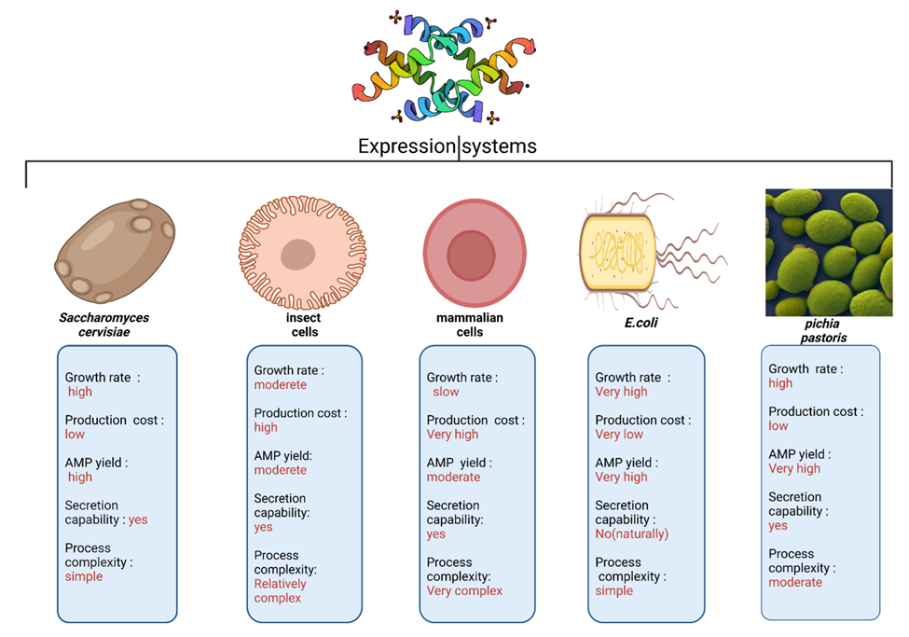
Figure 1. Comparative overview of commonly used heterologous expression systems for Antimicrobial Peptide (AMP) production.

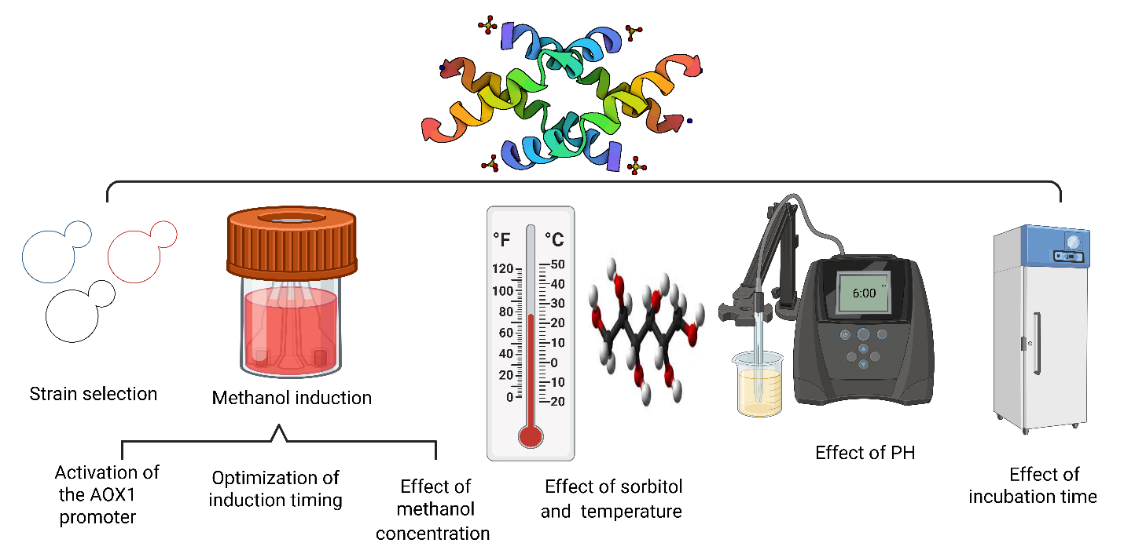
Figure 2. Schematic representation of key bioprocess parameters influencing antimicrobial peptide (AMP) expression in Pichia pastoris.
Table 1. Provides a comparative overview of common expression systems utilized for the production of AMP.
Feature/ expression system | P.pstoris | E.coli | Mammalian cells (CHO,HEK293) | Insect cells  (Sf9,baculovirus) | Saccharomyces cervisiae | Refrence
Organism type | Eukaryotic yeast | Prokaryotic bacterium | Eukaryotic mammalian cells | Eukaryotic insect cells | Eukaryotic yeast | [41]
Growth rate | high | Very high | slow | moderate | high | [41]
Production cost | low | Very low | Very high | high | low | [41]
Post-translational modifications | Yes(limited glycosylation) | no | Yes (complete) | Yes(limited) | Yes(excessive glycosylation) | [41]
Glycosylation quality | Close to human | absent | Human like | Different from human | hyperglycosylation | [41]
AMP yield | Very high | Very high | moderate | moderate | high | [41]
Secretion capability | yes | No(naturally) | yes | yes | yes | [41]
Process complexity | moderate | simple | Very complex | Relatively complex | simple | [41]
Inclusion body formation | no | yes | no | no | no | [41]
Common application | Therapeutic AMPs enzymes | Simple AMPs, enzymes | Biologics,  antibodies | Vaccines,  specific enzymes | Industrial enzymes | [41]

Table 2. Effect of time and methanol concentrations on the expression level of proteins.
Induction time (h) | Methanol concentration (v/v%) | Expression level (mg/l) | Refrence
24 | 0.5 | 12 | [54]
48 | 0.5 | 28 | [54]
72 | 0.5 | 25 | [54]
24 | 1.0 | 15 | [55]
48 | 1.0 | 35 | [55]
72 | 1.0 | 33 | [55]
24 | 2.0 | 13 | [56]
48 | 2.0 | 30 | [56]
72 | 2.0 | 27 | [56]

Table 3. Effect of pH on protein concentration
Refrence | pH | Effect on AMP expression in P. pastoris
[57, 59] | 3-4.5 | Poor growth, increased stress, low expression
[57, 59] | 5-5.5 | Good growth, relatively good expression
[57, 59] | 6.0-6.5 | Highest AMP expression efficiency, proper AOX1 activity
[57, 59] | +7 | Decreased metabolic activity and AMP expression

