New Insights into Skin Regeneration and Repair
Running title: Skin Regeneration and Repair

Abstract:
The skin serves as a protective barrier against a variety of pathogens, including viruses and bacteria; however, it may be susceptible to infection, inflammation, and wounding. Consequently, challenges remain in skin regeneration, particularly in chronic wound repair, which require innovative solutions that address the complex factors and processes involved. Because skin regeneration enhances beauty, attractiveness, and self-confidence, many people, scientists, and researchers are seeking new and effective ways to promote skin health and regeneration. Over recent decades, researchers have employed polymeric materials for skin regeneration and wound care. Multiple biopolymeric substances have been incorporated into commercial dressings, providing distinct benefits for wound healing and care. As a result, many dressings with distinct characteristics, such as nanofibrous, sponge, hydrogel, and composite dressings, have entered the market to prevent wound expansion and to facilitate wound management and healing. These dressings are used by patients under a doctor's prescription and in accordance with the instructions. However, scientists have recently developed new methods for skin regeneration and repair, including inducing tissue regeneration, using hyaluronic acid (HA), and incorporating extracellular matrix (ECM) components. In this paper, we investigate the conditions and factors affecting the skin that cause skin diseases, identify treatment methods and factors that cause skin inflammation, and scrutinize these in detail.

Keywords:
Hyaluronic Acid, Skin Wound Healing, Extracellular Matrix, Polymeric Materials, Composite

Abbreviations:
ECM: Extracellular Matrix
ES: Electrical Stimulation
ESP: Electrospinning
HA: Hyaluronic Acid
NIH: National Institutes of Health
SF: Silk Fibroin
UV: Ultraviolet
WHO: World Health Organization

Introduction:
Throughout history, cultures and civilizations, humans have developed skin care and health practices to maintain healthy, vibrant skin. Skin care, especially facial skin care, has gained greater attention across society, particularly among the upper class. With scientific and technological advancements, many skin care products have been developed and launched. Today, products such as creams, lotions, soaps, and sunscreens have attracted the attention of many individuals due to their impact on beauty and skin care. The skin protects against pathogens and water loss, but it is also exposed to hazards and can suffer damage. Severely damaged skin attempts to heal by forming scar tissue. The skin is the largest organ, composed of three main layers: the epidermis, the dermis, and the subcutaneous tissue. The epidermis, or outer skin, is the outermost layer and serves as a barrier against external factors such as dryness, ultraviolet (UV) radiation, and temperature changes, including cold and heat (1). Generally, skin cells are renewed from the inside out, aiding the immune system. Furthermore, sweat glands regulate body temperature, while hair and nerves serve as tactile receptors. Therefore, among the existing methods, one of the best is the use of biopolymers. Because they are designed to degrade in the environment, are accessible, and cost-effective (2).
The HA and electrical stimulation (ES) work examples summarized here, recent advances in conductive hydrogel design, and interactions between wound dressings have been reviewed. As HA and its multifunctional features are obtained, ES, where skin care and tissue repair by metal oxide nanoparticles are most relevant. HA is used as a conductive material to electro-activate hydrogels of carbon-based and conductive polymer sections. To understand skin regeneration and related processes, we must recognize that hydrogels are multifunctional systems with self-healing, adhesive, antimicrobial, injectable, and antioxidative properties (3). These hydrogels are notable for their biological activities, with HA-based wound dressings demonstrating superior healing compared to other materials. However, they can still improve by adding biomolecules or stem cells and by exploring gene therapy, hormones, enzymes, and controlled factor delivery to further advance (4, 5). Remaining challenges in skin regeneration, especially in chronic wound repair, call for innovative solutions that address all complex factors and processes (6, 7).

1. Skin Structure:
The skin constitutes the largest organ of the human body, comprising three layers: the epidermis, dermis, and subcutaneous tissue hypodermis (8).
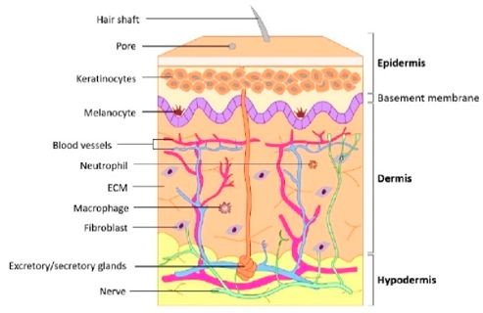
Figure 1- Schematic representation of human skin and underlying structure (9)
It serves as a protective barrier against mechanical, thermal, physical, and chemical agents, while also enabling the sensation of heat, touch, and cold. (10). Any injury that damages the structure of the skin results in tissue loss and compromise of skin integrity, leading to a wound that is eventually regenerated by the skin mechanism (11-13). A report by the NIH states that nearly 6 million people suffer from chronic wounds (14, 15). These numbers are rising annually; poor management will lead to more problems (16). According to a report by the World Health Organization (WHO), more than 11 million skin wounds occur, classified by size, nature, location, and depth, and categorized as open or closed. (17, 18). Open wounds damage skin and mucous membranes, the protectors of the body, allowing foreign materials to enter tissue (3). Examples include laceration and incision. However, closed wounds do not damage the skin surface; instead, they involve contusions or blisters beneath the skin. Skin regeneration and repair depend on depth, thickness, and duration (19).

2. Wound Healing Processes
A wound constitutes a disruption in the anatomical structure and function; wounds are classified into two categories: Acute and Chronic. Acute wounds frequently result from burns, trauma, and surgery. Under normal conditions, skin can regenerate in about 8 to 12 weeks, but deeper wounds may prolong the healing stages (9, 20). The wound spreads to the dermal layers, where tissue regeneration is delayed by impaired repair and disrupted regenerative processes. Chronic wounds, including bedsores, burns, and ulcers, heal slowly due to disrupted tissue regeneration (21-24).
Acute skin wounds generally undergo healing through four distinct stages: hemostasis, inflammation, proliferation, and maturation of healing. Following injury, platelets rapidly accumulate at the site of the wound, resulting in the formation of a blood clot. (25, 26). Subsequent hemostasis, the inflammatory stage ensues. Inflammatory cells, including leukocytes, macrophages, and platelets, as well as blood, accumulate within the wound. (27, 28). Inflammatory cells phagocytose bacteria from the wound, while macrophages release enzymes that assist in breaking down bacterial cell walls (28, 29).
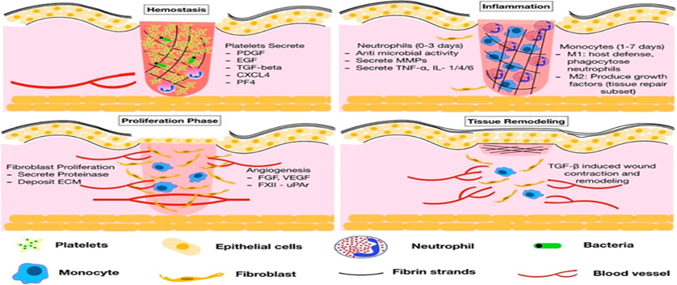
Figure 2- Stages of wound healing (hemostasis, inflammation, proliferation, and regeneration) processes and their main components (30)

3. Modern Methods in Skin Regeneration and Repair
The process of skin regeneration and repair is contingent upon the depth and thickness of the wound, which significantly influence the duration of the healing process. Deeper wounds necessitate a longer healing period compared to shallower wounds. Wounds are classified into two categories—acute and chronic—based on their etiology and manifestation. In cases of acute wounds, molecular events proceed in a sequential manner, facilitating healing within a period of four to eight weeks; in contrast, chronic wounds, characterized by infection or inflammation blister. Chronic wounds often begin as acute wounds but develop into chronic ones due to slow healing. The skin attempts to regenerate based on wound severity and extent of damage, but healing takes months and slows, leading to persistent wounds (27, 31). Acute wounds result from environmental factors like chemicals or extreme cold and heat, while chronic wounds develop from severe infections, tumors, recurrent inflammation, and bacterial growth (13). Besides skin repair, wound management remains a key challenge for personnel specialists. Combat wounds, or emergency wounds, require immediate care to minimize changes, as deformation and infection can increase complications and lead to worse outcomes and mortality. Timely wound care in the golden hours significantly improves the condition of patients until evacuation to medical centers, including hospitals. So far, only silver sulfadiazine has been used to treat these wounds; silver nitrate and Silverex can cleanse the cut area after debridement, but their use is not possible during combat (20). Proper management and timely healing of wounds, whether chronic or emergency, prevent complications like amputation or organ transplant, thereby reducing mortality (26).
Researchers, physicians, and engineers have developed biodegradable dressings made from natural and synthetic materials, which help reduce bacterial and injury-related infections. This biopolymer-based technology can accelerate skin repair and regeneration by reducing infection. Skin debridement is essential for the regeneration of skin and tissue, facilitating re-epithelialization. The dressing, composed of biopolymers, promotes autolytic debridement and enhances biological functions such as moisture retention, oxygen production, and vapor management permeability. This prevents tissue maceration and promotes cell and vascular growth, leading to re-epithelialization. Biological dressings, such as composite dressings, are preferred over synthetic dressings due to certain advantages (32, 33). Some features include biocompatibility, biodegradability, stable pH, and hydrophilic nature (34, 35). During skin regeneration, the biodegradability and controllability of natural biopolymers, such as ECM, on synthetic materials provide essential mechanical support for cell function (36, 37). In recent decades, various gauze, lint, fabric, cotton, mesh, film, hydrogel, and other dressings have been developed and become available (33). This review discusses the latest developments in natural and synthetic polymeric materials employed in skin regeneration and repair. (38). As mentioned earlier, wound treatment can vary depending on the type and severity of the wound. Simple wounds can heal faster due to abundant basal and mucosal keratinocyte stem cells. However, surface wounds often indicate that surgery is the only solution. Currently, autograft is considered the best treatment for damaged skin, but its use can be limited and involve risks (16, 18, 19). Another wound treatment method is allograft, where physicians aim to use cadaver skin as a graft. Nevertheless, allografts have limitations and risks, such as immune reactions and viral transmission. Tissue engineering investigates methods to repair damaged tissue and organs using biomaterials and biological materials, exploring various approaches, some of which are discussed in this article (33).

4. Recent advances in polymeric biomaterials and their potential uses in skin applications regeneration:

4.1. Polymeric
Recently, biomedical engineers and researchers developed biodegradable natural and synthetic dressings for wound care and bacterial control infections. This biopolymer-based technology has the potential to effectively repair and regenerate skin. Skin debridement is essential for skin regeneration and re-epithelialization. (39).
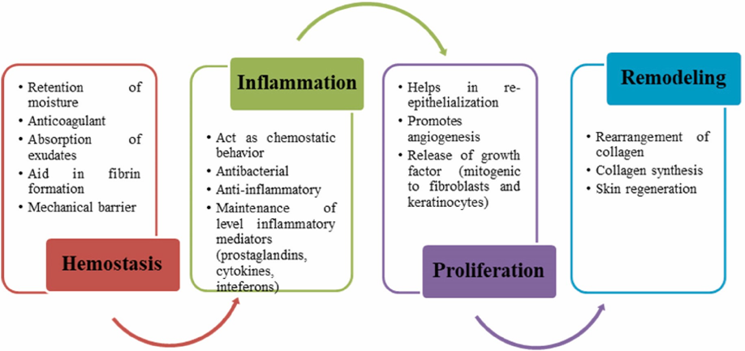
Figure 3- The role of polymeric materials in the four stages of wound healing
First, the process of producing natural biopolymeric materials is reviewed. Natural polymeric biomaterials used in skin regeneration and wound care include biopolymers obtained from living cells, made up of monomers bound together to create high-molecular-weight structures compounds. These materials are predominantly classified as protein and polysaccharide polymers that exhibit bioactive properties, including antimicrobial, antibacterial, anti-inflammatory, antioxidant, angiogenic, cell-proliferative, and adhesive characteristics, which are advantageous for wound healing. Various polymeric biomaterials are used as substitutes for autologous skin grafts in wound beds and are classified separately according to their chemical composition and structure. The dressing contains biopolymers that enhance autolytic debridement and support wound healing by maintaining wound moisture, providing oxygen, and removing exudates, thereby promoting tissue health. Composite dressings are preferred over synthetic ones because of their biocompatibility, biodegradability, hydrophilicity, immunogenicity, stability, and ability to mimic the extracellular matrix (40). During skin regeneration, natural dressings on synthetic materials degrade, thereby providing better mechanical support for cell growth and function. Research reviews highlight recent advances in natural and synthetic polymers used in wound-healing applications. Additionally, they included the advantages, disadvantages, and recommendations for addressing the challenges of each polymeric biomaterial, as well as guidance on demonstrating their commercial and clinical aspects for wound care management. It is believed that disseminating current knowledge on biopolymeric materials and commercial wound dressings will assist scientists and researchers engaged in skin tissue engineering and wound management research. Polysaccharides and protein-based natural biopolymers consist of chains of monosaccharide or disaccharide units linked by glycosidic bonds, with diverse carbon chain lengths. (41, 42).

4.2. Recent tissue engineering strategies to replicate the extracellular matrix structure for skin regeneration

4.2.1. Nanofibers: Electrospinning method (ESP)
When employed, it forms sheets of fine fibers, a few nanometers or micrometers thick, which are stacked on top of each other (43). Using these fibers and methods, nanofibrous wound dressings can prevent infection and promote healing. Sponges are typically chosen for their large pore size, high porosity, and water content compared to other porous materials (44). Collagen is usually selected as the base, with chitosan for antibacterial properties and SF for its healing properties. In a guinea pig model of second-degree burns, sponges composed of chitosan, heparin, and keratin-alginate accelerated wound closure. These findings highlight the importance of sponges in wound healing and treatment (31, 43).
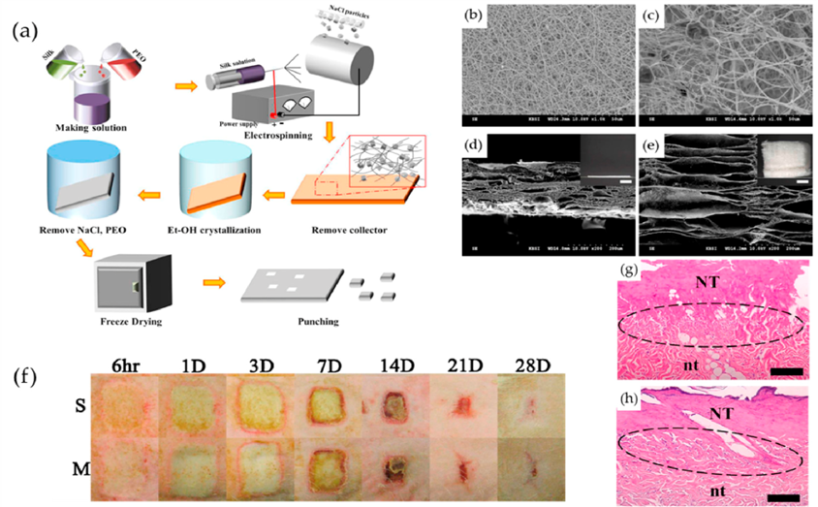
Figure 4- A schematic illustration of the fabrication of electrospun SF nanotrix and healed wounds (4)

4.2.2. Sponges
They are often constructed from porous materials due to their large size, high porosity, and water-retention capabilities capacity. (25, 37). Fabrication methods can cause variations in pore size, affecting water capacity. Pore sizes range from 20 to 160 micrometers and can be spherical particles. Lyophilization is commonly used to prepare tissue-engineering sponges. Selected sponges have micro-scale pores because of their simplicity (45).

4.3. Multifunctional conductive hyaluronic acid hydrogel designed for wound healing and skin regeneration
Wound and skin healing involve a complex, multi-phase process that includes hemostasis, inflammation, proliferation, and remodeling. Most skin defects and wounds usually heal within 2 weeks. However, chronic wounds—those that persist for months—may take longer to heal, often exceeding 8-12 weeks, and may require extended treatment. Recent data analyzed by Laurano et al. support the movement toward affordable wound care treatments. A 2013 study by G. Thakral et al. found that ES accelerated wound healing with few side effects. Rajendran and his team obtained results similar to those of their colleagues (46). Electroactive scaffolds are developed to promote cell migration and improve skin tissue engineering. Compared with methods such as debridement, negative-pressure therapy, or flap repair, ES treatments are efficient, cost-effective, and safe, speeding up the wound-healing process. Surgical debridement, requiring a skilled physician and local anesthesia, is the most common method for removing nonviable wound tissue and is also needed for flap procedures. The exact mechanism of action of negative pressure therapy remains unknown, and there is insufficient evidence to support its widespread use. An electronically stimulated, automated wound dressing uses sodium hyaluronate to accelerate healing under ES. Furthermore, natural bio-based monomers, such as pyrrole, gelatin, and alginate, were combined to create a cytocompatible 3D-printable hydrogel. However, HA alone does not form a hydrogel; it needs chemical functionalization for cross-linking. Due to the lack of an immune response, HA-based hydrogels have attracted attention as wound dressings (47-49).
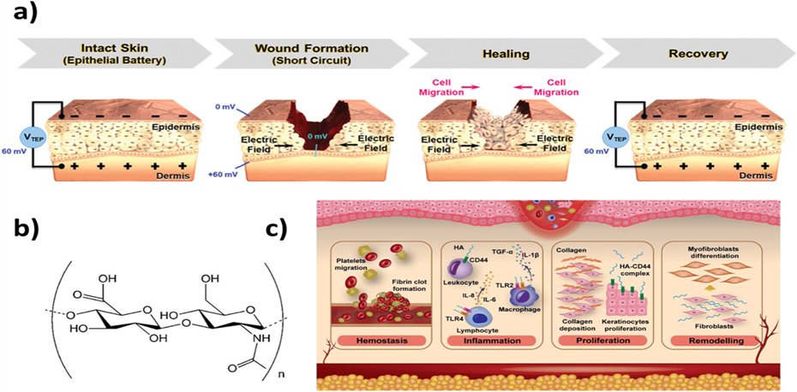
Figure 5- Skin care and wound healing with hyaluronic acid hydrogels and electrical stimulation (50)

4.4. Hydrogels
Hydrogels are used across industries like pharmaceuticals, healthcare, cosmetics, and tissue engineering (19, 21, 22, 32, 35). Today, reviews and analyses focus on developing advanced hydrogels, aiming to identify new applications and leverage them across various industrial fields (17, 18, 29, 30). Hydrogels are stable three-dimensional cross-linked networks that do not dissolve in water, offering high water-absorption capacity and interactions with biological fluids (14, 16, 28, 31). Hydrogels are synthesized from natural or synthetic polymers or monomers and have seen extraordinary advances across many applications. A composite hydrogel is a type of hydrogel formed by bonding hydrophilic groups such as hydroxyl (-OH), carboxylic acid (-COOH), imide (-CONH), sulfonic acid (-SO3H), amine (-NH2), and amide (-CONH). Additionally, the widespread use of hydrogels in purification, wastewater treatment, and medical, biomedical, and agricultural fields has increased attention to them (12, 13, 15, 19, 25-27, 35, 51).
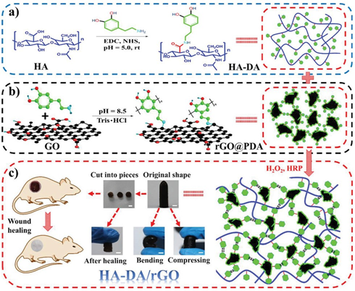
Figure 6- Diagram of hydrogel preparation (52)
4.5. Composite Dressing
Composites are materials used in commercial products in various forms; these dressings exhibit antibacterial activity and block bacterial penetration into wounds. They also prevent the spread of wound infection (53). Composite dressings are suitable for partial or full-thickness wounds with low to heavy exudate. They can keep the wound moist or dry, depending on the type of wound, in line with current clinical practices. Various dressings exist tailored to different wound types and severities, as illustrated in this article on wounds. Product dressings incorporate materials with proven medical use, primarily biological polymers such as collagen, gelatin, elastin, and glycosaminoglycans, as well as synthetic polymers such as silicone. Ensuring biocompatibility is essential to prevent excessive inflammatory reactions (54-56).

Discussion:
The skin, the largest organ of the body, consists of three layers: epidermis, dermis, and hypodermis. It acts as a barrier against external factors while enabling the perception of heat, cold, and touch. However, skin can sustain wounds from external or internal causes. A wound is a disruption in the anatomical structure or function. Acute wounds often result from burns, trauma, and surgery. Generally, skin has excellent regenerative capacity, but in acute wounds, healing typically takes 8 to 12 weeks. Heavy wounds delay healing because regeneration is disrupted. Acute skin wounds heal in four stages: hemostasis, inflammation, proliferation, and maturation. Wounds were graded by size, nature, location, depth, and thickness, categorized as open or closed. Open wounds involve damage to skin or mucous membranes, allowing the entry of foreign material (abrasions, incisions, etc.). In closed wounds, injuries such as contusions and blisters occur beneath the skin. To facilitate quick wound closure, nanofibers, sponges, hydrogels, and composites have been reviewed and compiled.

Conclusion:
The remaining challenges in skin regeneration, particularly for chronic wounds, demand innovative solutions that address the complex factors involved. To develop optimal methods, HA and ES materials are key components of cost-effective strategies. Recent advances focus on creating conductive, interactive hydrogels with multifunctional ES features for wound dressings. Hydrogels incorporating HA are used in skin repair, combined with conductive materials like metal oxide nanoparticles, carbon-based substances, and conductive polymers. Despite progress, further developments are expected in the future. Hydrogels are versatile systems supporting skin regeneration by offering properties such as self-healing, adhesion, antimicrobial action, injectability, and antioxidant effects. HA-based hydrogels can be paired with electrospun mats for short-term use to enhance performance and enable more complex substrate structures. Currently, these hydrogels outperform other materials in healing but can be further improved with HA wound dressings, biomolecules, or stem cells. Emerging approaches like gene therapy, hormones, enzymes, and short-term growth regulation are under investigation for their potential benefits. Overall, wound healing can be hindered by challenging conditions characterized by poor blood flow, chronic inflammation, nerve damage, infection, or slow angiogenesis. Addressing these issues requires clinically relevant interventions alongside current treatments to promote healing. Ensuring a smooth transition from laboratory research to clinical practice is crucial, and sharing results widely with healthcare professionals is essential to establishing effective, affordable options accessible to all.
Consent for publication:
All authors reviewed the results and approved the final version of the manuscript.
Authors’ contributions:
- HG: Conceptualization, Investigation, Methodology, Project Administration, Resources, Supervision, Validation, Writing – Review & Editing
- AA: Conceptualization, Investigation, Methodology, Resources, Visualization, Writing – Original Draft Preparation
- PA: Conceptualization, Investigation, Methodology, Resources, Visualization, Writing – Original Draft Preparation
- HS: Formal Analysis, Investigation, Writing – Review & Editing
Competing interests:
The authors declare that they have no competing interests.
Funding: No financial support.
References:

1. Yan S, Li J, Gao Y, You J, Xu S, Wang C, et al. Encapsulation of Sericin-Decorated Efficient Agents in Silk Hydrogels for Wound Dressings. ACS Applied Materials & Interfaces. 2023;15(42):48952–62. doi: 10.1021/acsami.3c10044.
2. Schultz GS, Sibbald RG, Falanga V, Ayello EA, Dowsett C, Harding K, et al. Wound Bed preparation: a Systematic Approach to Wound Management. Wound Repair and Regeneration. 2003;11(s1):S1–S28. doi: 10.1046/j.1524-475x.11.s2.1.x.
3. Stocum DL. Regenerative Biology and Medicine. Journal of Musculoskeletal & Neuronal Interactions. 2002;2(3):270–3. doi.
4. Clark RAF. The Molecular and Cellular Biology of Wound Repair: Springer US; 1988.9781489901873.
5. Müller WEG, Wiens M, Adell T, Gamulin V, Schröder HC, Müller IM. Bauplan of Urmetazoa: Basis for Genetic Complexity of Metazoa. International Review of Cytology. 2004;235:53–92. doi: 10.1016/s0074-7696(04)35002-3.
6. Li J, Guan S, Su J, Liang J, Cui L, Zhang K. The Development of Hyaluronic Acids Used for Skin Tissue Regeneration. Current Drug Delivery. 2021;18(7):836–46. doi: 10.2174/1567201817666201202094513.
7. Li S, Dong Q, Peng X, Chen Y, Yang H, Xu W, et al. Self-Healing Hyaluronic Acid Nanocomposite Hydrogels with Platelet-Rich Plasma Impregnated for Skin Regeneration. ACS Nano. 2022;16(7):11346–59. doi: 10.1021/acsnano.2c05069.
8. Tiwari N, Kumar D, Priyadarshani A, Jain GK, Mittal G, Kesharwani P, et al. Recent Progress in Polymeric Biomaterials and Their Potential Applications in Skin Regeneration and Wound Care Management. Journal of Drug Delivery Science and Technology. 2023;82:104319. doi: 10.1016/j.jddst.2023.104319.
9. Monteiro L, Barreto T, Gomes F, Alves LA. Natural Biopolymers as Additional Tools for Cell Microencapsulation Applied to Cellular Therapy. Polymers. 2022;14(13):2641–. doi: 10.3390/polym14132641.
10. Kirsner RS, Eaglstein WH. The Wound Healing Process. Dermatologic Clinics. 1993;11(4):629–40. doi: 10.1016/S0733-8635(18)30216-X.
11. Engel J. Visions for Novel Biophysical Elucidations of Extracellular Matrix Networks. The International Journal of Biochemistry & Cell Biology. 2006;39(2):311–8. doi: 10.1016/j.biocel.2006.08.003.
12. Lee CK, Hansen SL. Management of Acute Wounds. Clinics in Plastic Surgery. 2007;34(4):685–96. doi: 10.1016/j.cps.2007.08.011.
13. Mehra L, Mehra S, Tiwari N, Singh T, Rawat H, Belagavi S, et al. Fabrication, Characterization and Evaluation of the Efficacy of gelatin/hyaluronic Acid Microporous Scaffolds Suffused with aloe-vera in a Rat Burn Model. Journal of Biomaterials Applications. 2021;36(8):1346–58. doi: 10.1177/08853282211061821.
14. Monavarian M, Kader S, Moeinzadeh S, Esmaiel J. Regenerative Scar-Free Skin Wound Healing. Tissue Engineering Part B: Reviews. 2019;25(4). doi: 10.1089/ten.teb.2018.0350.
15. Nemati H. A Review of Hyaluronic acid/polycaprolactone Dermal Fillers for Skin Beauty Applications. Journal of Dermatology and Cosmetic. 2024;15(1):31–42. doi.
16. Nguyen AV, Soulika AM. The Dynamics of the Skin’s Immune System. International Journal of Molecular Sciences. 2019;20(8):1811. doi: 10.3390/ijms20081811.
17. Norouzi M, Boroujeni SM, Omidvarkordshouli N, Soleimani M. Advances in Skin Regeneration: Application of Electrospun Scaffolds. Advanced Healthcare Materials. 2015;4(8):1114–33. doi: 10.1002/adhm.201500001.
18. Nourian Dehkordi A, Mirahmadi Babaheydari F, Chehelgerdi M, Raeisi Dehkordi S. Skin Tissue engineering: Wound Healing Based on stem-cell-based Therapeutic Strategies. Stem Cell Research & Therapy. 2019;10(1). doi: 10.1186/s13287-019-1212-2.
19. Pereira RF, Barrias CC, Granja PL, Bartolo PJ. Advanced Biofabrication Strategies for Skin Regeneration and Repair. Nanomedicine. 2013;8(4):603–21. doi: 10.2217/nnm.13.50.
20. Francielle R, Carla F, Cristiane A, Luiza A, Moraes ÂM. Biopolymer-based Films and Membranes as Wound Dressings. Elsevier eBooks. 2020:165–94. doi: 10.1016/b978-0-12-818134-8.00007-9.
21. Chen B, Kumar G, Co CC, Ho C-C. Author Correction: Geometric Control of Cell Migration. Scientific Reports. 2018;8(1). doi: 10.1038/s41598-018-33004-x.
22. Chen L, Jiang F, Qiao Y, Li H, Wei Z, Huang T, et al. Nucleoskeletal Stiffness Regulates Stem Cell Migration and Differentiation through Lamin A/C. Journal of cellular physiology. 2018;233(7):5112–8. doi: 10.1002/jcp.26336.
23. Lazarus GS, Cooper DM, Knighton DR, Margolis DJ, Pecoraro RE, Rodeheaver G, et al. Definitions and Guidelines for Assessment of Wounds and Evaluation of Healing. Archives of Dermatology. 1994;130(4):489–93. doi: 10.1001/archderm.1994.01690040093015.
24. Hama R, Reinhardt JW, Ulziibayar A, Watanabe T, Kelly J, Shinoka T. Recent Tissue Engineering Approaches to Mimicking the Extracellular Matrix Structure for Skin Regeneration. Biomimetics. 2023;8(1):130–. doi: 10.3390/biomimetics8010130.
25. El M. Production of Polymer Hydrogel Composites and Their Applications. Journal of Polymers and the Environment. 2023;31. doi: 10.1007/s10924-023-02796-z.
26. Gobi R, Ravichandiran P, Babu RS, Yoo DJ. Biopolymer and Synthetic Polymer-Based Nanocomposites in Wound Dressing Applications: A Review. Polymers. 2021;13(12):1962. doi: 10.3390/polym13121962.
27. Raziyeva K, Kim Y, Zharkinbekov Z, Kassymbek K, Jimi S, Saparov A. Immunology of Acute and Chronic Wound Healing. Biomolecules. 2021;11(5):1–25. doi: 10.3390/biom11050700.
28. Wang C, Jiang X, Kim H-J, Zhang S, Zhou X, Chen Y, et al. Flexible Patch with Printable and Antibacterial Conductive Hydrogel Electrodes for Accelerated Wound Healing. Biomaterials. 2022;285:121479. doi: 10.1016/j.biomaterials.2022.121479.
29. Karimi K, Odhav A, Kollipara R, Fike J, Stanford C, Hall JC. Acute Cutaneous Necrosis: A Guide to Early Diagnosis and Treatment. Journal of Cutaneous Medicine and Surgery. 2017;21(5):425–37. doi: 10.1177/1203475417708164.
30. Auger FA, Lacroix D, Germain L. Skin Substitutes and Wound Healing. Skin Pharmacology and Physiology. 2009;22(2):94–102. doi: 10.1159/000178868.
31. Rahmani Del Bakhshayesh A, Annabi N, Khalilov R, Akbarzadeh A, Samiei M, Alizadeh E, et al. Recent Advances on Biomedical Applications of Scaffolds in Wound Healing and Dermal Tissue Engineering. Artificial Cells, Nanomedicine, and Biotechnology. 2017;46(4):691–705. doi: 10.1080/21691401.2017.1349778.
32. Guerra A, Belinha J, Jorge RN. Modelling Skin Wound Healing angiogenesis: A Review. Journal of Theoretical Biology. 2018;459:1–17. doi: 10.1016/j.jtbi.2018.09.020.
33. Wu C, Shen L, Lu Y, Hu C, Liang Z, Long L, et al. Intrinsic Antibacterial and Conductive Hydrogels Based on the Distinct Bactericidal Effect of Polyaniline for Infected Chronic Wound Healing. ACS Applied Materials & Interfaces. 2021;13(44):52308–20. doi: 10.1021/acsami.1c14088.
34. Pilehvar-Soltanahmadi Y, Dadashpour M, Mohajeri A, Fattahi A, Sheervalilou R, Zarghami N. An Overview on Application of Natural Substances Incorporated with Electrospun Nanofibrous Scaffolds to Development of Innovative Wound Dressings. Mini-Reviews in Medicinal Chemistry. 2018;18(5):414–27. doi: 10.2174/1389557517666170308112147.
35. Pina S, Ribeiro VP, Marques CF, Maia FR, Silva TH, Reis RL, et al. Scaffolding Strategies for Tissue Engineering and Regenerative Medicine Applications. Materials. 2019;12(11):1824. doi: 10.3390/ma12111824.
36. Rai M, Yadav A, Ingle A, dos Santos CA. An Introduction to biopolymer-based nanofilms, Their applications, and Limitations. Biopolymer-Based Nano Films. 2021:3–17. doi: 10.1016/b978-0-12-823381-8.00012-0.
37. Reddy MSB, Ponnamma D, Choudhary R, Sadasivuni KK. A Comparative Review of Natural and Synthetic Biopolymer Composite Scaffolds. Polymers. 2021;13(7):1105. doi: 10.3390/polym13071105.
38. Abatangelo G, Vindigni V, Avruscio G, Pandis L, Brun P. Hyaluronic Acid: Redefining Its Role. Cells. 2020;9(7):1743. doi: 10.3390/cells9071743.
39. Rusu AG, Nita LE, Simionescu N, Ghilan A, Chiriac AP, Mititelu-Tartau L. Enzymatically-Crosslinked Gelatin Hydrogels with Nanostructured Architecture and Self-Healing Performance for Potential Use as Wound Dressings. Polymers. 2023;15(3):780. doi: 10.3390/polym15030780.
40. Boyce ST, Lalley AL. Tissue Engineering of Skin and Regenerative Medicine for Wound Care. Burns & Trauma. 2018;6(1). doi: 10.1186/s41038-017-0103-y.
41. Distler T, Polley C, Shi F, Schneidereit D, Ashton MD, Friedrich O, et al. Electrically Conductive and 3D‐Printable Oxidized Alginate‐Gelatin Polypyrrole:PSS Hydrogels for Tissue Engineering. Advanced Healthcare Materials. 2021;10(9):2001876. doi: 10.1002/adhm.202001876.
42. Laurano R, Boffito M, Ciardelli G, Chiono V. Wound Dressing products: A Translational Investigation from the Bench to the Market. Engineered Regeneration. 2022;3(2):182–200. doi: 10.1016/j.engreg.2022.04.002.
43. Liu W, Wang M, Cheng W, Niu W, Chen M, Luo M, et al. Bioactive Antiinflammatory Antibacterial Hemostatic citrate-based Dressing with Macrophage Polarization Regulation for Accelerating Wound Healing and Hair Follicle Neogenesis. Bioactive Materials. 2021;6(3):721–8. doi: 10.1016/j.bioactmat.2020.09.008.
44. Chen X, Fu W, Cao X, Jiang H, Che X, Xu X, et al. Peptide SIKVAV-modified Chitosan Hydrogels Promote Skin Wound Healing by Accelerating Angiogenesis and Regulating Cytokine Secretion. American Journal of Translational Research. 2018;10(12):4258–68. doi.
45. Hama R, Ulziibayar A, Reinhardt JW, Watanabe T, Kelly J, Shinoka T. Recent Developments in Biopolymer-Based Hydrogels for Tissue Engineering Applications. Biomolecules. 2023;13(2):280. doi: 10.3390/biom13020280.
46. Tian Y, Jiang F, Xie H, Chi Z, Liu C. Conductive Hyaluronic Acid/Deep Eutectic Solvent Composite Hydrogel as a Wound Dressing for Promoting Skin Burn Healing Under Electrical Stimulation. Advanced Healthcare Materials. 2024;13(17). doi: 10.1002/adhm.202304117.
47. Hernandez JL, Woodrow KA. Medical Applications of Porous Biomaterials: Features of Porosity and Tissue‐Specific Implications for Biocompatibility. Advanced Healthcare Materials. 2022;11(9):2102087. doi: 10.1002/adhm.202102087.
48. Kamalathevan P, Ooi PS, Loo YL. Silk-Based Biomaterials in Cutaneous Wound Healing. Advances in Skin & Wound Care. 2018;31(12):565–73. doi: 10.1097/01.asw.0000546233.35130.a9.
49. Castrejón-Comas V, Alemán C, Pérez-Madrigal MM. Multifunctional Conductive Hyaluronic Acid Hydrogels for Wound Care and Skin Regeneration. Biomaterials Science. 2023;11(7):2266–76. doi: 10.1039/d2bm02057b.
50. Graça MFP, Miguel SP, Cabral CSD, Correia IJ. Hyaluronic acid—Based Wound dressings: A Review. Carbohydrate Polymers. 2020;241:116364. doi: 10.1016/j.carbpol.2020.116364.
51. Rana H, Anamika, Sareen D, Goswami S. Nanocellulose-Based Ecofriendly Nanocomposite for Effective Wastewater Remediation: A Study on Its Process Optimization, Improved Swelling, Adsorption, and Thermal and Mechanical Behavior. ACS Omega. 2024;9(8):8904–22. doi: 10.1021/acsomega.3c06924.
52. Ju HW, Lee OJ, Lee JM, Moon BM, Park HJ, Park YR, et al. Wound Healing Effect of Electrospun Silk Fibroin Nanomatrix in burn-model. International Journal of Biological Macromolecules. 2016;85:29–39. doi: 10.1016/j.ijbiomac.2015.12.055.
53. Morgado PI, Miguel SP, Correia IJ, Aguiar-Ricardo A. Ibuprofen Loaded PVA/chitosan membranes: A Highly Efficient Strategy Towards an Improved Skin Wound Healing. Carbohydrate Polymers. 2017;159:136–45. doi: 10.1016/j.carbpol.2016.12.029.
54. Sultan MT, Jeong JY, Seo YB, Lee OJ, Ju HW, Park HJ, et al. Fabrication and Characterization of the Porous Duck’s Feet Collagen Sponge for Wound Healing Applications. Journal of Biomaterials Science, Polymer Edition. 2017;29(7-9):960–71. doi: 10.1080/09205063.2017.1367636.
55. Sun L, Li L, Wang Y, Li M, Xu S, Zhang C. A collagen-based bi-layered Composite Dressing for Accelerated Wound Healing. Journal of Tissue Viability. 2022;31(1):180–9. doi: 10.1016/j.jtv.2021.09.003.
56. Vyas C, Ates G, Aslan E, Hart J, Huang B, Bartolo P. Three-Dimensional Printing and Electrospinning Dual-Scale Polycaprolactone Scaffolds with Low-Density and Oriented Fibers to Promote Cell Alignment. 3D Printing and Additive Manufacturing. 2020;7. doi: 10.1089/3dp.2019.0091.

