Biotechnological Approaches to Probiotic and Postbiotic Therapies through the Gut-Brain Axis

Abstract
The gut microbiome, in conjugation with the Gut-Brain Axis (GBA), plays a fundamental role in maintaining systemic homeostasis. Dysbiosis or distributions in microbial balance is increasingly linked to the onset and progression of chronic conditions, particularly those affecting the nervous and gastrointestinal system. Neurodegenerative disorders such as Alzheimer's and Parkinson's have been associated with dysbiosis. Also, diseases such as inflammatory bowel disease (IBD), irritable bowel syndrome (IBS), and fibromyalgia (FM), have been associated with reductions in beneficial microbes (e.g., Faecalibacterium prausnitzii and Bifidobacterium) and increased levels in bacteria (e.g., Escherichia coli and Clostridium scindens). Although therapies involving probiotics, prebiotics, postbiotics, and synbiotics have shown promise in restoring microbial equilibrium, clinical outcomes remain variable. Advances in genetic engineering and biotechnology (e.g., CRISPR Cas9, Genetic Kill Switch) enable the development of precision probiotics and postbiotics, offering novel therapeutic tools. However, issues related to safety, genetic stability, horizontal gene transfer, and immune system compatibility remain significant concerns. To enhance translational potential, future research must integrate multi-omics and Machine learning technologies with bioengineering strategies. Encapsulation and nanoencapsulation techniques have shown promise in enhancing the viability and site-specific delivery of probiotics. Accordingly, microencapsulation of Lactobacillus acidophilus and Bifidobacterium animalis using alginate and pectin significantly improved bacterial survival during freeze-drying, storage, and exposure to gastrointestinal conditions. This review examines the microbial-neural interface and highlights emerging biotechnological approaches to improve the efficacy of microbial-based therapies.

Key words: Gut-Brain Axis, Microbiota, Dysbiosis, Probiotics

Introduction
The gut-brain axis (GBA) is a two-way communication network linking the gastrointestinal tract and the central nervous system. This system integrates neural, endocrine, immune, and microbial pathways to regulate both physiological and pathological processes. The vagus nerve is the primary neural link, regulating appetite and metabolism, especially in conditions like obesity and diabetes. In addition, the enteric nervous system, often referred to as the “second brain”, operates semi-autonomously while maintaining direct interactions with the central nervous system, affecting emotional and stress-related behaviors. Hormonal signaling further reinforces GBA connectivity. For example, glucagon-like peptide-1 (GLP-1) serves as a metabolic regulator and facilitates communication between gut microbes and brain function (1). Serotonin, predominantly synthesized within the gut, is another key signaling molecule involved in mood regulation and gastrointestinal motility (2). Endocrine stress responses are coordinated via the hypothalamic-pituitary-adrenal (HPA) axis, which releases cytokines and chemokines that modulate immune activity in response to the microbial signal (3).
The gut microbiota contains approximately 10¹⁴ bacteria (4), and has been shown to exert significant influence over neurological health. Microbial imbalances have been implicated in the pathophysiology of disorders such as Parkinson’s and Alzheimer’s disease, in part through their effects on microglial activation, neuroinflammation, and synaptic plasticity (5). Gut microbiota-derived metabolites such as short-chain fatty acids (SCFAs), neurotransmitters and neuromodulators can traverse the blood-brain barrier, modulate neurotransmitter systems, and influence central nervous system integrity. These interactions underscore the therapeutic potential of microbiota-based interventions (5). Dysbiosis has been linked to altered brain connectivity and accelerated aging in conditions, highlighting the role of the microbiota in neuropsychiatric health (6).
The gut-brain axis can be modulated through interventions involving microbiota, probiotics, and postbiotics. Probiotics are live microorganisms that promote gut health by enhancing the intestinal barrier, modulating immunity, and suppressing harmful bacteria. In contrast, Postbiotics are non-living microbes or their components, offering health benefits through bioactive compounds like SCFAs, exopolysaccharides, and bacteriocins. postbiotics are more stable than probiotics and safer, avoiding risks linked to live microorganisms (7).

Recent advances in biotechnology have enhanced the precision with which probiotics and postbiotics can be engineered to influence the GBA. Technologies such as metagenomics, machine learning, and genetic engineering enable optimization of microbiome composition, thereby enhancing therapeutic outcomes related to cognitive function and neurological disorders. Metagenomic analysis facilitates the identification of microbial strains with potential for maintaining gut balance (8). Additionally, machine learning models, such as the Multivariate Adaptive Regression Splines (MARS) algorithm, can predict the metabolic profiles of probiotic formulations, aiding the design of microbial consortia that produce targeted therapeutic metabolites (9). Genetic engineering also plays a pivotal role; for example, probiotics engineered to express glucose dehydrogenase can interfere with specific metabolic pathways in disease states such as cancer, effectively depriving malignant cells of energy sources (10). Furthermore, the application of CRISPR-Cas9 technology allows for precise editing of the gut microbiome, facilitating the development of engineered probiotics capable of targeting and eliminating antibiotic-resistant bacteria, thereby restoring microbial balance (11).

Fig 1. Gut-Brain-Axis communication (created by Biorender.com)

Gut-Brain Axis: Microbial Diversity and Composition
The microbiota in the gut is the largest microbial environment in the human body, containing more than 10¹³ to 10¹⁴ bacteria. Collectively, these microorganisms possess a genetic repertoire—referred to as the microbiome—that is estimated to be ten times larger than the human genome. Recent estimates suggest that the ratio between microbial and human cells in the body approaches 1:1 (12). This microbial community develops rapidly after birth and typically reaches structural and functional maturity between the ages of two and three. The adult gut is home to roughly 500 to 1,000 distinct bacterial species, with the dominant phyla being Firmicutes, Bacteroidetes, Actinobacteria, and Proteobacteria. These microbes exist in a mutualistic or commensal relationship with the host and play essential roles in maintaining physiological equilibrium. A decline in microbial diversity or a shift in composition—known as dysbiosis—can disrupt host-microbe interactions, alter metabolic outputs, and contribute to various disease states (13, 14).
Microbial metabolites are bioactive compounds produced by gut microbiota through the fermentation of dietary components. These metabolites play crucial roles in host metabolism, immune regulation, and maintaining gut-brain axis homeostasis.

Short-Chain Fatty Acids (SCFAs)
Short-chain fatty acids, primarily acetate, propionate, and butyrate are produced through the fermentation of dietary fiber by the gut microbiota. These compounds help preserve intestinal barrier integrity, enhance mucosal secretion, and exert anti-inflammatory effects. SCFAs exert their functions by activating G protein-coupled receptors (GPCRs), including GPR41, GPR43, GPR109A, and GPR164, on epithelial and immune cells. This receptor signaling modulates the release of hormones such as glucagon-like peptide-1 (GLP-1) and peptide YY (PYY), as well as insulin secretion from pancreatic β-cells, ultimately influencing appetite and glucose metabolism (15, 16). Butyrate and propionate also exhibit anti-inflammatory properties by reducing the expression of cytokines and nitric oxide via GPCR signaling, thus contributing to immune homeostasis (17, 18). In addition, acetate and butyrate play roles in lipid metabolism by converting to acetyl-CoA, which serves as a substrate for energy production and triglyceride synthesis. These SCFAs can also activate AMP-activated protein kinase (AMPK), thereby upregulating PGC-1α and modulating transcription factors like PPARα and PPARγ that govern lipid utilization. Furthermore, SCFAs influence lipolysis through hormone-sensitive lipase (HSL) and adipose triglyceride lipase (ATGL), thereby modulating fat storage and mobilization (19, 20).

Fig 2. Gut microbial metabolites: The functional effect of SCFAs on signal transduction pathways. (created by Biorender.com)

Neurotransmitter Production
Emerging evidence indicates that the gut microbiota significantly influences the biosynthesis of key neurotransmitters, including γ-aminobutyric acid, dopamine, norepinephrine, serotonin, and histamine. These microbial activities affect central and enteric nervous system functions and are linked to mood regulation and neuropsychiatric conditions. Neurotransmitters can be broadly categorized into amino acid derivatives (e.g., glutamate, γ-aminobutyric acid, glycine), monoamines (e.g., dopamine, norepinephrine), trace amines, peptides, purines, and acetylcholine—all playing diverse roles in neural communication (21).
Glutamate (Glu) is the principal excitatory neurotransmitter in the brain, crucial for learning, memory, and synaptic plasticity. It acts on ionotropic receptors, triggering calcium influx and downstream signaling pathways. γ-aminobutyric acid (GABA), derived from glutamate, serves as the main inhibitory neurotransmitter, maintaining neuronal balance. Certain Lactobacillus species can enhance GABA synthesis and receptor expression, thereby influencing anxiety and mood disorders. Glycine functions both as an excitatory and inhibitory neurotransmitter and acts in conjunction with glutamate at NMDA receptors to support motor control and cognitive processing. Dopamine (DA), synthesized in regions such as the substantia nigra and ventral tegmental area, regulates reward pathways, motor control, and emotional responses. It is produced from the amino acid tyrosine, and can be further converted into norepinephrine (NE) and epinephrine. Gut bacteria such as Bacillus and Serratia are known to produce dopamine, which may interfere with levodopa efficacy in Parkinson’s disease treatment. NE, in addition to its role in alertness and inflammation, has been shown to influence gut microbial composition. Notably, colonization of germ-free animals has been demonstrated to restore NE levels. Serotonin (5-HT), largely synthesized in the gastrointestinal tract, plays a central role in mood, digestion, and immune modulation. Its production is closely regulated by gut microbiota. Lastly, histamine, produced by gut bacteria like Lactobacillus and Klebsiella, influences arousal, appetite, and physiological homeostasis (22).
Aromatic amino acids (AAAs) such as phenylalanine, tyrosine, and tryptophan serve as microbial precursors to a variety of neuroactive compounds. Phenylalanine is a substrate for dopamine, norepinephrine, epinephrine, glutamate, aspartate, and glycine synthesis. Tryptophan metabolism results in the production of serotonin, niacin (vitamin B3), NAD(P)+, and kynurenine pathway metabolites like indole, which are implicated in immune regulation and psychiatric disorders including depression and schizophrenia (23, 24). Bacterial genera such as Escherichia, Lactobacillus, and Bifidobacterium are actively involved in AAA metabolism (25).
Trimethylamine N-oxide (TMAO), another gut-derived metabolite, has been linked to systemic and neuroinflammation, particularly in the aging population. TMAO is formed when gut microbes convert dietary nutrients such as choline and L-carnitine into trimethylamine (TMA), which is then oxidized in the liver by flavin-containing monooxygenase 3 (FMO3). Elevated TMAO levels have been associated with inflammatory conditions and cardiovascular risks (26) . Furthermore, studies have shown that exposure of human astrocytes to TMAO results in morphological changes and increased expression of activation markers, suggesting a direct role in astrocyte-mediated neuroinflammation. These findings underscore the potential of TMAO as a biomarker and therapeutic target for age-related cognitive decline (27).

Probiotics

Mechanisms of Intestinal Barrier Function and Regulation of neuroinflammation
The gastrointestinal (GI) tract functions as a selectively permeable barrier, allowing the absorption of essential nutrients while preventing the entry of harmful pathogens and toxins. When this barrier becomes compromised—commonly referred to as “leaky gut”—it allows the translocation of microbial products and antigens, which can contribute to conditions such as inflammatory bowel disease. The integrity of the intestinal barrier is primarily maintained by tight junction proteins (TJPs), including occludin, claudins, and zonula occludens, which are regulated by both host and microbial factors (28). Probiotic strains such as Lactobacillus rhamnosus LR 32, Bifidobacterium lactis BL 04, and Bifidobacterium longum BB 536 have been shown to strengthen the gut barrier by modulating the expression of TJPs. Additionally, Lactobacillus and Bifidobacterium species promote gut health by reducing inflammation, preventing pathogenic adhesion, producing bioactive compounds, and stimulating digestive enzymes, thereby supporting both gastrointestinal and systemic health (29). In contrast, pathogenic bacteria like Salmonella Typhimurium and Escherichia coli can disrupt the epithelial barrier, worsening inflammation and tissue damage. (30).
The gut microbiota contributes to central nervous system (CNS) regulation through immunological pathways and neurotransmitter modulation. For instance, Bifidobacterium longum CCFM1077 has been shown to reduce microglial activation in the cerebellum, influence neurotransmitters such as glutamic acid and gamma-aminobutyric acid, and improve kynurenine pathway metabolism by lowering quinolinic acid levels (31). Probiotic strains such as B. lactis, L. rhamnosus, and L. reuteri have also demonstrated potential in modulating the gut-brain axis by reducing neuroinflammatory cytokines like interleukin-1β (IL-1β) and interleukin-6 (IL-6) in both the brain and gastrointestinal tract. These effects help preserve intestinal integrity, decrease oxidative stress, and maintain homeostasis, thereby mitigating symptoms of anxiety and supporting overall brain health (32).

Pathophysiological context of Gut-Brain Dysregulation
Dysbiosis has been linked to various neurological and inflammatory disorders. In Parkinson’s disease, alterations in gut microbiota composition can affect neurotransmitter production and promote inflammation, contributing to disease progression. Similarly, in Alzheimer’s disease, reductions in beneficial phyla such as Actinobacteria and Firmicutes are associated with increased gut permeability and systemic inflammation (33). In multiple sclerosis (MS), gut dysbiosis characterized by elevated levels of Bacteroides, Prevotella, and Streptococcus thermophilus has been linked to immune dysregulation and disease advancement. Decreased populations of butyrate-producing Firmicutes and compromised intestinal integrity may also impair the blood-brain barrier (34).
Major depressive disorder (MDD) and generalized anxiety disorder (GAD) frequently co-occur with chronic conditions such as fibromyalgia and autoimmune diseases, amplifying symptoms and disability. These psychiatric disorders are associated with dysregulation of the hypothalamic-pituitary-adrenal (HPA) axis and are influenced by microbial endotoxins and inflammatory cytokines like IL-6 and tumor necrosis factor-alpha (TNF-α). Alterations in gut microbiota—particularly increased Bacteroidetes and Proteobacteria and decreased Firmicutes—have been reported in individuals with MDD (35).
Serotonin imbalance, significantly influenced by microbial activity in the gut, has been implicated in mood disorders including depression. Decreased production of short-chain fatty acids, especially butyrate which possesses antidepressant properties, may exacerbate depressive symptoms. Furthermore, gut-derived inflammation and HPA axis abnormalities further contribute to emotional disturbances (36).
While the exact pathogenesis of inflammatory bowel disease remains under investigation, strong evidence supports a role for the gut microbiota. Individuals with IBD commonly exhibit reduced microbial diversity, lower levels of beneficial phyla such as Bacteroidetes and Firmicutes, and increased levels of Proteobacteria, notably Escherichia coli. Commensal species like Faecalibacterium prausnitzii and Roseburia hominis are frequently diminished (37).
Fibromyalgia, which often coexists with irritable bowel syndrome (IBS) and rheumatoid arthritis (RA), presents with chronic pain, fatigue, cognitive impairments, and mood disorders. Low-grade systemic inflammation characterized by elevated levels of IL-6 and IL-8 has been implicated in increased pain sensitivity. Dysbiosis, including small intestinal bacterial overgrowth (SIBO) and a decline in butyrate-producing bacteria such as Faecalibacterium prausnitzii, may aggravate inflammatory responses and gastrointestinal symptoms (38, 39). Notably, both irritable bowel syndrome and fibromyalgia are marked by reductions in the abundance of Bifidobacterium and Ruminococcaceae (including F. prausnitzii), alongside increased levels of Clostridium scindens (40).

Clinical evidence
A recent study explored the therapeutic potential of probiotics—Bifidobacterium lactis, Levilactobacillus brevis, and Limosilactobacillus fermentum—in a 5xFAD transgenic mouse model of Alzheimer’s disease (AD). These probiotics were administered orally, with a phosphatidylserine-enriched diet serving as the control. Behavioral assessments demonstrated notable improvements in spatial learning and recognition memory in the probiotic-treated mice. Additionally, histopathological analysis revealed reductions in amyloid-β accumulation, tau phosphorylation, and microglial activation in brain regions commonly affected by AD. These findings suggest that probiotic supplementation may beneficially alter the gut microbiota and provide neuroprotective effects relevant to Alzheimer's disease (41).
In another study, the probiotic Bifidobacterium animalis subsp. lactis NJ241 was investigated in a murine model of Parkinson’s disease (PD) induced by the neurotoxin MPTP. The research incorporated behavioral tests, molecular assays, gut microbiota profiling, and short-chain fatty acid analysis. The results indicated that NJ241 improved motor performance, prevented weight loss and gastrointestinal dysfunction, and protected dopaminergic neurons from MPTP-induced neurotoxicity. Furthermore, probiotic treatment reduced glial cell activation in the substantia nigra, restored microbial diversity, elevated SCFA production, and enhanced glucagon-like peptide-1 (GLP-1) signaling in the colon and brain. Blocking the GLP-1 receptor partially diminished these benefits, highlighting its critical role in mediating the neuroprotective effects of NJ241. This study emphasizes the therapeutic potential of gut-derived GLP-1 modulation in PD management through probiotic intervention (42).
The impact of probiotics on mood-related symptoms has also been explored in human models. A study evaluated the effects of Lactobacillus helveticus R0052 and Bifidobacterium longum R0175 on the gut microbiota of individuals with mild anxiety using the Simulator of the Human Intestinal Microbial Ecosystem (SHIME) model. Over a two-week intervention period, the probiotics promoted a favorable microbial profile by increasing Lactobacillus and Olsenella and reducing Lachnospira and Escherichia-Shigella. Additionally, ammonia levels declined, while levels of acetic acid and total SCFAs increased. Immunological assays revealed elevated levels of anti-inflammatory cytokines (IL-6, IL-10) and reduced tumor necrosis factor-alpha (TNF-α). These results support the concept of psychobiotics—probiotic strains that influence brain function via the gut-brain axis—offering a promising approach to managing anxiety and mood disorders (43).
Furthermore, the immunoregulatory effects of probiotics have been investigated in autoimmune disease models. In rat models of experimental autoimmune myasthenia gravis (EAMG) and experimental autoimmune encephalomyelitis (EAE), probiotic administration led to reduced disease severity. In EAMG, neuromuscular junctions were preserved, while in EAE, spinal cord myelin integrity was maintained. Treatment also resulted in increased levels of transforming growth factor-beta (TGF-β) and regulatory T cells in circulation, alongside enhanced immunomodulatory maturation of dendritic cells. These findings suggest that specific probiotic strains may offer therapeutic benefit in autoimmune disorders by promoting anti-inflammatory immune responses (43).

Postbiotics as Next-Generation Therapeutics
The concept of postbiotics has evolved over time with varying definitions. Initially, Tsilingiri et al. described postbiotics as metabolic byproducts generated by probiotic microorganisms that confer health benefits to the host (44). In 2019, the International Scientific Association of Probiotics and Prebiotics (ISAPP) offered a more precise definition: “a preparation of inanimate microorganisms and/or their components that confers a health benefit on the host” (45). This definition underscores the functional value of non-viable microbes or their structural elements in promoting health.

Table 1. Classification of postbiotics

Advantages of Postbiotics Over Probiotics
Stability: One of the primary advantages of postbiotics over live probiotics is their enhanced stability. Postbiotics are resistant to degradation from environmental stressors such as heat, pH fluctuations, and oxygen exposure. Unlike probiotics, which require cold-chain logistics for storage and transportation, postbiotics retain their structural and functional integrity throughout processing and shelf life (46), This stability allows for their incorporation into a wide range of formulations—including capsules, powders, and functional foods—via processes like spray-drying and microencapsulation. As a result, postbiotics ensure consistent dosing, prolonged shelf life, and predictable bioactivity, making them a dependable option for modulating the gut-brain axis and supporting immune function, particularly in inflammatory bowel diseases and related conditions (47, 48).
Targeted action: Postbiotics such as butyrate demonstrate targeted immunomodulatory effects through well-defined molecular pathways. Butyrate exerts its anti-inflammatory actions by concurrently activating G protein-coupled receptor 109A (GPR109A) and inhibiting histone deacetylases (HDACs) in human dendritic cells. This dual signaling mechanism promotes the differentiation of Type 1 regulatory T cells (Tr1), which secrete interleukin-10 (IL-10), an anti-inflammatory cytokine essential for immune homeostasis. By engaging both receptor-mediated and epigenetic pathways, short-chain fatty acids like butyrate hold considerable therapeutic potential for managing chronic inflammation (49).
Safety: Compared to live probiotic organisms, postbiotics offer a safer alternative. Since they are non-viable, postbiotics do not pose risks associated with live microbial administration, such as infections or horizontal gene transfer. Nevertheless, they retain functional bioactivity through molecules like SCFAs, peptides, and cell wall components, which support neuroimmune modulation and gut-brain axis stability. This safety profile makes postbiotics particularly suitable for immunocompromised populations or clinical settings requiring controlled microbial exposure (50).

Biotechnological Opportunities

Tools for mapping microbiota-Gut-Brain Axis interactions

Metagenomics: Advances in omics technologies have significantly enhanced our understanding of the microbiota–gut-brain axis. Among these, metagenomics plays a crucial role by allowing comprehensive analysis of entire microbial communities through techniques such as 16S rRNA gene sequencing and whole-genome shotgun sequencing. This approach enables researchers to profile the taxonomic diversity, structural complexity, and functional capabilities of gut microbiota. Metagenomic data have been instrumental in reframing disease models—such as those for inflammatory bowel disease and bacterial vaginosis (BV)—as ecological imbalances involving microbial community shifts, rather than single-pathogen etiologies. Metagenomics also supports the keystone pathogen hypothesis, which posits that specific low-abundance microbes can disproportionately disrupt community stability and contribute to disease pathogenesis, particularly in oral and gastrointestinal environments. Additionally, it provides insights into microbial communication systems like quorum sensing, aiding the development of targeted antimicrobial and anti-biofilm strategies (51). For example, Clostridioides difficile infection (CDI) commonly arises from antibiotic-induced dysbiosis, where the loss of protective microbial diversity permits opportunistic overgrowth of C. difficile. High-throughput sequencing techniques have revealed that CDI patients typically exhibit decreased levels of beneficial bacterial families—such as Bacteroidaceae, Lachnospiraceae, and Ruminococcaceae—and elevated levels of opportunistic pathogens like Enterobacteriaceae. Consequently, metagenomic tools have become essential for understanding CDI pathogenesis and guiding microbiota-based therapeutic interventions (52). Moreover, metagenomics can detect virulence factors and antibiotic resistance genes that are often missed by conventional diagnostics. This capability is particularly valuable for precision medicine, as it enables the integration of microbiome profiles into drug development pipelines and regulatory frameworks. Accordingly, it may help prevent or mitigate complications arising from dysbiosis (53).
Metabolomics: metabolomics is a powerful analytical approach that investigates small molecules and metabolites produced during metabolic processes. It provides real-time insights into the functional dynamics of host-microbiota interactions and the broader metabolic landscape, offering valuable biomarkers for both health monitoring and disease diagnosis. Common analytical techniques used in metabolomics include nuclear magnetic resonance (NMR) spectroscopy, which provides detailed structural information, and mass spectrometry (MS) coupled with chromatography, which enables sensitive and precise metabolite identification. By profiling metabolic signatures, researchers can link specific metabolites to complex conditions such as obesity, type 2 diabetes, and gastrointestinal disorders, thus facilitating the development of targeted microbiome-informed therapeutic interventions(54).
Multi-omics approaches, which integrate data from metagenomics, meta-transcriptomics, metabolomics, and glycomics, provide a comprehensive view of microbial functions and interactions within the host. These approaches enable the discovery of diagnostic biomarkers and therapeutic targets, supporting the advancement of precision medicine. Hybrid sequencing technologies, combining short- and long-read platforms, further enhance taxonomic resolution and genome assembly accuracy. Short reads offer high-throughput profiling, while long reads are essential for resolving repetitive or complex genomic regions. The integration of patient metadata—such as clinical history and lifestyle factors—further refines the interpretability and relevance of microbiome studies. Bioinformatics tools such as QIIME2 plays a critical role in analyzing microbial community structure, function, and metabolomic profiles. Accurate microbial identification relies on high-quality reference databases such as NCBI’s NT and Greengenes (55), while sequence alignment tools like BLAST and Bowtie facilitate optimal data comparison and annotation (56).
Machine Learning in Microbiome Research: Machine learning (ML) has emerged as a transformative tool in microbiome science, enabling the identification of complex patterns in high-dimensional biological datasets. ML techniques support disease classification, risk prediction, and the development of personalized therapeutic strategies. Supervised learning algorithms, which are trained on labeled data, are commonly used to predict clinical outcomes or microbial shifts. Unsupervised learning, in contrast, detects hidden structures or clusters within unlabeled data, revealing previously unknown biological associations. Despite the challenges posed by noise and dimensionality in microbiome datasets, advanced techniques such as feature selection, ranking, and permutation testing enhance model performance and interpretability. These methods help identify key microbial taxa or gene signatures associated with specific host traits or disease phenotypes, facilitating the development of targeted, microbiome-based precision therapies (57).
Biotechnological Innovations: CRISPR-Cas9 and Synthetic Biology Applications
The CRISPR-Cas9 genome editing system offers a precise and efficient tool for modifying probiotic strains, enabling the enhancement of beneficial functions or the elimination of harmful genes. For example, Escherichia coli Nissle 1917 (EcN) has been genetically engineered using CRISPR-Cas9 to produce anti-inflammatory molecules such as interleukin-10 (IL-10). Additionally, synthetic genetic circuits have been designed to act as biosensors—allowing EcN to detect intestinal inflammation and release therapeutic agents in response. Heterologous gene expression strategies further extend the functional repertoire of engineered probiotics by enabling the production of metabolites such as short-chain fatty acids, γ-aminobutyric acid, and glucagon-like peptide-1. These molecules are involved in immune regulation, metabolic homeostasis, and neuro-modulatory processes linked to the gut-brain axis. For improved genetic stability, these engineered traits are often inserted directly into the bacterial genome rather than maintained on plasmids. Additionally, metabolic pathway engineering can optimize the yield and functionality of health-promoting metabolites (58).
Biocontainment through Genetic Kill Switches
To address safety concerns associated with engineered probiotics, synthetic biology has introduced genetic “kill switches”—programmable mechanisms that ensure microbes self-destruct after delivering their therapeutic payload. Despite the potential, maintaining the stability of these kill switches remains a challenge due to evolutionary pressures that may favor escape mutants. Recent advancements include the development of two CRISPR-based kill switch systems in E. coli Nissle 1917: one activated by a chemical input and another by a combination of chemical and thermal signals. To improve reliability, researchers employed multiple stabilization strategies such as redundant circuit design, modulation of the bacterial SOS response, plasmid-free gene maintenance, and the use of competitive bacterial strains to prevent overgrowth. In preclinical mouse models, these systems effectively eliminated engineered strains in vivo, even after excretion, demonstrating their promise for safe deployment in future microbial therapies (59).
Fig 3. Kill switch design concept (created with Biorender.com). A) Permissive condition has low level of the toxin which is repressed. B) The effect of environment changing on non-permissive condition leads to increase the level of toxin which no longer capable to inhibit a lethal level of free toxin.

Encapsulation Technologies and Synbiotic Development
Encapsulation technologies, including microencapsulation and nanoencapsulation, are being employed to improve the viability and targeted delivery of probiotics. These techniques protect beneficial microbes from harsh gastrointestinal conditions such as stomach acidity and bile salts, enhancing their survival and efficacy upon reaching the intestine (60). Furthermore, the formulation of synbiotics—combinations of probiotics with complementary prebiotics—offers synergistic benefits by supporting microbial colonization and activity. These formulations help restore microbial balance and improve host outcomes across a range of disorders (61). Additionally, postbiotics—non-viable microbial products with bioactive effects—are emerging as a safer, more stable class of next-generation therapeutics that do not rely on live organisms yet still deliver significant health benefits (62).

Table 2. Biotechnological advances on probiotics

Challenges and Future direction

Low Survival Rates of Probiotics
Typical daily probiotic intake ranges between 10⁷ to 10⁹ CFU/mg (63). However, the viability of probiotics is significantly compromised by the harsh conditions of the gastrointestinal (GI) tract, including exposure to gastric acid, bile salts, and digestive enzymes (64). These factors contribute to survival rates as low as 7% to 30% during passage through the GI system (65). To address this, advanced encapsulation technologies have been developed to enhance probiotic stability. Techniques such as covalent conjugation, non-covalent adsorption, and substrate encapsulation help protect bacterial cells from oxidative stress and enable controlled release at specific GI sites. Recent innovations in encapsulation materials include the use of food-grade biopolymers like polysaccharides and proteins, as well as novel substances such as amino acids, polyphenol complexes, and Eudragit polymers. For instance, Eudragit L100-55, a pH-sensitive polymer, dissolves at intestinal pH levels above 5.5 and significantly improves targeted delivery and survival of probiotics (64). Additionally, research has shown that probiotic strains such as Lactobacillus acidophilus CCM 4833, Bifidobacterium longum CCM 4990, B. breve CCM 3763, L. reuteri HFI-LD5, and L. rhamnosus HFI-K demonstrate markedly higher survivability when administered as biofilms rather than planktonic forms. Biofilm structures offer enhanced protection in both acidic stomach environments and alkaline conditions of the proximal small intestine (66, 67). Moreover, Bacillus subtilis NCIB3610 has been found to facilitate biofilm formation, thereby providing a protective niche for co-administered probiotics such as Lactobacillus plantarum (68).

Limited Precision in Targeted Delivery
Current delivery platforms for both probiotics and postbiotics lack specificity in targeting precise regions of the gastrointestinal tract. For example, postbiotics like short-chain fatty acids are often absorbed in the upper GI tract, limiting their intended effects in the colon (69). To overcome this, nanoparticle-based delivery systems have been developed. One study demonstrated that lysate extracts of Lactobacillus paracasei GMNL-133, when encapsulated in nanoparticles composed of arginine-chitosan (Arg-CS) and fucoidan (FC), exhibited improved resistance to gastric acid, enhanced mucosal adhesion, and sustained release. These innovations significantly improved the therapeutic potential of postbiotics in gastric cancer models (70).

Lack of Reliable Biomarkers
The development and evaluation of psychobiotics interventions are hindered by the absence of validated biomarkers. Synthetic biology has made it possible to engineer microbial systems that both detect and respond to disease states. A notable example is i-ROBOT, an engineered E. coli Nissle 1917 strain designed to sense and treat inflammatory bowel disease (IBD). In a murine colitis model, i-ROBOT responded to thiosulfate levels by activating a heritable base-editing mechanism, producing visible readouts and secreting the immunomodulatory protein AvCystatin. This multifunctional design illustrates the potential for diagnostic and therapeutic integration in microbial therapeutics (71).

Future Directions in Personalized Synbiotics
Synbiotics are formulated by combining specific probiotics with prebiotic substrates that enhance their growth and metabolic activity. Common prebiotics include inulin and fructooligosaccharides (FOS), which selectively stimulate the colonization and activity of beneficial strains such as Bifidobacterium and Lactobacillus (72). Moving forward, the focus of synbiotics development is expected to shift toward personalized formulations tailored to an individual’s unique microbiota composition. Advances in high-throughput sequencing and microbiome profiling now allow for the identification of individual microbial imbalances and deficiencies. This data can inform the design of targeted synbiotics interventions that not only restore gut microbial balance but also modulate specific physiological functions. Personalized synbiotics may aim to increase SCFA production, enhance mucosal immunity, and influence neural pathways by supporting the biosynthesis of neurotransmitters such as serotonin and GABA (73, 74). This precision approach represents a significant leap in the application of microbiome science for individualized health optimization.

Ethical consideration
While genetic engineering and synthetic biology offer transformative potential in microbiome-based therapies, their application raises critical ethical and biosafety concerns. Key challenges include maintaining the genetic stability and containment of engineered microbes within the complex human gut ecosystem. There is also the risk of unintended consequences, such as dysbiosis, immune dysregulation, or interference with resident beneficial microbes. Additional concerns include the potential for horizontal gene transfer, ecological unpredictability, and gene dissemination via bacteriophages. Addressing these risks requires rigorous regulatory frameworks, robust biosafety measures such as kill switches, and the integration of systems biology approaches for dynamic modeling and risk prediction (74, 75).

Another important ethical aspect involves ensuring safety, transparency, and responsible use of microbial therapies, particularly in vulnerable populations such as immunocompromised individuals, pregnant or lactating women, and preterm infants. Although adverse events like sepsis remain rare, continuous monitoring and clear reporting of both risks and benefits are essential. For instance, while probiotics are generally regarded as safe during pregnancy, increased vigilance is warranted in cases with a predisposition to complications such as pre-eclampsia.

In neonatal care, where data on long-term outcomes remain limited, follow-up periods of at least two years are recommended to assess immune, metabolic, and developmental safety. Additionally, product quality should be guaranteed through third-party verification of strain identity, potency, and purity. Transparent labeling, standardized reporting of adverse events (including definitions, absolute risks, and reasons for participant withdrawal), and collaboration between healthcare professionals, researchers, and manufacturers are essential for ensuring public trust and responsible clinical application (76).

conclusion

The gut microbiome plays a fundamental role in regulating human health through its bidirectional communication with the gut-brain axis. Dysbiosis has been implicated in the pathogenesis of numerous chronic conditions, including inflammatory, metabolic, and neurodegenerative disorders. Advances in metagenomics, synthetic biology, and genome editing have significantly enhanced our ability to functionally characterize and manipulate the microbiota, laying the foundation for novel therapeutic strategies. Emerging gene-editing technologies, such as CRISPR-Cas9, have enabled the development of genetically engineered probiotics, synthetic postbiotics, recombinant protein expression systems, and customized microbial chassis. These innovations support the goals of precision medicine by enabling the targeted modulation of microbiota-derived functions such as neurotransmitter synthesis, immune regulation, and epithelial barrier maintenance. Despite this progress, several key challenges hinder clinical application. These include maintaining the stability of engineered genetic circuits, preventing unintended gene transfer, minimizing off-target immune responses, and implementing robust biocontainment mechanisms such as kill-switch systems. Addressing these challenges requires a systems-level approach supported by multi-omics integration—including metagenomics, transcriptomics, metabolomics, and proteomics—to comprehensively map host-microbiota interactions and predict therapeutic outcomes. Additionally, the use of advanced computational tools, including artificial intelligence (AI)-driven design and simulation, along with the establishment of standardized regulatory frameworks, will be essential for ensuring the efficacy, reproducibility, and safety of these interventions. Ultimately, the convergence of microbiology, bioengineering, and data science offers a promising pathway for transforming microbiome research into practical, individualized solutions for managing chronic diseases in clinical settings.

Confilict of interest: The authors declare that they have no known competing financial or personal relationships that could have appeared to influence the work reported in this paper.

References

1. Longo S, Rizza S, Federici M. Microbiota-gut-brain axis: Relationships among the vagus nerve, gut microbiota, obesity, and diabetes. Acta diabetologica. 2023;60(8):1007-17.
2. Kargbo RB. Microbiome–gut–brain axis modulation: New approaches in treatment of neuropsychological and gastrointestinal functional disorders. ACS Publications; 2023. p. 692-5.
3. Ashique S, Mohanto S, Ahmed MG, Mishra N, Garg A, Chellappan DK, et al. Gut-brain axis: A cutting-edge approach to target neurological disorders and potential synbiotic application. Heliyon. 2024;10(13).
4. Thursby E, Juge N. Introduction to the human gut microbiota. Biochemical journal. 2017;474(11):1823-36.
5. Kustrimovic N, Balkhi S, Bilato G, Mortara L. Gut Microbiota and Immune System Dynamics in Parkinson’s and Alzheimer’s Diseases. International Journal of Molecular Sciences. 2024;25(22):12164.
6. Hadrich I, Turki M, Chaari I, Abdelmoula B, Gargouri R, Khemakhem N, et al. Gut mycobiome and neuropsychiatric disorders: insights and therapeutic potential. Frontiers in Cellular Neuroscience. 2025;18:1495224.
7. Zhou P, Chen C, Patil S, Dong S. Unveiling the therapeutic symphony of probiotics, prebiotics, and postbiotics in gut-immune harmony. Frontiers in nutrition. 2024;11:1355542.
8. Yang J, Qin S, Zhang H. Precise strategies for selecting probiotic bacteria in treatment of intestinal bacterial dysfunctional diseases. Frontiers in Immunology. 2022;13:1034727.
9. Westfall S, Carracci F, Estill M, Zhao D, Wu Q-l, Shen L, et al. Optimization of probiotic therapeutics using machine learning in an artificial human gastrointestinal tract. Scientific reports. 2021;11(1):1067.
10. Ji P, An B, Jie Z, Wang L, Qiu S, Ge C, et al. Genetically engineered probiotics as catalytic glucose depriver for tumor starvation therapy. Materials today bio. 2023;18:100515.
11. Neil K, Allard N, Roy P, Grenier F, Menendez A, Burrus V, et al. High‐efficiency delivery of CRISPR‐Cas9 by engineered probiotics enables precise microbiome editing. Molecular Systems Biology. 2021;17(10):e10335.
12. Sender R, Fuchs S, Milo R. Revised estimates for the number of human and bacteria cells in the body. PLoS biology. 2016;14(8):e1002533.
13. Kim S, Kim H, Yim YS, Ha S, Atarashi K, Tan TG, et al. Maternal gut bacteria promote neurodevelopmental abnormalities in mouse offspring. Nature. 2017;549(7673):528-32.
14. Rutsch A, Kantsjö JB, Ronchi F. The gut-brain axis: how microbiota and host inflammasome influence brain physiology and pathology. Frontiers in immunology. 2020;11:604179.
15. Silva YP, Bernardi A, Frozza RL. The role of short-chain fatty acids from gut microbiota in gut-brain communication. Frontiers in endocrinology. 2020;11:508738.
16. Cherbut C, Ferrier L, Rozé C, Anini Y, Blottière H, Lecannu G, et al. Short-chain fatty acids modify colonic motility through nerves and polypeptide YY release in the rat. American Journal of Physiology-Gastrointestinal and Liver Physiology. 1998;275(6):G1415-G22.
17. Vinolo MA, Rodrigues HG, Nachbar RT, Curi R. Regulation of inflammation by short chain fatty acids. Nutrients. 2011;3(10):858-76.
18. He J, Zhang P, Shen L, Niu L, Tan Y, Chen L, et al. Short-chain fatty acids and their association with signalling pathways in inflammation, glucose and lipid metabolism. International journal of molecular sciences. 2020;21(17):6356.
19. May KS, den Hartigh LJ. Modulation of adipocyte metabolism by microbial short-chain fatty acids. Nutrients. 2021;13(10):3666.
20. Cao S, Liu M, Han Y, Li S, Zhu X, Li D, et al. Effects of saponins on lipid metabolism: the gut–liver axis plays a key role. Nutrients. 2024;16(10):1514.
21. Dicks LM. Gut bacteria and neurotransmitters. Microorganisms. 2022;10(9):1838.
22. Chen Y, Xu J, Chen Y. Regulation of neurotransmitters by the gut microbiota and effects on cognition in neurological disorders. Nutrients. 2021;13(6):2099.
23. Parthasarathy A, Cross PJ, Dobson RC, Adams LE, Savka MA, Hudson AO. A three-ring circus: metabolism of the three proteogenic aromatic amino acids and their role in the health of plants and animals. Frontiers in molecular biosciences. 2018;5:29.
24. Swer NM, Venkidesh B, Murali TS, Mumbrekar KD. Gut microbiota-derived metabolites and their importance in neurological disorders. Molecular Biology Reports. 2023;50(2):1663-75.
25. Lee J-H, Lee J. Indole as an intercellular signal in microbial communities. FEMS microbiology reviews. 2010;34(4):426-44.
26. Wang Z, Klipfell E, Bennett BJ, Koeth R, Levison BS, DuGar B, et al. Gut flora metabolism of phosphatidylcholine promotes cardiovascular disease. nature. 2011;472(7341):57-63.
27. Brunt VE, LaRocca TJ, Bazzoni AE, Sapinsley ZJ, Miyamoto-Ditmon J, Gioscia-Ryan RA, et al. The gut microbiome–derived metabolite trimethylamine N-oxide modulates neuroinflammation and cognitive function with aging. GeroScience. 2021;43(1):377-94.
28. Bischoff SC, Barbara G, Buurman W, Ockhuizen T, Schulzke J-D, Serino M, et al. Intestinal permeability–a new target for disease prevention and therapy. BMC gastroenterology. 2014;14:1-25.
29. Alvarez C-S, Badia J, Bosch M, Giménez R, Baldomà L. Outer membrane vesicles and soluble factors released by probiotic Escherichia coli Nissle 1917 and commensal ECOR63 enhance barrier function by regulating expression of tight junction proteins in intestinal epithelial cells. Frontiers in microbiology. 2016;7:1981.
30. Fusco A, Savio V, Cimini D, D’Ambrosio S, Chiaromonte A, Schiraldi C, et al. In vitro evaluation of the most active probiotic strains able to improve the intestinal barrier functions and to prevent inflammatory diseases of the gastrointestinal system. Biomedicines. 2023;11(3):865.
31. Chandrasekaran P, Weiskirchen S, Weiskirchen R. Effects of probiotics on gut microbiota: an overview. International journal of molecular sciences. 2024;25(11):6022.
32. Michels M, Jesus GFA, Abatti MR, Córneo E, Cucker L, de Medeiros Borges H, et al. Effects of different probiotic strains B. lactis, L. rhamnosus and L. reuteri on brain-intestinal axis immunomodulation in an endotoxin-induced inflammation. Molecular Neurobiology. 2022;59(8):5168-78.
33. Yang J, Liang J, Hu N, He N, Liu B, Liu G, et al. The gut microbiota modulates neuroinflammation in Alzheimer's disease: elucidating crucial factors and mechanistic underpinnings. CNS Neuroscience & Therapeutics. 2024;30(10):e70091.
34. Barcutean L, Maier S, Burai-Patrascu M, Farczadi L, Balasa R. The immunomodulatory potential of short-chain fatty acids in multiple sclerosis. International Journal of Molecular Sciences. 2024;25(6):3198.
35. Garvey M. The association between dysbiosis and neurological conditions often manifesting with chronic pain. Biomedicines. 2023;11(3):748.
36. Góralczyk-Bińkowska A, Szmajda-Krygier D, Kozłowska E. The microbiota–gut–brain axis in psychiatric disorders. International journal of molecular sciences. 2022;23(19):11245.
37. Santana PT, Rosas SLB, Ribeiro BE, Marinho Y, de Souza HS. Dysbiosis in inflammatory bowel disease: pathogenic role and potential therapeutic targets. International journal of molecular sciences. 2022;23(7):3464.
38. Erdrich S, Hawrelak JA, Myers SP, Harnett JE. A systematic review of the association between fibromyalgia and functional gastrointestinal disorders. Therapeutic Advances in Gastroenterology. 2020;13:1756284820977402.
39. Sanada K, Díez MA, Valero MS, Pérez-Yus MC, Demarzo MM, García-Toro M, et al. Effects of non-pharmacological interventions on inflammatory biomarker expression in patients with fibromyalgia: a systematic review. Arthritis research & therapy. 2015;17:1-16.
40. Garofalo C, Cristiani CM, Ilari S, Passacatini LC, Malafoglia V, Viglietto G, et al. Fibromyalgia and irritable bowel syndrome interaction: a possible role for gut microbiota and gut-brain axis. Biomedicines. 2023;11(6):1701.
41. Kim YJ, Mun B-R, Choi KY, Choi W-S. Oral administration of probiotic bacteria alleviates tau phosphorylation, aβ accumulation, microglia activation, and memory loss in 5xFAD mice. Brain Sciences. 2024;14(3):208.
42. Dong Y, Qi Y, Chen J, Han S, Su W, Ma X, et al. Neuroprotective Effects of Bifidobacterium animalis subsp. lactis NJ241 in a Mouse Model of Parkinson’s Disease: Implications for Gut Microbiota and PGC-1α. Molecular Neurobiology. 2024;61(10):7534-48.
43. De Oliveira FL, Salgaço MK, de Oliveira MT, Mesa V, Sartoratto A, Peregrino AM, et al. Exploring the potential of Lactobacillus helveticus R0052 and Bifidobacterium longum R0175 as promising psychobiotics using SHIME. Nutrients. 2023;15(6):1521.
44. Zhong Y, Wang S, Di H, Deng Z, Liu J, Wang H. Gut health benefit and application of postbiotics in animal production. Journal of Animal Science and Biotechnology. 2022;13(1):38.
45. Salminen S, Collado MC, Endo A, Hill C, Lebeer S, Quigley EM, et al. The International Scientific Association of Probiotics and Prebiotics (ISAPP) consensus statement on the definition and scope of postbiotics. Nature reviews Gastroenterology & hepatology. 2021;18(9):649-67.
46. Dodd MC, Bouwer JJ. The supply value chain of fresh produce from field to home: Refrigeration and other supporting technologies. Postharvest handling: Elsevier; 2014. p. 449-83.
47. Wu Y, Wang Y, Hu A, Shu X, Huang W, Liu J, et al. Lactobacillus plantarum-derived postbiotics prevent Salmonella-induced neurological dysfunctions by modulating gut–brain axis in mice. Frontiers in Nutrition. 2022;9:946096.
48. Banfi D, Moro E, Bosi A, Bistoletti M, Cerantola S, Crema F, et al. Impact of microbial metabolites on microbiota–gut–brain axis in inflammatory bowel disease. International journal of molecular sciences. 2021;22(4):1623.
49. Kaisar MM, Pelgrom LR, Van der Ham AJ, Yazdanbakhsh M, Everts B. Butyrate conditions human dendritic cells to prime type 1 regulatory T cells via both histone deacetylase inhibition and G protein-coupled receptor 109A signaling. Frontiers in immunology. 2017;8:1429.
50. Liaqat H, Parveen A, Kim SY. Neuroprotective natural products’ regulatory effects on depression via gut–brain axis targeting tryptophan. Nutrients. 2022;14(16):3270.
51. Chaudhari HG, Prajapati S, Wardah ZH, Raol G, Prajapati V, Patel R, et al. Decoding the microbial universe with metagenomics: a brief insight. Frontiers in Genetics. 2023;14:1119740.
52. Wang L, Chen X, Pollock NR, Villafuerte Gálvez JA, Alonso CD, Wang D, et al. Metagenomic analysis reveals distinct patterns of gut microbiota features with diversified functions in C. difficile infection (CDI), asymptomatic carriage and non-CDI diarrhea. Gut Microbes. 2025;17(1):2505269.
53. Mulcahy-O’Grady H, Workentine ML. The challenge and potential of metagenomics in the clinic. Frontiers in immunology. 2016;7:29.
54. Vernocchi P, Del Chierico F, Putignani L. Gut microbiota profiling: metabolomics based approach to unravel compounds affecting human health. Frontiers in microbiology. 2016;7:1144.
55. DeSantis TZ, Hugenholtz P, Larsen N, Rojas M, Brodie EL, Keller K, et al. Greengenes, a chimera-checked 16S rRNA gene database and workbench compatible with ARB. Applied and environmental microbiology. 2006;72(7):5069-72.
56. Wu J, Singleton SS, Bhuiyan U, Krammer L, Mazumder R. Multi-omics approaches to studying gastrointestinal microbiome in the context of precision medicine and machine learning. Frontiers in molecular biosciences. 2024;10:1337373.
57. Abavisani M, Khoshrou A, Foroushan SK, Ebadpour N, Sahebkar A. Deciphering the gut microbiome: The revolution of artificial intelligence in microbiota analysis and intervention. Current Research in Biotechnology. 2024;7:100211.
58. Zhou S, Zhao L, Zuo W, Zheng Y, Zhang P, Sun Y, et al. Minimizing endogenous cryptic plasmids to construct antibiotic-free expression systems for Escherichia coli Nissle 1917. Synthetic and Systems Biotechnology. 2024;9(1):165-75.
59. Rottinghaus AG, Ferreiro A, Fishbein SR, Dantas G, Moon TS. Genetically stable CRISPR-based kill switches for engineered microbes. Nature communications. 2022;13(1):672.
60. Motalebi Moghanjougi Z, Rezazadeh Bari M, Alizadeh Khaledabad M, Amiri S, Almasi H. Microencapsulation of Lactobacillus acidophilus LA‐5 and Bifidobacterium animalis BB‐12 in pectin and sodium alginate: A comparative study on viability, stability, and structure. Food Science & Nutrition. 2021;9(9):5103-11.
61. Markowiak P, Śliżewska K. Effects of probiotics, prebiotics, and synbiotics on human health. Nutrients. 2017;9(9):1021.
62. Aggarwal S, Sabharwal V, Kaushik P, Joshi A, Aayushi A, Suri M. Postbiotics: From emerging concept to application. Frontiers in Sustainable Food Systems. 2022;6:887642.
63. Ranjha MMAN, Shafique B, Batool M, Kowalczewski PŁ, Shehzad Q, Usman M, et al. Nutritional and health potential of probiotics: a review. Applied Sciences. 2021;11(23):11204.
64. Garcia-Brand AJ, Quezada V, Gonzalez-Melo C, Bolaños-Barbosa AD, Cruz JC, Reyes LH. Novel developments on stimuli-responsive probiotic encapsulates: from smart hydrogels to nanostructured platforms. Fermentation. 2022;8(3):117.
65. Yoha K, Nida S, Dutta S, Moses J, Anandharamakrishnan C. Targeted delivery of probiotics: perspectives on research and commercialization. Probiotics and Antimicrobial Proteins. 2022:1-34.
66. Grossova M, Rysavka P, Marova I. Probiotic biofilm on carrier surface: A novel promising application for food industry. Acta Alimentaria. 2017;46(4):439-48.
67. Klopper KB, Bester E, Deane SM, Wolfaardt GM, Dicks LM. Survival of planktonic and sessile cells of lactobacillus rhamnosus and lactobacillus reuteri upon exposure to simulated fasting-state gastrointestinal conditions. Probiotics and Antimicrobial Proteins. 2019;11:594-603.
68. Yahav S, Berkovich Z, Ostrov I, Reifen R, Shemesh M. Encapsulation of beneficial probiotic bacteria in extracellular matrix from biofilm-forming Bacillus subtilis. Artificial Cells, Nanomedicine, and Biotechnology. 2018;46(sup2):974-82.
69. McClements DJ. Designing biopolymer microgels to encapsulate, protect and deliver bioactive components: Physicochemical aspects. Advances in Colloid and Interface Science. 2017;240:31-59.
70. Huang H-L, Lai C-H, Tsai W-H, Chen K-W, Peng S-L, Lin J-H, et al. Nanoparticle-enhanced postbiotics: Revolutionizing cancer therapy through effective delivery. Life Sciences. 2024;337:122379.
71. Zou Z-P, Du Y, Fang T-T, Zhou Y, Ye B-C. Biomarker-responsive engineered probiotic diagnoses, records, and ameliorates inflammatory bowel disease in mice. Cell Host & Microbe. 2023;31(2):199-212. e5.
72. Pandey K, Naik S, Vakil B. Probiotics, prebiotics and synbiotics-a review. Journal of food science and technology. 2015;52(12):7577-87.
73. Abouelela ME, Helmy YA. Next-generation probiotics as novel therapeutics for improving human health: current trends and future perspectives. Microorganisms. 2024;12(3):430.
74. Nazir A, Hussain FHN, Raza A. Advancing microbiota therapeutics: the role of synthetic biology in engineering microbial communities for precision medicine. Frontiers in Bioengineering and Biotechnology. 2024;12:1511149.
75. Cruz KCP, Enekegho LO, Stuart DT. Bioengineered probiotics: synthetic biology can provide live cell therapeutics for the treatment of foodborne diseases. Frontiers in bioengineering and biotechnology. 2022;10:890479.
76. Merenstein D, Pot B, Leyer G, Ouwehand AC, Preidis GA, Elkins CA, et al. Emerging issues in probiotic safety: 2023 perspectives. Gut microbes. 2023;15(1):2185034.

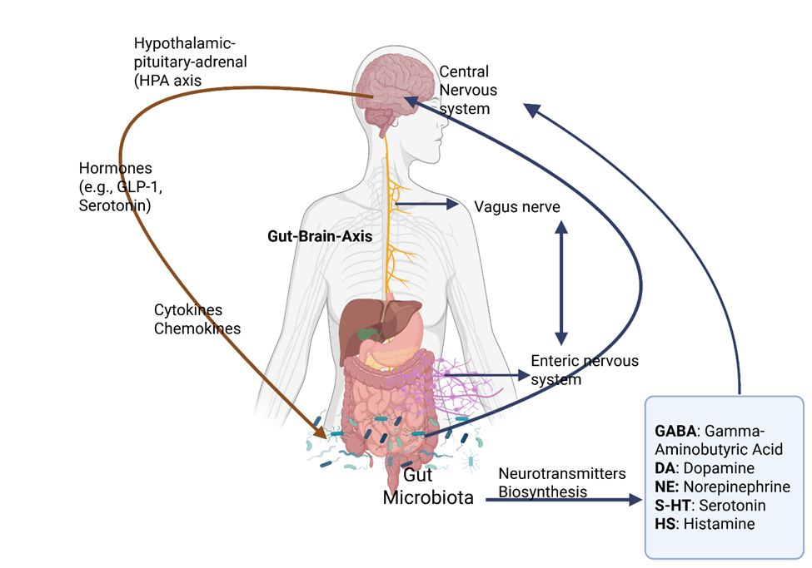

Fig 1. Gut-Brain-Axis communication (created by Biorender.com)

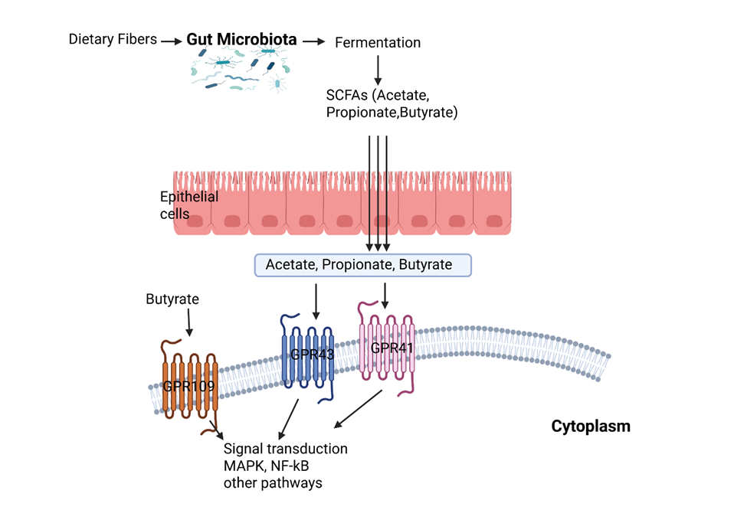

Fig 2. Gut microbial metabolites: The functional effect of SCFAs on signal transduction pathways. (created by Biorender.com)

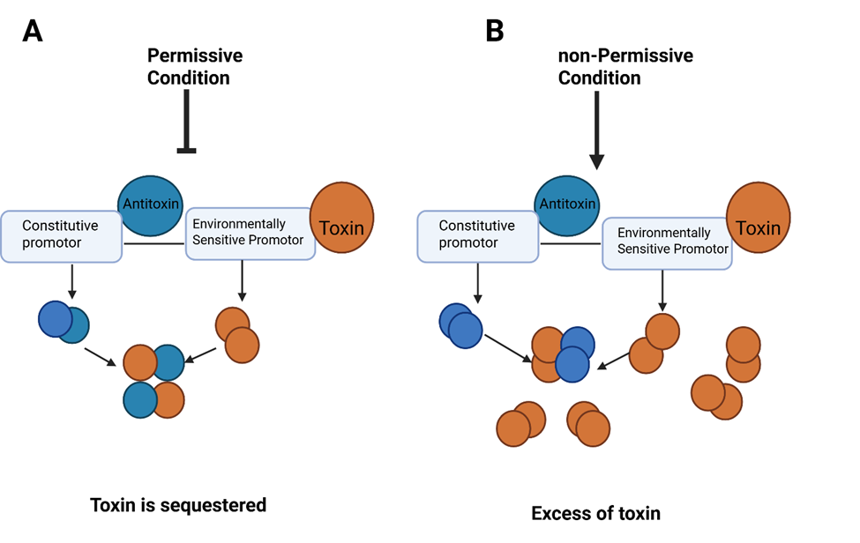

Fig 3. Kill switch design concept (created with Biorender.com). A) Permissive condition has low level of the toxin which is repressed. B) The effect of environment changing on non-permissive condition leads to increase the level of toxin which no longer capable to inhibit a lethal level of free toxin.

Table 1. Classification of postbiotics
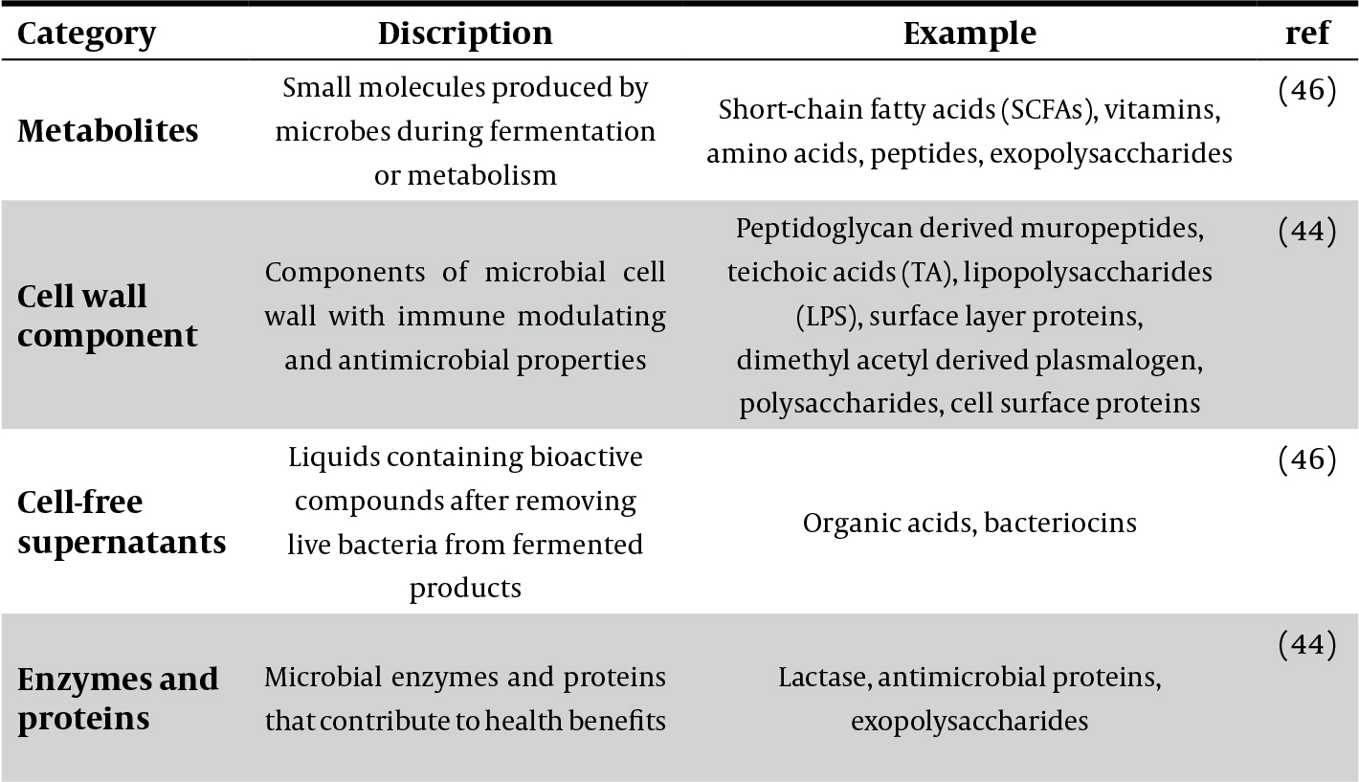

Table 2. Biotechnological advances on probiotics
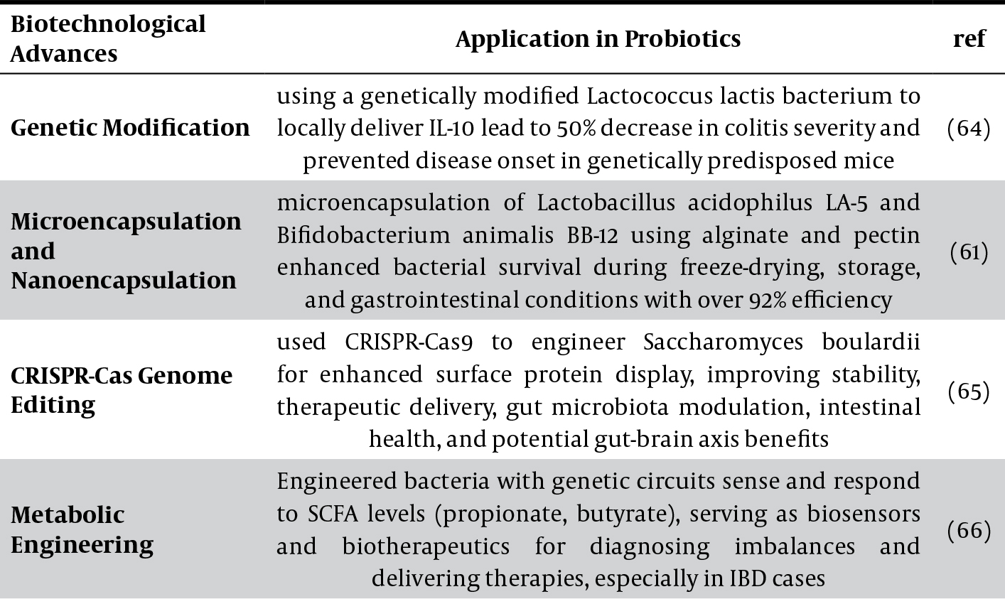

N-Methyl-D-Aspartate
Levodopa or L-DOPA is dopaminergic medication for the treatment of Parkinson`s disease
a protein that stabilizes microtubules in neurons
1-methyl-4-phenyl-1,2,3,6-tetrahydropyridine
Quantitative Insights into Microbial Ecology
NCBI`s nt (nucleotide)
Greengenes offers annotated, chimera-cheked, full length 16S rDNA gene sequences in standard alignment formats.
Eudragit is a copolymer of poly (ethylacrylate, methyl-methacrylate, and chloro trimethyl-ammonioethyl methacrylate), which is insoluble at physiologic pH
AvCystatin, a recombinant cysteine protease inhibitor derived from the filarial nematode Acanthocheilonema viteae.

