Article type: Full Length/Original Article

Combined Role of Growth Differentiation Factor 15 and Oxidative Stress Markers in Hemoglobin H Disease: A Genotype-Based Insight
Running title: GDF-15 and Oxidative Stress in Hb H Disease

Declarations
Acknowledgments
Not applicable
Ethical Approval
The study protocol complied with the ethical standards of the 1964 Declaration of Helsinki and was approved by the Ethics Committee of the Pasteur Institute of Iran (IR.PII.REC.1403.027).
Consent to participate
Written informed consent was obtained from all participants or their legal guardians.
Consent for publication
All authors reviewed the results and approved the final version of the manuscript.
Author contributions
Data availability
Not applicable
Competing interests
The authors declare no conflicts of interest relevant to this article.
Funding
No financial support was provided relevant to this article.
List of Abbreviations
CRP: C-reactive protein
D: Deletional mutation
GDF-15: Growth Differentiation Factor 15
Hb H: Hemoglobin H
Hb F: Fetal hemoglobin
HbA₂: Hemoglobin A₂
MDA: Malondialdehyde
ND: Non-deletional mutation
NTD: Non-transfusion-dependent
OTD: Occasionally transfusion-dependent
ROS: Reactive oxygen species
TD: Transfusion-dependent

Combined Role of Growth Differentiation Factor 15 and Oxidative Stress Markers in Hemoglobin H Disease: A Genotype-Based Insight

ABSTRACT
Background: Hemoglobin H (Hb H) disease presents with a broad spectrum of clinical severity influenced by underlying α-globin genotypes. Growth Differentiation Factor 15 (GDF-15) and oxidative stress biomarkers have emerged as potential indicators of ineffective erythropoiesis and disease burden in thalassemic disorders, yet their genotype-specific role in Hb H disease remains understudied.
Methods: In this multicenter cross-sectional study, 152 patients with confirmed Hb H disease were genotypically stratified into three groups: ND/ND, ND/D, and D/D. Patients were also categorized clinically as transfusion-dependent (TD), occasionally transfusion-dependent (OTD), or non-transfusion-dependent (NTD). Comprehensive hematologic, biochemical, and molecular analyses were performed alongside quantification of plasma GDF-15 and malondialdehyde (MDA) levels. Statistical correlations with clinical, genotypic, and inflammatory parameters were assessed.
Results: GDF-15 and MDA levels were significantly elevated in TD patients compared to OTD and NTD subgroups (p < 0.001), and were highest among ND/D genotypes. GDF-15 showed strong positive correlations with reticulocyte count (r = 0.77) and negative correlations with hemoglobin levels (r = –0.64), while MDA correlated with serum ferritin (r = 0.65), CRP (r = 0.31), and GDF-15 (r = 0.55) (all p < 0.01). Post-transfusion GDF-15 levels decreased significantly in TD patients (p < 0.001). Splenectomized patients exhibited significantly higher MDA, reticulocyte, and CRP levels. Genotypic analysis revealed a higher prevalence of non-deletional mutations in TD patients, with deletional genotypes dominating in NTD cases.
Conclusion: GDF-15 and MDA are significantly associated not only with erythropoietic activity and oxidative stress, respectively, but also with the severity of Hb H disease. Their levels vary significantly across genotypes and transfusion statuses, highlighting their potential as adjunct biomarkers for clinical monitoring and risk stratification in patients with Hb H disease.
Keywords: Hemoglobin H disease; GDF-15; Oxidative stress; Malondialdehyde; α-globin genotype; Thalassemia; Transfusion dependency
INTRODUCTION
Alpha-thalassemia is among the most common inherited hemoglobinopathies globally. Hemoglobin H (Hb H) disease, arising from the deletion or dysfunction of three α-globin genes, constitutes a clinically intermediate form of alpha-thalassemia, with manifestations ranging from mild or asymptomatic anemia to severe transfusion-dependent anemia ^{[1]}. The broad phenotypic spectrum of Hb H disease is largely driven by underlying genetic variations, with non-deletional (ND) mutations typically associated with more severe clinical phenotypes than deletional (D) forms ^{[2]}. Although conventional classification systems—based on either transfusion requirements or genotypic categories—offer useful clinical guidance, they may not adequately capture the complex biochemical and pathophysiological mechanisms that influence disease progression ^{[1, 3]}.
The underlying pathophysiology of Hb H disease is shaped by a multifactorial interplay involving ineffective erythropoiesis, hemolysis, oxidative stress, and progressive iron overload. Among these, oxidative stress has emerged as a key pathogenic contributor in various hemoglobinopathies, including Hb H disease. The presence of unstable hemoglobin variants and the accumulation of excess β-globin chains promote the generation of reactive oxygen species (ROS), which in turn trigger lipid peroxidation, membrane disruption, and premature red blood cell destruction ^{[3, 4]}.
Malondialdehyde (MDA), a stable end-product of lipid peroxidation, serves as a reliable biomarker of oxidative injury and has been consistently reported to be elevated in various thalassemia syndromes ^{[4]}. Furthermore, several studies have demonstrated significant correlations between MDA levels and clinical parameters, including serum ferritin, inflammatory markers, and transfusion frequency ^{[5]}. Importantly, emerging evidence suggests that non-deletional genotypes in Hb H disease are associated with higher oxidative stress levels, potentially contributing to more severe clinical manifestations in these patients ^{[3]}. Elevated MDA levels may reflect the oxidative damage mediated by excess free iron, a common finding among chronically transfused thalassemia patients ^{[6]}.
The heightened oxidative environment in Hb H disease appears to be intricately linked with dysregulated erythropoiesis, as reflected by emerging biomarkers such as Growth Differentiation Factor-15 (GDF-15). GDF-15 is a stress-responsive cytokine upregulated during late-stage erythroid maturation and has gained recognition as a sensitive marker of ineffective erythropoiesis and iron dysregulation in hemoglobinopathies^{[7]}. Elevated GDF-15 levels contribute to systemic iron overload by suppressing hepcidin expression, thereby increasing intestinal iron absorption even in the presence of sufficient or excessive iron stores ^{[8]}. Recent evidence supports the clinical utility of GDF-15 as a sensitive biomarker in both β- and α-thalassemia, particularly in monitoring ineffective erythropoiesis and iron dysregulation ^{[9]}. Notably, GDF-15 has shown positive correlations with oxidative stress markers, serum ferritin, and reticulocyte count, suggesting its potential role in mediating the interplay between iron homeostasis, oxidative injury, and erythroid drive ^{[10]}.
Despite growing evidence, the relationship between specific α-globin genotypes, oxidative stress markers, and erythropoietic activity in Hb H disease remains incompletely understood. The molecular mechanisms linking these genetic variants to downstream biochemical alterations and clinical severity are yet to be fully elucidated. A deeper understanding of these interactions may help shift the current management paradigm from one primarily based on transfusion needs to a more refined, biomarker-driven approach incorporating both molecular and biochemical stratification. ^{[3]}.

Therefore, the present study aims to comprehensively investigate the interrelationships among genotypic determinants, oxidative stress (assessed by malondialdehyde [MDA]), erythropoietic activity (measured by growth differentiation factor-15 [GDF-15]), and iron metabolism across clinically and genetically stratified subgroups of patients with Hb H disease. By integrating these parameters, we seek to identify novel biomarkers that can enhance patient stratification beyond conventional genotype- or transfusion-based frameworks and support more personalized therapeutic strategies. This multidimensional approach may ultimately inform critical clinical decisions regarding transfusion thresholds, initiation of iron chelation therapy, and the identification of patients at higher risk of complications who may benefit from closer surveillance. The findings of this study may offer novel insights into personalized management of Hb H disease.

MATERIALS AND METHODS

Study Population and Design

This cross-sectional, multicenter study was conducted between April 2024 and December 2024 at several major thalassemia referral centers in Iran. A total of 152 individuals were enrolled following the laboratory-based identification of Hb H disease, initially detected through hematologic profiling and capillary electrophoresis. All participating centers followed a standardized recruitment protocol, and data collection procedures were centrally coordinated to ensure methodological consistency across sites. The study protocol complied with the ethical standards of the 1964 Declaration of Helsinki and was approved by the Ethics Committee of the Pasteur Institute of Iran (IR.PII.REC.1403.027). Written informed consent was obtained from all participants or their legal guardians.

Eligibility Criteria and Patient Selection

Patients were eligible for inclusion if they presented with clinical and laboratory evidence of anemia and had Hb H disease confirmed by hemoglobin electrophoresis. Additional inclusion criteria required HbA₂ levels within or below the normal reference range and fetal hemoglobin (Hb F) concentrations consistent with age-appropriate physiological values. Exclusion criteria included a confirmed diagnosis of β-thalassemia major or intermedia, silent α-thalassemia carrier status, or anemia due to non-thalassemic causes such as iron deficiency, chronic inflammatory diseases, or autoimmune hemolytic anemia.

Clinical and Genotypic Classification

Following comprehensive molecular and biochemical characterization, patients were stratified based on both clinical phenotype and underlying α-globin genotype. Clinically, patients were categorized into three transfusion-dependency subgroups: regularly transfusion-dependent, occasionally transfusion-dependent, and non-transfusion-dependent Hb H disease. This classification was determined through evaluation of longitudinal transfusion records and systematic physical examinations conducted by hematologists specializing in red blood cell disorders. Molecularly, patients were classified into three genotypic subgroups according to the nature of their α-globin gene mutations: patients with two non-deletional mutations (ND/ND), compound heterozygotes with one non-deletional and one deletional mutation (ND/D), and patients with two deletional mutations (D/D). This genotypic classification provided a framework for examining the correlation between specific genetic determinants and the clinical heterogeneity of Hb H disease.

Clinical Assessment and Biospecimen Collection
Comprehensive demographic and clinical information was obtained through structured interviews and review of medical records. Collected variables included age, sex, transfusion parameters (age at first transfusion and transfusion frequency), medication history (with emphasis on iron chelation regimens), hepatic and cardiac status, and splenic parameters (including splenomegaly, splenectomy history, and post-splenectomy complications).Once consent had been secured from each subject or their parent/legal guardian, peripheral blood samples were collected in EDTA tubes for hematologic and molecular analyses, and in serum separator tubes for biochemical assays. All samples were processed and stored according to standardized protocols to ensure specimen integrity.

Hematological and Biochemical Analyses

A comprehensive hematological evaluation was performed for all participants. Complete blood count (CBC) parameters—including hemoglobin (Hb), mean corpuscular volume (MCV), and mean corpuscular hemoglobin (MCH)—along with reticulocyte counts, were measured using the Sysmex XN-2500 automated hematology analyzer (Sysmex Corporation, Japan). Hemoglobin fraction analysis, including HbA, HbA₂, HbF, Hb H, and Hb Bart’s, was conducted via capillary electrophoresis using the Sebia Capillary Electrophoresis System (Model 2 or 3; Sebia, France).

Iron status assessment included serum ferritin measurement by chemiluminescent immunoassay (Abbott Architect i1000 or Roche Cobas e411), and determination of serum iron and total iron-binding capacity (TIBC) using the Mindray BS-200 chemistry analyzer. Liver function was evaluated by quantifying alanine aminotransferase (ALT) and aspartate aminotransferase (AST) levels via standard colorimetric assays. Inflammatory status was assessed by measuring serum C-reactive protein (CRP) concentrations using an immunoturbidimetric method.

Molecular Genetic Characterization
Genomic DNA was extracted from peripheral blood samples using a standardized salting-out method ^{[11]}. A multiplex gap-PCR assay was used for the initial screening of common α-globin gene deletions, including -α^{3.7}, -α^{4.2}, -(α)^{20.5}, and --^{Med}. The PCR products were separated on a 1% agarose gel and evaluated against appropriate normal and positive control samples ^{[12]}.
For samples lacking detectable deletions in the initial screening, further molecular analysis was conducted via PCR amplification of the HBA1 and HBA2 genes using specific primers (listed in Table 1), followed by Sanger sequencing using the ABI 3130xl Genetic Analyzer to identify non-deletional variants, including point mutations and small insertions/deletions. The resulting sequence data were aligned to reference transcripts from the NCBI RefSeq database (NM_000558.5 for HBA1 and NM_000517.6 for HBA2) using CodonCode Aligner software to detect potential pathogenic alterations.
In cases where no causative variants were detected by either multiplex gap-PCR or sequencing, additional analysis was performed using multiplex ligation-dependent probe amplification (MLPA) with the SALSA® MLPA® Probemix P140 HBA. The MLPA products were analyzed using an ABI 3500 Genetic Analyzer and interpreted using GeneMarker V2.6.3 software.

Oxidative Stress Assessment

Plasma levels of Malondialdehyde (MDA), a stable end-product of lipid peroxidation and a well-established biomarker of oxidative stress, was quantified using the thiobarbituric acid reactive substances (TBARS) assay, following the method described by Ohkawa et al.^{[13]}. A commercial TBARS kit (Arsam Fara Zist, Iran) was used for the analysis. In this assay, MDA reacts with thiobarbituric acid under acidic and high-temperature conditions to form a pink chromogen, which exhibits maximum absorbance at 532 nm and was measured spectrophotometrically.

Growth Differentiation Factor-15 Quantification

Plasma levels of Growth Differentiation Factor-15 (GDF-15) were measured using a commercial sandwich enzyme-linked immunosorbent assay (ELISA) kit (MyBioSource, Cat. No. MBS763896), following the manufacturer’s instructions. Optical density was read at 450 nm using a microplate reader, and GDF-15 concentrations were calculated based on a standard calibration curve.
Statistical Analysis
All statistical analyses were conducted using SPSS version 23.0 (IBM Corp., Armonk, NY, USA). Continuous variables were reported as means ± standard deviations, and categorical variables as frequencies and percentages. The Kolmogorov–Smirnov test was applied to assess the normality of distribution. Group comparisons were performed using the independent samples t-test for normally distributed data or the Mann–Whitney U test for non-normally distributed data. Categorical variables were compared using the Chi-square test or Fisher’s exact test, as appropriate.Analysis of covariance (ANCOVA) was used to control for potential confounders such as age and sex in comparisons involving ferritin levels. Paired samples t-test was applied to assess differences in GDF-15 levels before and after transfusion among transfusion-dependent patients. A two-tailed P-value <0.05 was considered statistically significant.
RESULTS
Baseline demographic and patient Characteristics
A total of 152 patients with Hb H disease enrolled in the study, consisting of 51% females and 49% males. Based on molecular characterization, patients were categorized into three genotype groups: ND/ND (25%), ND/D (35%), and D/D (40%) (Table 2).
The proportion of female patients was significantly higher in the ND/D and D/D groups compared to the ND/ND group (p = 0.01), while no significant difference was observed in mean age between genotypes.
In terms of hematological indices, MCV was significantly lower in D/D compared to ND/ND patients (p < 0.001), and hemoglobin concentration was higher in ND/ND than in D/D (p = 0.01). A borderline significant difference was also observed in reticulocyte count between ND/D and D/D groups (p = 0.05).
Regarding hemoglobin electrophoresis, Hb H levels were significantly higher in ND/D compared to both ND/ND (p = 0.04) and D/D (p < 0.001), and also significantly higher in ND/ND versus D/D (p = 0.007). Hb A levels were significantly lower in ND/D compared to D/D (p = 0.01), while no significant differences were observed for Hb A₂, Hb F, or Hb Bart’s across genotypes.
Liver enzyme analysis showed significantly elevated AST levels in ND/D compared to D/D (p = 0.03). CRP levels were significantly higher in ND/D compared to both ND/ND (p = 0.005) and D/D (p = 0.04). Although splenectomy was more frequent in ND/D patients compared to other groups, the difference did not reach statistical significance (p = 0.06).
Iron Burden and Transfusion Requirements Across Clinical and Genotypic Subgroups
In terms of transfusion dependency, 26.3% of the total patients (n = 40) were classified as transfusion-dependent (TD), 18.4% (n = 28) as occasionally transfusion-dependent (OTD), and 55.3% (n = 84) as non-transfusion-dependent (NTD).
Among the genotypic subgroups, the ND/D group showed the highest frequency of transfusion-dependent patients (35.8%), compared to 21.1% in the ND/ND group and 21.3% in the D/D group. The distribution of occasionally transfusion-dependent cases was relatively similar across genotypes: 18.4% in ND/ND, 18.9% in ND/D, and 18.0% in D/D patients. Non-transfusion-dependent status was most prevalent in the ND/ND (60.5%) and D/D (60.7%) groups, while being less common among ND/D patients (45.3%). Although these differences in transfusion status across genotypic groups were observed, they were not statistically significant (p = 0.36).
Based on genotypic stratification, serum ferritin levels were significantly higher in patients with the ND/D genotype (569.72 ± 924.14 ng/mL) compared to those with the D/D genotype (258.38 ± 276.31 ng/mL; p = 0.02). In contrast, no statistically significant differences were observed in serum iron or total iron-binding capacity (TIBC) among the genotypic groups (Table 2).
Spectrum of α-Globin Gene Mutations Among Hb H Patients Stratified by Transfusion Requirement
Among ND/ND patients, the α^{polyA1}α/ α^{polyA1}α genotype was the most frequent, observed across all transfusion categories (4 TD, 3 OTD, and 8 NTD) (Table 3). Genotype such as as α^{codon19}α / α^{codon19}α and α^{PolyA2}α / α^{PolyA2}α were confined to NTD patients.
In the ND/D group, compound genotypes involving --^{Med} deletion were more prevalent among TD patients, particularly --^{Med}/α^{CS} α and --^{Med} / α^{PolyA2}α (4 and 2 cases, respectively). Other combinations, including -(α)^{20.5}/ α^{-5nt}α and -(α)^{20.5}/ α^{PolyA2}α, were detected across all transfusion categories.
Among patients with D/D genotypes, the --^{Med}/-α^{3.}7 genotype was the most common, predominantly identified in the NTD subgroup (n = 27), but also found in TD and OTD patients (n = 7 each). Other deletional genotypes, such as --^{Med} /-α^{4.2} and -(α)^{20.5}/-α^{3.7}, were less frequent but exhibited a similar distribution pattern — primarily among NTD patients, with limited presence in TD and OTD groups.
Overall, a greater diversity of α-globin mutations was observed among TD patients, with a predominance of non-deletional variants. In contrast, deletional genotypes were more commonly found in NTD patients
Growth Differentiation Factor-15 as a Marker of Ineffective Erythropoiesis: Association with Genotype and Transfusion Dependency
Transfusion-dependent (TD) patients exhibited the highest mean GDF-15 levels (8354.78 ± 740.94 pg/mL), followed by occasionally transfusion-dependent (OTD) patients (6598.63 ± 1570.03 pg/mL), and non-transfusion-dependent (NTD) individuals (3647.55 ± 931.75 pg/mL), with the differences reaching statistical significance (p < 0.001) (Figure 1A).
A similar gradient was observed across genotypic groups. GDF-15 concentrations were highest in ND/D patients (6704.20 ± 2325.23 pg/mL), followed by D/D (5726.29 ± 1906.68 pg/mL) and ND/ND genotypes (5399.17 ± 2890.37 pg/mL) (Figure 1B).
A weak but statistically significant positive correlation was observed between GDF-15 and serum ferritin (r = 0.33, p = 0.03) (Figure 1C). Moderate positive correlations were also observed with total bilirubin (r = 0.41, p = 0.009) (Figure 1D), and a strong positive correlation with reticulocyte count (RETIC) (r = 0.77, p < 0.0001) (Figure 1F). In contrast, a significant negative correlation was found between GDF-15 and hemoglobin levels (r = –0.64, p = 0.004) (Figure 1E).
In a subset of TD patients, GDF-15 levels were measured both pre- and post-transfusion. A significant reduction was observed following transfusion (8354.78 ± 740.94 pg/mL vs. 1586.77 ± 264.28 pg/mL; p < 0.001) (Figure 1G).
Additionally, GDF-15 levels were markedly elevated in patients with Hb H disease compared to healthy controls (p < 0.001) (Table 4).

Malondialdehyde as a Biomarker of Oxidative Stress: Association with Genotype and Transfusion Status
Transfusion-dependent (TD) patients exhibited the highest malondialdehyde (MDA) levels (3.85 ± 1.71 µM), while non-transfusion-dependent (NTD) and occasionally transfusion-dependent (OTD) groups showed similar levels (2.93 ± 1.15 µM and 2.98 ± 0.97 µM, respectively). The differences in MDA concentrations among transfusion-based subgroups and healthy controls were statistically significant (p < 0.001) (Figure 2A).
Across genotypic groups, ND/D patients displayed the most elevated MDA levels (4.31 ± 1.28 µM), followed by ND/ND (3.15 ± 0.80 µM), and D/D individuals (2.13 ± 0.82 µM) (Figure 2B).
A strong positive correlation was found between MDA levels and serum ferritin (r = 0.65, p < 0.001) (Figure 2C). MDA also showed a modest but significant correlation with C-reactive protein (CRP) (r = 0.31, p = 0.006) (Figure 2D), and a moderate correlation with hemoglobin levels (r = 0.46, p < 0.01) (Figure 2E). Additionally, MDA concentrations correlated positively with GDF-15 levels (r = 0.55, p < 0.001) (Figure 2F).
Notably, MDA levels were significantly higher in Hb H disease patients compared to healthy controls (p < 0.001) (Table 4).
Serum Ferritin Levels and Oxidative Stress in Hb H Disease
In addition to genotypic influences on iron burden, ferritin levels were also evaluated across transfusion-based clinical subgroups, alongside biomarkers of oxidative stress and inflammation. Serum ferritin levels varied significantly across transfusion subgroups in patients with Hb H disease, with an overall mean of 368.05 ± 560.76 ng/mL. Transfusion-dependent (TD) patients exhibited the highest ferritin concentrations (700.33 ± 998.76 ng/mL), followed by occasionally transfusion-dependent (OTD) patients (326.04 ± 338.35 ng/mL) and non-transfusion-dependent (NTD) individuals (253.13 ± 300.95 ng/mL). Statistical analysis revealed significant differences between TD and NTD groups (p = 0.003), as well as between TD and OTD groups (p = 0.01). However, the difference between OTD and NTD patients did not reach statistical significance (p = 0.38)
Splenectomy-Associated Alterations in Oxidative, Erythropoietic, and Inflammatory Markers
In addition to transfusion-related variation, splenectomy status was also evaluated in relation to key clinical biomarkers.Malondialdehyde (MDA) levels were significantly higher in splenectomized patients (4.64 ± 1.36 µM) compared to non-splenectomized individuals (3.00 ± 1.23 µM; p < 0.001). Reticulocyte counts were also elevated in the splenectomized group (6.80 ± 3.26%) compared to those without splenectomy (4.21 ± 3.30%; p = 0.03). Similarly, C-reactive protein (CRP) levels were significantly increased in splenectomized patients (4.18 ± 4.65 mg/L) versus non-splenectomized individuals (2.46 ± 2.08 mg/L; p = 0.009) (Figure 3)
DISCUSSION
This comprehensive analysis of patients with Hb H disease highlights the critical role of genotype in modulating disease severity by influencing a wide range of clinical and biochemical parameters. The findings demonstrate significant associations between molecular subtypes, transfusion requirements, and key biochemical markers, underscoring the multifactorial nature of Hb H pathophysiology. Prior studies have emphasized the substantial clinical and genetic heterogeneity of Hb H disease across different ethnic populations, reinforcing the importance of genotype-based risk assessment and personalized management strategies ^{[14]}.
In the present study, a notable gender disparity was observed across transfusion subgroups. Females accounted for a higher proportion of transfusion-dependent and occasionally transfused patients, whereas males were more frequently represented among non-transfusion-dependent individuals. While the underlying cause of this distribution remains uncertain, hormonal modulation of erythropoiesis and iron homeostasis may contribute to this trend. Estrogen, in particular, has been implicated in the regulation of hepcidin and systemic iron metabolism, suggesting a potential biological basis for sex-related differences in disease severity ^{[15]}. Further investigation into the interplay between gender, hormonal status, and clinical phenotype is warranted, particularly in light of physiological factors such as menstrual blood loss and pregnancy, which may contribute to increased transfusion requirements in female patients.
Our findings demonstrated clear genotype–phenotype correlations in Hb H disease. Non-deletional mutations, particularly in the ND/D genotype, were associated with more severe clinical manifestations and a greater transfusion requirement, consistent with previous observations ^{[9, 15]}. ND/ND patients exhibited an intermediate phenotype, both clinically and hematologically, while D/D individuals generally displayed milder profiles. This pattern appears to reflect the progressive hemoglobin instability linked to different genotypic configurations ^{[2, 16]}.
Hematological findings in our study further confirmed genotype-specific differences. Patients with the D/D genotype demonstrated more pronounced microcytosis, consistent with classical thalassemic morphology ^{[6]}. Hemoglobin levels, however, were relatively higher in ND/ND individuals, reflecting less severe anemia. Notably, ND/D patients demonstrated the highest Hb H levels, likely due to a more profound globin chain imbalance and ineffective erythropoiesis ^{[2, 17]}, supporting earlier evidence linking non-deletional mutations to hemoglobin instability and more severe clinical manifestations ^{[18]}.
Ferritin concentrations were significantly higher in ND/D patients compared to those with the D/D genotype, potentially reflecting a combination of increased transfusion burden and enhanced ineffective erythropoiesis ^{[6]}. However, given the variability in transfusion dependency across genotypes, comparisons of ferritin levels should be interpreted with caution. Nonetheless, these findings support the utility of genotypic classification in anticipating anemia severity and associated iron burden in Hb H disease.
The mechanisms underlying iron overload in Hb H disease appear to be multifactorial, extending beyond transfusional exposure alone. In our cross-sectional study, ferritin levels were significantly higher in transfusion-dependent patients compared to occasionally or non-transfused individuals. This suggests that iron accumulation results from both exogenous (transfusional) and endogenous (dysregulated absorption) pathways. While repeated transfusions directly increase iron stores, ineffective erythropoiesis may promote intestinal iron absorption by suppressing hepcidin expression, as reported in other thalassemia syndromes ^{[8, 15, 19]}. Although hepcidin was not measured in our study, the observation of elevated ferritin in less-transfused patients supports the possibility of endogenous iron loading. These findings highlight the importance of evaluating iron burden in relation to both transfusion history and erythropoietic activity.
Molecular characterization revealed distinct patterns of α-globin mutations within the transfusion-dependent subgroup. This group demonstrated greater genotypic diversity, with a predominance of non-deletional variants — particularly compound heterozygous combinations involving the--^{Med} deletion. Among these, the --^{Med} / α^{CS} α and --^{Med} / α^{PolyA2}α genotypes were notably frequent, suggesting that these specific configurations confer increased hemoglobin instability and more severe ineffective erythropoiesis ^{[2, 20]}. Additionally the –(α)20.5 / α-5ntα genotype, observed in five transfusion-dependent and six non-transfusion-dependent individuals, represents a relatively frequent compound heterozygous combination in our cross-sectional study. Its distribution across both severe and milder clinical phenotypes highlights the complexity of genotype–phenotype correlations in Hb H disease and suggests that its clinical expression may be influenced by genetic or environmental modifiers. Previous reports have described the variable severity of these mutations, with the 5-nt deletion specifically implicated in disrupting mRNA stability and α-globin protein synthesis ^{[21]}.
Notably, the --^{Med} /-α^{3.7}genotype, which has previously been associated with milder clinical phenotypes in Mediterranean populations ^{[20]}, was most frequently observed among non-transfusion-dependent patients in our study. This finding aligns with prior reports from Iranian cohorts ^{[14]}. However, the occurrence of this genotype in a subset of transfusion-dependent individuals challenges the assumption of its uniformly benign behavior and suggests the potential influence of additional modifying factors — genetic, epigenetic, or environmental — on phenotypic expression.
The α^{polyA1}α/ α^{polyA1}α genotype, despite being a non-deletional and structurally destabilizing mutation, was observed across all transfusion-requirement subgroups in our cross-sectional study, including patients with minimal transfusion needs. These finding challenges prior assumptions about its uniformly severe clinical impact and suggests phenotypic variability, potentially modulated by genetic or environmental modifiers. Previous reports have documented its association with clinical severity^{[14]}.
Taken together, these findings raise important concerns about the adequacy of genotypic data alone in predicting clinical severity in Hb H disease. The phenotypic variability observed — particularly in well-characterized mutations such as α^{polyA1}α— suggests that risk stratification should incorporate not only molecular profiles but also individual patient characteristics and potential modifying factors.
Given the heterogeneity in clinical outcomes across genotypic subgroups, attention was subsequently directed toward metabolic contributors such as iron dysregulation and oxidative imbalance. The findings reveal a strong interplay between α-globin genotype, iron metabolism, and oxidative stress in Hb H disease. Serum ferritin levels were markedly elevated in ND/D patients compared to those with the D/D genotype, consistent with increased transfusion demand and enhanced ineffective erythropoiesis, which likely promotes heightened intestinal iron absorption ^{[3]}.
Oxidative stress, assessed via MDA levels, exhibited a genotype-dependent gradient: highest in ND/D patients, intermediate in ND/ND, and lowest in those with the D/D genotype. This pattern reflects the underlying molecular instability of non-deletional α-globin variants, which are prone to precipitation and membrane damage ^{[6, 22]}. The combination of deletional and non-deletional mutations in ND/D individuals may create a synergistically detrimental oxidative environment. The parallel increases in oxidative stress markers (MDA) and iron overload (ferritin) support the concept of a converging pathophysiological axis. This link between genotype, iron dysregulation, and oxidative imbalance may contribute to the clinical heterogeneity observed in Hb H disease and could represent a future target for personalized therapeutic strategies ^{[5]}.
GDF-15 has emerged as a promising biomarker of disease burden in patients with Hb H disease ^{[8, 9]}. Its levels showed a stepwise elevation across transfusion requirement groups, from non-transfusion-dependent to transfusion-dependent patients, mirroring the clinical progression of disease severity. A similar trend was observed in genotypic comparisons, with ND/D patients exhibiting the highest GDF-15 levels, consistent with greater clinical and hematologic impairment. Beyond its role as a severity marker, GDF-15 may actively contribute to the dysregulation of iron homeostasis. In a seminal study, Tanno et al. ^{[23]} demonstrated that elevated GDF-15 suppresses hepcidin expression, thereby enhancing intestinal iron absorption even in the context of systemic iron overload. Although this mechanism has been primarily established in β-thalassemia, its relevance to Hb H disease remains less well defined. Our findings provide additional support for this model, as evidenced by the observed positive correlation between GDF-15 and serum ferritin in our cross-sectional study. Furthermore, the inverse association with TIBC suggests that increased GDF-15 levels may coincide with reduced transferrin synthesis — a known feature of iron-loading anemias, as previously reported by Musallam et al. These results further position GDF-15 as a potential mechanistic link between ineffective erythropoiesis, iron dysregulation, and disease severity in Hb H disease ^{[9]}.
Further stratification based on splenectomy status revealed an additional layer of complexity in the systemic profile of patients with Hb H disease. In our cohort, splenectomized individuals exhibited significantly elevated levels of malondialdehyde (MDA), reticulocyte counts, and C-reactive protein (CRP) compared to non-splenectomized patients. These findings suggest that splenectomy may exacerbate oxidative stress, stimulate erythropoietic activity, and amplify systemic inflammation — potentially due to the loss of splenic clearance of damaged erythrocytes and dysregulated immune activation. Similar observations have been reported in studies of β-thalassemia, where splenectomy was associated with increased circulating oxidized red cells and heightened inflammatory responses ^{[24]}. The interplay between impaired splenic function, iron turnover, and ineffective erythropoiesis may thus contribute to the elevated systemic burden observed in splenectomized individuals ^{[25]}. These results underscore the importance of considering surgical history in the comprehensive pathophysiological assessment of Hb H disease
The findings of our study suggest several clinical considerations that may enhance the management of patients with Hb H disease. The identification of genotype-specific biochemical profiles has important clinical implications. ND/D patients, who comprised approximately one-third of the cohort, consistently exhibited the most severe biochemical abnormalities and highest transfusion demands. These individuals may benefit from closer clinical follow-up, earlier initiation of iron chelation therapy, and potentially, the use of antioxidant support.
Elevated levels of inflammatory markers — particularly CRP and AST — in this subgroup raise concerns about tissue stress and the risk of hepatic or other organ involvement. Splenectomy was also more common among ND/D patients compared to other genotypes, indicating a greater likelihood of splenic complications. Notably, even individuals with the D/D genotype, often considered the mildest form, demonstrated significantly elevated levels of GDF-15 and MDA relative to controls. This suggests that underlying disease activity may still be present in less severe genotypes and that ongoing clinical monitoring remains warranted.
Given the significant disease burden observed in certain genotypic subtypes — particularly compound heterozygotes involving non-deletional mutations — prenatal diagnosis (PND) and pre-implantation genetic diagnosis (PGD) should be strongly considered in at-risk couples, especially those with a family history of Hb H disease or known α-globin variants. Early molecular diagnosis during pregnancy enables the identification of fetuses at risk for clinically significant forms of the disease, thereby facilitating timely counseling and informed reproductive decision-making. This approach is especially important in regions with a high carrier frequency of complex α-globin mutations, where the likelihood of conceiving severely affected offspring is substantial. Integrating targeted PND programs into routine preventive strategies may substantially reduce the incidence of severe α-thalassemia syndromes and support broader public health efforts aimed at early intervention and genetic counseling. Such initiatives are particularly vital in countries with limited access to comprehensive postnatal care, where prevention remains the most practical and cost-effective strategy for reducing disease burden ^{[26-28]}.
While our findings offer novel insights into genotype–phenotype relationships in Hb H disease, several methodological limitations should be acknowledged. The cross-sectional design of the study precludes causal inferences and limits the assessment of temporal trends in biomarker changes. Moreover, the relatively small sample sizes within certain genotypic subgroups may have reduced statistical power for some comparisons. The absence of longitudinal follow-up also restricts evaluation of the prognostic value of the studied biomarkers over time.
Future research should aim to monitor these biomarkers prospectively to clarify their longitudinal trends and predictive value. Studies targeting the GDF-15–hepcidin axis or oxidative pathways may offer promising therapeutic avenues. Additionally, further investigation into potential genetic and epigenetic modifiers is warranted to better understand the phenotypic variability observed within genotypic subgroups and to refine risk stratification models in Hb H disease.
CONCLUSION
This study demonstrates that α-globin genotypes play a central role in determining the clinical and biochemical manifestations of Hemoglobin H disease. Patients with non-deletional variants, particularly compound heterozygotes, consistently showed more severe hematologic abnormalities, higher transfusion needs, and elevated markers of oxidative stress and ineffective erythropoiesis.
Importantly, even patients with genotypes traditionally considered mild exhibited subclinical biochemical burden, indicating that genetic classification alone may not fully predict disease severity. The observed progressive rise in malondialdehyde (MDA) and GDF-15 levels across both genotypic and transfusion-defined subgroups highlights their potential as practical biomarkers for monitoring disease activity.
These findings suggest that incorporating GDF-15 and oxidative stress markers into routine diagnostic and monitoring protocols could improve risk stratification and enable more personalized management strategies for Hb H patients. Future studies should validate these biomarkers in larger cohorts and explore their potential in guiding therapeutic decisions.
References
1. Lal A, Goldrich ML, Haines DA, Azimi M, Singer ST, Vichinsky EPJNEJoM (2011). Heterogeneity of hemoglobin H disease in childhood. N Engl J Med;364(8):710-8.
2. Fucharoen S, Viprakasit VJAEPB (2009). Hb H disease: clinical course and disease modifiers. Hematology Am Soc Hematol Educ Program;2009(1):26-34.
3. Chiou SS, Tsao CJ, Tsai SM, Wu YR, Liao YM, Lin PC, et al. (2014). Metabolic pathways related to oxidative stress in patients with hemoglobin H disease and iron overload. J Clin Lab Anal;28(4):261-8.
4. Fibach E, Rachmilewitz EAJAotNYAoS (2010). The role of antioxidants and iron chelators in the treatment of oxidative stress in thalassemia. Ann N Y Acad Sci;1202(1):10-6.
5. Walter PB, Fung EB, Killilea DW, Jiang Q, Hudes M, Madden J, et al. (2006). Oxidative stress and inflammation in iron‐overloaded patients with β‐thalassaemia or sickle cell disease. Br J Haematol;135(2):254-63.
6. Yao X, Xu L-H, Xu H-G, Li X-Y, Liu Y, Fang J-PJH (2019). Iron metabolism and oxidative status in patients with Hb H disease. Hemoglobin;43(1):38-41.
7. Piolatto A, Teti M, Tesio N, Ferrero GB, Piga A, Longo FJB (2021). Serum GDF15 in β-thalassemia: a quantitative marker of ineffective erythropoiesis? Blood;138:2017.
8. Tanno T, Bhanu NV, Oneal PA, Goh S-H, Staker P, Lee YT, et al. (2007). High levels of GDF15 in thalassemia suppress expression of the iron regulatory protein hepcidin. Nat Med;13(9):1096-101.
9. Musallam KM, Taher AT, Duca L, Cesaretti C, Halawi R, Cappellini MDJBC, Molecules,, et al. (2011). Levels of growth differentiation factor-15 are high and correlate with clinical severity in transfusion-independent patients with β thalassemia intermedia. Blood Cells Mol Dis;47(4):232-4.
10. Youssry I, Samy RM, AbdelMohsen M, Salama NMJPR (2024). The association between growth differentiation factor-15, erythroferrone, and iron status in thalassemic patients. Pediatr Res;95(4):1095-100.
11. MWer S, Dykes D, Polesky HJNar (1988). A simple salting out procedure for extracting DNA from human nucleated cells. Nucleic Acids Res;16(3):1215.
12. Chong SS, Boehm CD, Higgs DR, Cutting GRJB, The Journal of the American Society of Hematology (2000). Single-tube multiplex-PCR screen for common deletional determinants of α-thalassemia. Blood;95(1):360-2.
13. Ohkawa H, Ohishi N, Yagi KJAb (1979). Assay for lipid peroxides in animal tissues by thiobarbituric acid reaction. Anal Biochem;95(2):351-8.
14. Abolghasemi H, Kamfar S, Azarkeivan A, Karimi M, Keikhaei B, Abolghasemi F, et al. (2022). Clinical and genetic characteristics of hemoglobin H disease in Iran. Pediatr Hematol Oncol;39(6):489-99.
15. Ganz T, Nemeth E (2012). Hepcidin and iron homeostasis. BBA Mol Cell Res;1823(9):1434-43.
16. Farashi S, Harteveld CLJBC, Molecules,, Diseases (2018). Molecular basis of α-thalassemia. Blood Cells Mol Dis;70:43-53.
17. Chui DHJAotNYAoS (2005). α‐Thalassemia: Hb H disease and Hb Barts hydrops fetalis. Ann N Y Acad Sci;1054(1):25-32.
18. Ünal Ş, Gümrük FJTJoH (2015). The Hematological and molecular spectrum of α-thalassemias in Turkey: The Hacettepe Experience. Turk J Haematol;32(2):136.
19. Taher AT, Weatherall DJ, Cappellini MD (2018). Thalassaemia. The Lancet;391(10116):155-67.
20. Taher AT, Weatherall DJ, Cappellini MDJTL (2018). Thalassaemia.391(10116):155-67.
21. Farashi S, Harteveld CL (2018). Molecular basis of α-thalassemia. Blood Cells, Molecules, and Diseases;70:43-53.
22. Origa R, Cazzola M, Mereu E, Danjou F, Barella S, Giagu N, et al. (2015). Differences in the erythropoiesis-hepcidin-iron store axis between hemoglobin H disease and β-thalassemia intermedia. Haematologica;100(5):e169.
23. Tanno T, Bhanu NV, Oneal PA, Goh S-H, Staker P, Lee YT, et al. (2007). High levels of GDF15 in thalassemia suppress expression of the iron regulatory protein hepcidin. Nature medicine;13(9):1096-101.
24. Hirsch RE, Sibmooh N, Fucharoen S, Friedman JM (2017). HbE/β-thalassemia and oxidative stress: the key to pathophysiological mechanisms and novel therapeutics. Antioxid Redox Signal;26(14):794-813.
25. Kolnagou A, Michaelides Y, Kontoghiorghe CN, Kontoghiorghes GJ (2013). The importance of spleen, spleen iron, and splenectomy for determining total body iron load, ferrikinetics, and iron toxicity in thalassemia major patients. Toxicol Mech Methods;23(1):34-41.
26. Ammar SA, Elsayh KI, Zahran AM, Embaby M (2014). Splenectomy for patients with β-thalassemia major: long-term outcomes. Egypt J Surg;33(4).
27. Advani R, Rubin E, Mohandas N, Schrier S (1992). Oxidative red blood cell membrane injury in the pathophysiology of severe mouse beta-thalassemia. Blood.
28. Basu S, Rahaman M, Dolai TK, Shukla PC, Chakravorty N (2023). Understanding the intricacies of iron overload associated with β-thalassemia: a comprehensive review. Thalass Rep;13(3):179-94.

Table 1. Primers used for PCR amplification of the HBA1 and HBA2 genes prior to Sanger sequencing

Type of PCR | Product Length | Primer Sequence | Primer Name | Gene
Sequencing-PCR | 1001 bp | GCT CCG CGC CAG CCA ATG AG | Alpha Seq1-F | HBA1
Sequencing-PCR | 1001 bp | CAT GTGTGT CCC AGC TGC TGT C | Alpha Seq1-R | HBA1
Sequencing-PCR | 999 bp | GCT CCG CGC CAG CCA ATG AG | Alpha 2-F | HBA2
Sequencing-PCR | 999 bp | GAG AGG TCC TTG GTCTGA GAC AG | Alpha 2-R | HBA2

Table 2. Clinical and Laboratory Characteristics of Hb H Patients According to α-Globin Genotype
Variable | Total  (n=152) | ND/ND  (n=38) | ND/D  (n=53) | D/D  (n=61) | P-value* | P-value** | P-value***
Age (Years)ª | 30.05±16.42 | 25.97±14.45 | 31.83±17.38 | 31.04±16.54 | 0.09 | 0.12 | 0.80
Sex (Female)^{b} | 77 (51%) | 12 (31.6%) | 30 (56.6%) | 35 (57.4%) | 0.01 | 0.01 | 0.93
Complete Blood Count
MCV (fL) | 62.66±8.57 | 66.25±8.27 | 63.23±7.08 | 59.92±9.13 | 0.06 | <0.001 | 0.03
MCH (pg) | 18.96±4.42 | 20.08±3.51 | 19.17±2.97 | 18.08±5.69 | 0.18 | 0.05 | 0.21
Hb (g/dL) | 9.43±1.59 | 9.95±1.84 | 9.39±1.68 | 9.13±1.26 | 0.13 | 0.01 | 0.35
RETIC (%) | 4.43±3.34 | 4.76±4.73 | 4.87±2.84 | 3.89±2.60 | 0.89 | 0.31 | 0.05
Hemoglobin Electrophoresis
Hb A2 (%) | 1.47±0.75 | 1.62±0.58 | 1.41±0.88 | 1.43±0.72 | 0.19 | 0.18 | 0.89
Hb F (%) | 1.92±8.89 | 0.71±0.92 | 3.47±15.02 | 1.48±3.20 | 0.33 | 0.21 | 0.43
Hb A (%) | 89.68±11.25 | 91.25±7.85 | 86.15±14.06 | 91.87±8.76 | 0.06 | 0.73 | 0.01
Hb H (%) | 9.88±8.00 | 10.54±8.52 | 14.94±8.46 | 5.37±3.70 | 0.04 | 0.007 | <0.001
Hb Barts (%) | 3.53±12.21 | 1.26±0.57 | 1.47±0.93 | 5.63±17.28 | 0.72 | 0.67 | 0.41
Iron Status
TIBC (µg/dL) | 303.84±253.50 | 297.89±115.98 | 333.57±416.19 | 282.19±62.20 | 0.60 | 0.44 | 0.34
Ferritin (ng/mL) | 368.05±560.76 | 335.93±327.12 | 569.72±924.14 | 258.38±276.31 | 0.09 | 0.20 | 0.02
Fe (µg/dL) | 119.03±57.51 | 130.70±83.21 | 121.86±46.22 | 109.34±44.64 | 0.55 | 0.15 | 0.14
Liver Function Tests
ALT (U/L) | 24.33±17.41 | 24.75±10.51 | 26.04±26.71 | 22.70±9.78 | 0.78 | 0.32 | 0.40
AST (U/L) | 26.38±13.03 | 27.32±12.21 | 29.10±17.57 | 23.62±7.90 | 0.60 | 0.10 | 0.03
Inflammatory Marker
Total Bilirubin (mg/dL) | 4.39±24.45 | 2.56±2.18 | 2.65±2.41 | 6.99±38.28 | 0.86 | 0.37 | 0.41
CRP (mg/L) | 2.66±2.56 | 1.86±1.28 | 3.65±3.85 | 2.40±1.47 | 0.005 | 0.07 | 0.04
Splenectomy status
SP | 22 (14.5%) | 2 (5.3%) | 13 (24.5%) | 7 (11.5%) | 0.01 | 0.29 | 0.06
*= comparison between ND/ND and ND/D groups, **= comparison between ND/ND and D/D, ***= comparison between ND/D and D/D, Abbreviations: a= mean± SD; b= mean± SD; MDA=Malondialdehyde; GDF-15=Growth Differentiation Factor 15, SP= Splenectomized patients

Table3. Frequency of α-Globin Gene Mutations Among Patients with Hb H Disease, Categorized by Transfusion Dependency
Types of mutation | Total  (n=152) | TD  (n=40) | OTD  (n=28) | NTD  (n=84)
ND/ND
α^{codon19}α / α^{codon19}α | 4 (2.6%) | 0 | 4 (4.8%) | 0
α^{codon90}α / α^{codon19}α | 1 (0.7%) | 0 | 0 | 1 (1.2%)
α^{codon59}α / α^{codon59}α | 2 (1.3%) | 1 (2.5%) | 0 | 1 (1.2%)
α^{codon59}α / α^{polyA1}α | 1 (0.7%) | 1 (2.5%) | 0 | 0
α^{CS} α/ α^{CS} α | 8 (5.3%) | 2 (5%) | 2 (7.1%) | 4 (4.8%)
α^{CS} α/ α^{polyA1}α | 1 (0.7%) | 0 | 1 (3.6%) | 0
Hb Dartmouth/Hb Dartmouth | 1 (0.7%) | 0 | 1 (3.6%) | 0
Hb Setif/ Hb Setif | 1 (0.7%) | 0 | 0 | 1 (1.2%)
α^{polyA1}α/ α^{polyA1}α | 15 (9.9%) | 4 (10%) | 3 (10.7%) | 8 (9.5%)
α^{PolyA2}α / α^{PolyA2}α | 4 (2.6%) | 0 | 0 | 4 (4.8%)
ND/D
-(α)^{20.5}/ α^{-5nt}α | 11 (7.2%) | 5 (12.5%) | 0 | 6 (7.1%)
-(α)^{20.5}/ α^{PolyA2}α | 4 (2.6%) | 2 (5%) | 1 (3.6%) | 1 (1.2%)
-(α)^{20.5}/ α^{PolyA1}α | 2 (1.3%) | 0 | 1 (3.6%) | 1 (1.2%)
-α^{3.7}/ α^{-5nt} α | 2 (1.3%) | 1 (2.5%) | 0 | 1 (1.2%)
-α^{3.7}/ α^{polyA1}α | 1 (0.7%) | 0 | 1 (3.6%) | 0
-α^{3.7}/ α^{polyA1}α | 1 (0.7%) | 0 | 0 | 1 (1.2%)
-(α)^{20.5}/ α^{CS} α | 5 (3.3%) | 2 (5%) | 2 (7.1%) | 1 (1.2%)
α^{65 bp indel}α, -α^{3.7}/-α^{3.7} | 1 (0.7%) | 0 | 0 | 1 (1.2%)
--^{Med}/ α^{-5nt}α | 2 (1.3%) | 0 | 1 (3.6%) | 1 (1.2%)
--^{Med} /α^{codon 19}α | 4 (2.6%) | 2 (5%) | 0 | 2 (2.4%)
--^{Med} / α^{codon 90}α | 2 (1.3%) | 1 (2.5%) | 1 (3.6%) | 0
--^{Med} / α^{codon108}α | 1 (0.7%) | 0 | 0 | 1 (1.2%)
--^{Med} / α^{CS} α | 6 (3.9%) | 4 (10%) | 0 | 2 (2.4%)
--^{Med} / α^{PolyA2}α | 11 (7.2%) | 2 (5%) | 3 (10.7%) | 6 (7.1%)
D/D
-(α)^{20.5}/-α^{3.7} | 11 (7.2%) | 2 (5%) | 3 (10.7%) | 6 (7.1%)
-α^{4.2}/-(α)^{20.5} | 1 (0.7%) | 1 (2.5%) | 0 | 0
-α^{3.7}/-α^{unknown deletion} | 1 (0.7%) | 0 | 0 | 1 (1.2%)
--^{Med} /-α^{3.7} | 41 (27%) | 7 (17.5%) | 7 (25%) | 27 (32.1%)
--^{Med}/α^{21 bp dup}α | 1 (0.7%) | 1 (2.5%) | 0 | 0
--^{Med} /-α^{4.2} | 5 (3.3%) | 2 (5%) | 1 (3.6%) | 2 (2.4%)
--^{SEA} /-α^{3.7} | 1 (0.7%) | 0 | 0 | 1 (1.2%)
TOTAL | 152 (100%) | 40 (100%) | 28 (100%) | 84 (100%)

Table 4. Comparison of Oxidative Stress and Erythropoiesis Markers between Hb H Patients and Healthy Controls
Variable | Hb H  (n=152) | Controls  (n=14) | P-value
MDA | 3.19±1.35 | 1.50±0.26 | <0.001
GDF-15 | 6002.98±2369.41 | 676.28±238.44 | <0.001

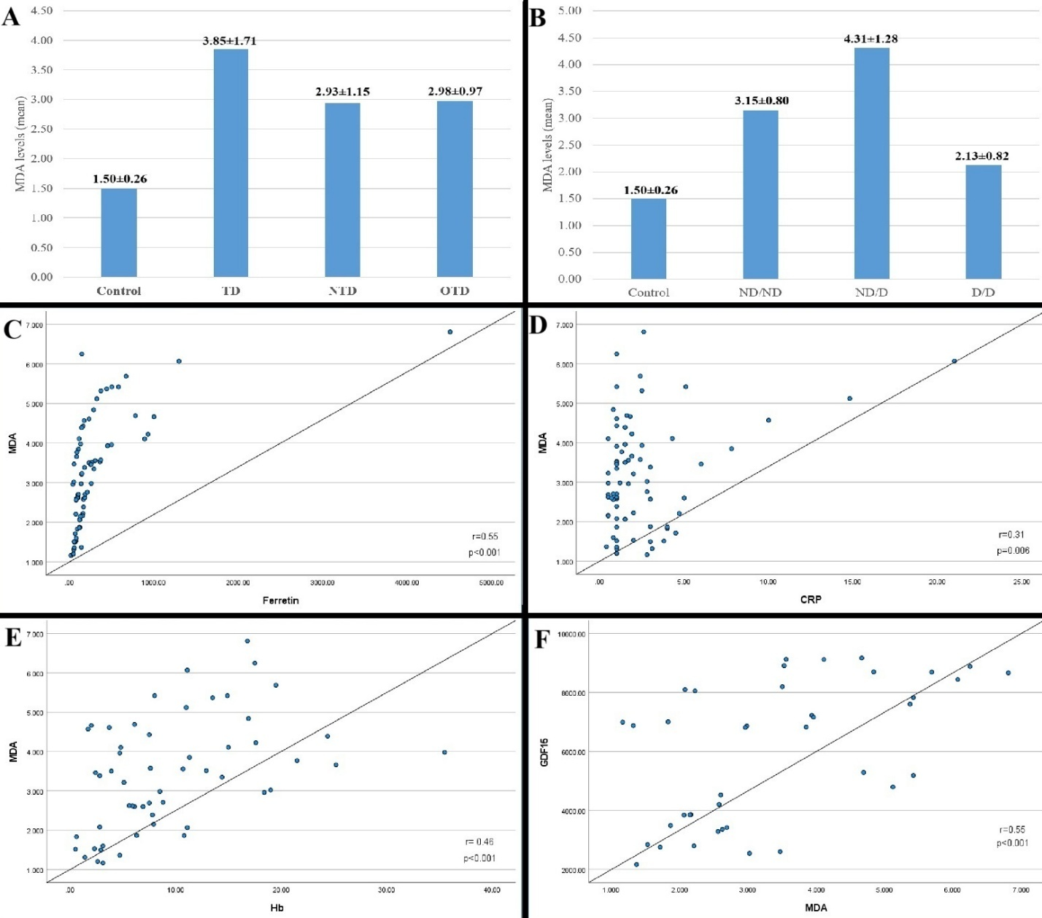
Figure 1: (Part A) Comparison of GDF15 levels among control, TD, NTD, and OTD patients. (Part B) GDF15 levels based on transfusion status: ND/ND, ND/D, and D/D. (Part C–F) Correlation analyses between GDF15 levels and: (Part C) ferritin, (Part D) total bilirubin, (Part E) hemoglobin (Hb), and (Part F) reticulocyte count (RETIC). (Part G) GDF15 levels before and after the blood transfusion in TD patients.

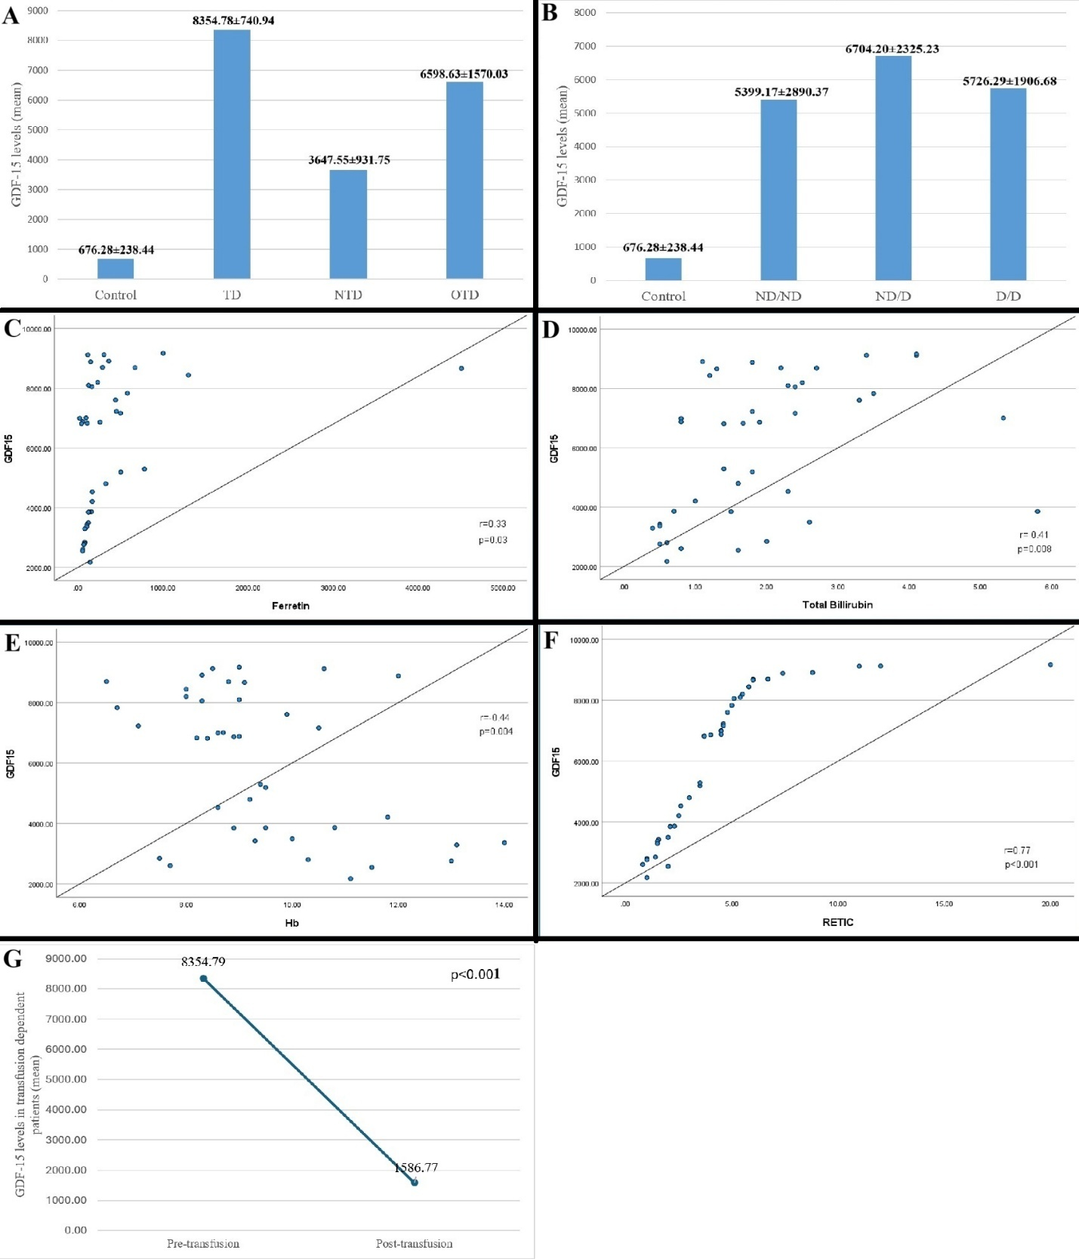
Figure 2: (Part A) Comparison of MDA levels among control, TD, NTD, and OTD patients. (Part B) MDA levels based on transfusion status: ND/ND, ND/D, and D/D. (Part C–F) Correlation analyses between MDA levels and: (Part C) ferritin, (Part D) CRP, (Part E) hemoglobin (Hb), and (Part F) GDF15 levels.

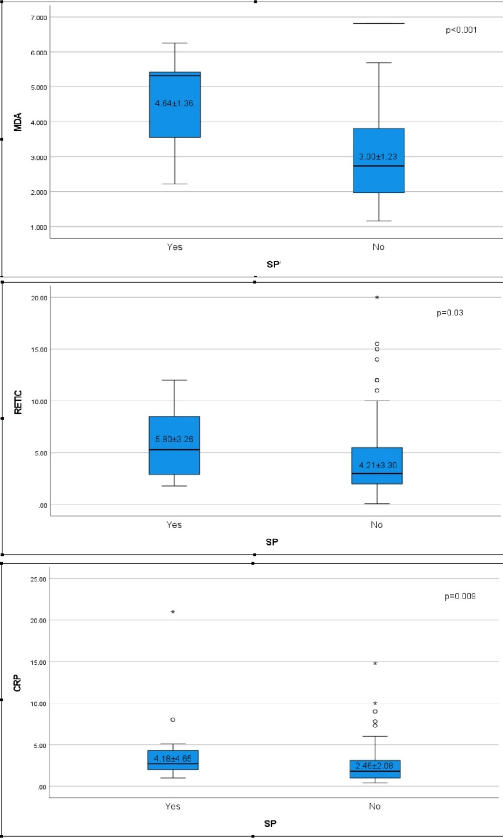
Figure 3: Comparison of MDA, Reticulocyte Count, and CRP Levels Between Splenectomized (Yes) and Non-Splenectomized (NO) Hb H Patients.

