Translating Mesenchymal Stem Cell Research into Clinical Applications for Chronic Kidney Disease Therapy: A systematic and Clinical Review

Abstract: This systematic review aims to evaluate the therapeutic potential of mesenchymal stem cell (MSC) therapy in the treatment of chronic kidney diseases (CDK). A comprehensive search of PubMed, Medline, Embase, Cochrane Library, and Scopus was conducted up to March 2025 using keywords such as “mesenchymal stem cells,” “cell therapy,” and “renal failure”. Inclusion criteria encompassed peer-reviewed studies evaluating the efficacy and safety of MSC therapy in patients with acute kidney injury (AKI) or chronic kidney disease (CKD). Key outcomes analyzed included renal function improvement, inflammatory marker reduction, fibrosis attenuation, and adverse events. Out of 1421 identified studies, 18 met the inclusion criteria, covering both preclinical and clinical investigations. Findings indicated that MSC therapy contributed to renal tissue repair, immunomodulation, and functional recovery, with some studies reporting improvements in glomerular filtration rate (GFR), reduced proteinuria, and histological recovery of kidney tissue. While short-term safety profiles were favorable, long-term efficacy and optimal administration protocols remain uncertain. Further high-quality clinical trials are needed to establish standardized treatment protocols and validate long-term benefits.
Keywords: mesenchymal stem cells, cell therapy, renal failure, chronic kidney disease.

Introduction
Chronic kidney disease (CKD) is a progressive condition characterized by a gradual loss of kidney function and structure, affecting a significant portion of the global population (1). Common causes of CKD include inflammation, aging, hypertension, and diabetes. Despite advancements in CKD management through medications and renal replacement therapies, it remains a significant public health concern due to its numerous complications and substantial disease burden (2). Patients in the advanced stages of CKD often exhibit common manifestations such as glomerulosclerosis, vascular sclerosis, and tubulointerstitial fibrosis, suggesting a shared final pathway of progressive injury involving processes like apoptosis, oxidative damage, and microvascular rarefaction (3, 4). Various cellular and molecular pathways, including mesangial and fibroblast activation, renin-angiotensin-aldosterone system (RAAS) activation, cytokine and growth factor production, epithelial-mesenchymal transition (EMT), and immune cell infiltration, contribute to the progression of kidney damage in CKD (5, 6). While the kidney possesses some regenerative capacity that allows for organ recovery, this ability is often limited and insufficient to prevent fibrosis. CKD can ultimately progress to end-stage renal disease (ESRD), underscoring the need for novel therapies to halt or slow down the kidney damage process (7).
Stem cell transplantation, particularly utilizing mesenchymal stromal cells (MSCs), has shown promise in preclinical and clinical settings for CKD treatment (8, 9). MSCs are adult stem cells of mesodermal origin that exhibit regenerative and paracrine properties, releasing proteins and hormones that can impact processes like apoptosis, fibrosis, inflammation, and microvascular rarefaction. These characteristics render MSCs a suitable option for addressing CKD (10). This review paper has provided an overview of the clinical applications of various types of mesenchymal stem cells (MSCs) in different types of chronic kidney disease (CKD). By comparing the efficacy and outcomes of using different MSCs in CKD therapy, we have gained valuable insights into the potential benefits and limitations of each MSC type. The findings highlight the promising role of MSC-based therapies in the management of CKD and underscore the need for further research to optimize treatment strategies and improve patient outcomes. As we continue to bridge the gap between laboratory research and clinical practice, using MSCs for therapy shows great potential in improving CKD treatment and helping patients.
Search strategy
A thorough search of PubMed, Medline, Embase, Cochrane Library, and Scopus was conducted up to March 2025 using keywords like “mesenchymal stem cells,” “cell therapy,” and “renal failure.” Studies were included if they were peer-reviewed and assessed the efficacy and safety of MSC therapy in patients with acute kidney injury (AKI) or chronic kidney disease (CKD).
Inclusion Criteria
-Clinical trials (randomized and non-randomized) investigating MSC therapy in patients with renal failure
-Studies reporting therapeutic effects, safety, and functional outcomes of MSC administration
-Studies involving human participants
-Articles published in English
Exclusion Criteria
-Animal studies, in vitro research, reviews, conference abstracts, book chapters, expert opinions
-Studies that did not characterize MSCs or provide clear methodology on their administration
-Articles focusing on other diseases unrelated to renal failure
Two independent reviewers screened the retrieved articles based on titles and abstracts. If eligibility was unclear, the full text was reviewed. Disagreements were resolved through discussion or consultation with a third reviewer.
Data Extraction and Study Characteristics
Relevant data were extracted into a structured Excel spreadsheet, including:
1. First Author / Year
2. Type of Mesenchymal Stem Cell (MSC) used (e.g., bone marrow-derived, adipose-derived, umbilical cord-derived)
3. Route of Administration (intravenous, intra-arterial, etc.)
4. Dosage and Frequency of MSC Injection
5. Number of Patients Enrolled
6. Renal Failure Type (acute kidney injury, chronic kidney disease, end-stage renal disease)
7. Primary Clinical Outcomes (GFR, proteinuria, creatinine levels, inflammatory markers
8. Follow-up Duration
9. Adverse Events / Safety Profile
Data extraction was performed independently by two reviewers, and discrepancies were resolved through consensus.
Results
A total of 1421 articles were identified through database searches. After removing duplicates (952 articles), 452 studies remained for screening. Based on title and abstract review, 401 studies were excluded for not meeting the inclusion criteria. A total of 68 full-text articles were assessed for eligibility, of which 51 were excluded due to reasons such as preclinical studies, lack of MSC characterization, or insufficient outcome reporting. Finally, 18 studies met the inclusion criteria and were included in the systematic review. The PRISMA flowchart summarizing the study selection process is presented in Figure 1.
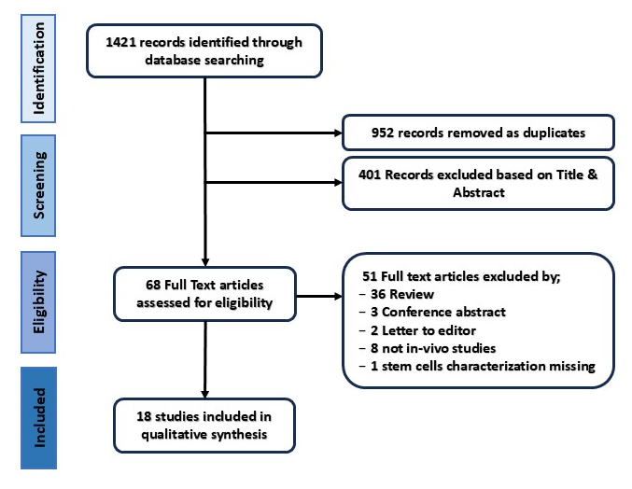
Figure1- PRISMA flow diagram of literature search to March 2025.
Kidney Transplantation
In this study, we have given less emphasis to the use of mesenchymal stem cells (MSCs) in conjunction with or following kidney transplantation, as transplantation itself cannot inherently be classified as a renal disorder and we will briefly discuss its applications at the outset.
Mesenchymal stem cells (MSCs) have attracted significant interest in the field of kidney transplantation due to their unique immunomodulatory and regenerative properties. Clinical studies investigating the use of MSCs in kidney transplant recipients have shown promising results, suggesting that MSC therapy may offer a novel approach to improve outcomes in this patient population (11). The primary objectives of clinical trials exploring MSC application in kidney transplant recipients encompass the prevention of rejection, renal repair, and regeneration, reduction of drug toxicity, and enhancement of graft survival early clinical studies have shown promising results in terms of safety and feasibility. In a study by Perico et al. in 2011, two patients with End-Stage Renal Disease (ESRD) who underwent renal transplantation received autologous MSCs post-transplantation. The infused cells (1.7–2.0×10⁶/kg body weight) were administered intravenously seven days after the kidney transplant. Although both patients developed renal insufficiency after cell infusion, they were carefully monitored, and their graft function stabilized over time. The study also explored the in vivo effects of MSC infusion on T cell homeostasis and function post-transplantation. It was observed that MSC infusion led to a decrease in memory CD8+ T cells and an increase in regulatory T cells, potentially contributing to a protolerogenic environment. Further research is imperative to refine the timing and protocol of MSC infusion to minimize adverse effects and maximize therapeutic benefits in solid organ transplantation settings (12). In a subsequent study by El-Ansary et al., a dose-dependent approach was adopted to optimize MSC therapy in kidney transplant recipients. Patients from three groups (inactive SLE patients with diffuse proliferative lupus nephritis, renal transplantation cases with chronic allograft nephropathy, and a control group with impaired renal function due to other causes), received intravenous infusions of MSCs at a dose of 50 to 70 million MSCs in 10 mL saline, administered in two divided doses one week apart. There was a significant correlation between MSC dose and the decrease in serum creatinine levels after injection. Microchimerism studies confirmed the persistence of donor MSC cells in the renal transplanted group, aiding in the development and maintenance of immunological tolerance. The follow-up of the patients at 1, 3, and 6 months after MSC injection showed higher HB levels lowering of mean serum creatinine, and elevation of mean creatinine clearance levels (13).
Another study in 2013 explored dose-dependent and interval administration post-transplantation, where 6 renal transplant recipients with subclinical rejection (SCR) and interstitial fibrosis/tubular atrophy (IF/TA) received two intravenous doses of 1–2 x 10⁶ BM-MSCs per kilogram of body weight, administered seven days apart. Clinical and immune monitoring was conducted for up to 24 weeks post-MSC infusions. Notably, a downregulation of the mixed lymphocyte reaction to the donor was observed in five out of six patients, indicating an immunomodulatory effect of MSC therapy. Additionally, in recipients with allograft rejection, renal biopsies post-MSC treatment demonstrated the resolution of tubulitis without interstitial fibrosis/tubular atrophy (IFTA), hinting at the potential of MSCs in mitigating rejection episodes. levels of Interferon-g, interferon-g-induced protein (IP)-10, and monocyte chemoattractant protein (MCP)-1 decreased in the majority of patients upon stimulation with donor-specific PBMCs, indicating a potential immunomodulatory effect of MSC treatment. This study provides valuable insights into the potential benefits and immunological effects of MSC therapy in renal transplant recipients (14). A 6-month randomized, double-blind, phase 2 study investigated the efficacy and safety of combining concentration-controlled everolimus with Mesenchymal Stem Cells (MSCs) compared to everolimus with standard tacrolimus in de novo renal recipients. Thirty-five patients received everolimus with MSCs, while the other 35 received everolimus with standard tacrolimus. Autologous BM-MSCs were administered in two doses of 1.5×10⁶ MSCs per kg body weight at weeks 6 and 7 post-transplantation. This study aims to explore the potential of MSCs and everolimus in providing a more effective and tolerogenic approach to immunosuppression in transplant recipients. Previous trial has shown promising results in reducing peripheral blood mononuclear cell (PBMC) proliferation and enhancing regulatory T cells with MSC treatment. The current trial seeks to conduct meaningful comparisons of immune profiles in MSC-treated and untreated groups to assess the immunomodulatory effects of MSCs. Additionally, the study explores the potential cardio-protective effects of everolimus and MSCs in reducing the burden of cardiovascular disease post-transplantation (15).
The study by Zhang et al. in 2021 focused on 11 renal transplanted patients with IFTA. Following intra-arterial infusion of BM-MSCs, serum creatinine levels decreased significantly at 7 days, 1 month, and 3 months compared to baseline, while creatinine clearance increased significantly at these time points. Cystatin-C levels showed a similar trend to serum creatinine. Individual patients’ analysis revealed that renal function improved in 54.5% of patients, remained stable in 27.3%, and worsened in 18.2% at 12 months post-infusion. Protein expressions of key renal fibrotic factors (TGF-b1 and CTGF) were significantly decreased post-BM-MSC treatment, underlining the therapeutic potential of MSCs in ameliorating renal fibrosis. No severe adverse events were reported during the one-year follow-up. The study underscores the significance of the administration route in achieving positive outcomes, highlighting the potential benefits of intra-arterial delivery of MSCs over intravenous infusion. Moreover, a specific treatment protocol involving intra-arterial infusion followed by intravenous infusions was proposed to enhance therapeutic effects (Figure 1) (16).

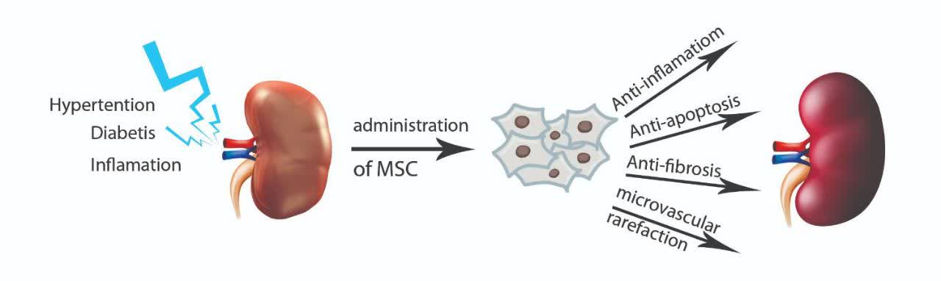
Figure 1- Causes of chronic kidney disease and how MSCs work in treating kidney diseases.

First Author | Year | Phase of Clinical Trial | MSC Source and Type | Ad. Route | Dose and Frequency | Patients | CKD Type | Clinical Outcomes | Follow-Up Duration | Adverse Events
Stavas (17)* | 2024 | Phase 2 | Renal autologous cells | Bilateral percutaneous kidney injections | 2 injections, 3 months apart | 53 adults | Type 1 and Type 2 Diabetes-related CKD | Potential to preserve or improve kidney function, delay disease progression | Ongoing | No significant adverse events reported
Stavas (18)* | 2023 | Phase 1 | Renal autologous cells | Percutaneous kidney cortex injections | 2 injections, 7±3 months apart | 22 adults | Type 2 Diabetes-related CKD | Improved eGFR slope, stable renal function in some patients | 1 year | 2 remote fatal adverse events unrelated to the treatment
Carstens (19) | 2023 | Not mentioned | Adipose-derived stromal vascular fraction (SVF) | Bilateral renal artery catheterization | Single infusion | 18 patients | Mesoamerican nephropathy (CKDu) | Safe, improved perfusion, renal function maintained in some patients | 36 months | No serious adverse events, treatment-related complications
Stavas (20)* | 2022 | Not mentioned | Renal autologous cells | Percutaneous subcortical kidney injections | 2 doses, 7±3 months apart | 22 adults | Type 2 Diabetes-related CKD | Improved eGFR slope, stabilized renal function | 1 year | 2 remote fatal adverse events unrelated to treatment
Riordan (21) | 2022 | Case Report | Allogeneic UC-MSC | IV | Not specified | 1F, 42y | Acute renal failure and IgA nephropathy | Improvement in kidney function | 3 months | None mentioned
Stavas (22)* | 2021 | Phase 1 | Renal autologous cells | Image-guided locoregional reinjection into renal cortex | 2 doses at 6-month intervals | 5 patients | CAKUT-associated CKD | No complications, potential to stabilize or improve renal function | Ongoing | No complications or adverse events
Zhang (16) | 2021 | Pilot Study | Autologous Bone Marrow MSC | Intra-arterial/ IV | 5 × 10⁶ on day0 and 1 × 10⁶ (7 days and 1 month later) | 11 patients | IFTA post-kidney transplant | Kidney function improvement in 54.5%, 27.3% stable, 18.2% worsened. Decreased TGF-b1 and CTGF expression | 1 year | 2 cases of infection and allergy
Shao (23) | 2021 | Pilot Study | Autologous  BMMSC | IV | 1–2 × 10⁶ /kg | 200 patients | Chronic renal failure | Cr ↓ 11 → 2 mg/dL; regained limb movement  ↓Cr, Cys-C, TGF-b1, ROS  ↑ COL1, COL4 | Not specified | Not specified
Swaminathan (24) | 2021 | Phase I/II  NCT03015623 | Allogeneic MSC | IV by NxStage System dialysis | 300 million cells (single dose) | 15 Patients | Acute kidney injury and systemic inflammation | Improvement in kidney function, ↓TNFα, IFNγ &  Monocytes | 18 months | None mentioned
Villanueva (25) | 2019 | Pilot Study | Autologous Adipose Tissue MSC | IV | 1 million cells/kg (single dose) | 10 Patients | Chronic kidney disease | Safety and clinical feasibility confirmed, Stabilized eGFR; reduced proteinuria | 12 months | Mild (transient fever)
Makhlough (26) | 2018 | Safety Study | Autologous Bone Marrow MSC | IV | 1–2 × 10⁶ /kg | 7 patients | Chronic kidney disease | Safety of treatment confirmed, Nonsignificant reduction in the rate of eGFR decrease | 18 months | None mentioned
Rahyussalim (27) | 2017 | Case Report | Allogeneic Umbilical Cord MSC | IT & IV | 16 × 10⁶ (Three dose) | 1F, 62y | Chronic renal failure and spinal cord entrapment | Improvement in kidney function and ability to move toes, creatinine reduced to 2 mg/dl | 8 months | None mentioned
Kim (28) | 2017 | Phase I | Autologous BM-MSC | IV | 4 × 10⁸ (Single dose) | 1M, 33y | Renal insufficiency | Rapid deterioration of renal function after therapy | Short-term | Worsened Cr/clearance
Packham (29) | 2016 | Phase 1/2 | Allogeneic bone marrow-derived mesenchymal precursor cells (MPC, rexlemestrocel-L) | Intravenous | 150-300 × 10⁶ MPC | 10 placebo  20 diabetic nephropathy | Diabetic nephropathy (eGFR 20-50 ml/min/1.73m²) | Trend towards stabilization or improvement in eGFR and mGFR  GFR was stabilized in MSC group | 12 weeks | No treatment-related serious adverse events
Wang (30) | 2014 | Phase 2 | Allogeneic umbilical cord mesenchymal stem cells (UC-MSC) | Intravenous (IV) | Two infusions on days 0 and 7 | 40 patients | Systemic lupus erythematosus (SLE) with lupus nephritis | Significant decrease in SLEDAI and BILAG scores, reduced proteinuria, improved renal function | 12 months | No transplantation-related adverse events
EL-Ansary (13) | 2012 | Pilot Study | Autologous Bone Marrow MSC | IV | 0.7–1.0×10⁶ cells in 2 doses (1 week apart) | 30 patients (age 22-68 years) | 10 SLE-related GN, 10 kidney transplant, 10 controls | Significant improvement in creatinine and clearance in SLE group | 6 months | None significant
Humes (31) | 2003 | Phase I/II | Human renal proximal tubule cells (RAD) | Intravenous | Not specified | 9 patients | ARF + MOSF | Cardiovascular stability, metabolic activity | Not specified | Rapid and variable responses
Tumlin (32) | 2008 | Phase II | Renal tubule cells (RAD) | Intravenous | Up to 72h treatment | 58 | ARF | Improved survival, faster kidney recovery | 180 days | Expected profile for critically ill patients

Table 1- summarizes details from 18 clinical trials on mesenchymal stem cell (MSC) therapy for Renal Failure, including trial phase, MSC source and administration, patient demographics, clinical outcomes, and adverse events. (NS: Not specified, IT: Intrathecal, IV: Intravenous, RCT: Randomized Controlled Trial) *It appears that all these articles are derived from a larger overarching study.

chronic kidney disease CDK
chronic kidney disease (CKD) is a progressive condition characterized by a gradual loss of kidney function and structure, affecting a significant portion of the global population. In the context of CKD caused by chronic metabolic diseases such as diabetes and hypertension(33), MSC therapy holds promise in reducing kidney damage. The immunomodulatory and regenerative properties of MSCs, along with their ability to reprogram inflammatory responses and promote tissue repair, make them a valuable tool in combating the progression of diabetic nephropathy and other forms of CDK(34). A double-blind, placebo-controlled trial was conducted in 2016 involving an allogeneic, bone marrow-derived mesenchymal lineage cell product (rexlemestrocel-L) in 30 patients with CKD due to type 2 diabetes and advanced diabetic nephropathy. The trial administered a single intravenous infusion of rexlemestrocel-L at two fixed doses (150×10^6 or 300×10^6 cells), which were well-tolerated with a consistent safety profile across all treatment groups. While the study was not powered for efficacy, The primary exploratory efficacy parameter was the effect of rexlemestrocel-L on renal function over 12 weeks. there were no significant effects on various biomarkers, but there was a suggestion of stabilization of eGFR in the rexlemestrocel-L 150 × 10^6 group compared to placebo at the 12-week endpoint. The lack of changes in glycemic parameters suggests that the observed effects were not related to changes in diabetes control (29)
Rahyussalim et al. explored the use of human umbilical cord mesenchymal stem cells (hUC-MSCs) in a case study involving a 62-year-old Indonesian woman with thoracic spinal cord entrapment, paraplegia, and chronic renal failure in hemodialysis. The treatment protocol involved six cycles of hUC-MSCs intrathecal implantation and intravenous injection at three-month intervals. After the second cycle, the patient showed improvement in leg movement, increased sensory level, and the ability to urinate for the first time in two years. Notably, her creatinine level decreased significantly to 2 mg/dl after the treatment, indicating improved renal function. This study emphasized the potential of hUC-MSCs in regenerative medicine due to their self-renewal ability and differentiation potential. Compared to bone marrow MSCs, hUC-MSCs have advantages such as easy acquisition, high proliferation ability, low immunogenicity, and fewer ethical concerns (27).
An Open-label, single-arm trial evaluates the safety and tolerability of an autologous Mesenchymal Stem Cell (MSC) infusion in 7 chronic kidney disease (CKD) patients with various etiologies including hypertension, nephrotic syndrome, focal segmental glomerulosclerosis (FSGS), and unknown etiology. The study did not demonstrate a significant improvement in eGFR or SCr levels following intravenous single-dose (1–2 × 106 cells/kg) of autologous MSC infusion in CKD patients. Despite the safe and tolerable nature of the intervention, the progressive decline in kidney function, as indicated by eGFR and SCr levels(26), suggests that the single dose of MSC infusion may not be effective in halting or reversing the course of CKD in these patients consistent with previous findings (12). The Limitations of the trial included a limited sample size and the absence of a control group. which affected the ability to draw definitive conclusions on efficacy. The main advantage of this study was the longest follow-up period (18 months) trial to assess the safety and tolerability of autologous MSC infusion in CKD patients (26).
In 2021, a randomized controlled trial was conducted in China involving 200 patients diagnosed with Chronic Renal Failure (CRF) and an estimated Glomerular Filtration Rate (eGFR) below 60 ml per minute per 1.73 m². The trial compared the effects of intravenous infusion of marrow-derived autologous Mesenchymal Stem Cells (MSCs) at a dosage ranging from 1 × 10^6 to 2 × 10^6/kg with oral administration of N-acetylcysteine (NACys) at a dose of 600 mg twice daily for 8 weeks. the findings revealed that both MSCs and NACys led to significant reductions in creatinine, cystatin C, and reactive oxygen species levels compared to baseline measurements. However, the reduction in these biomarkers was significantly greater in patients who were treated with MSCs compared to those who received NACys. Additionally, MSC therapy resulted in greater enhancements in type 1 and 4 collagen levels when compared to NACys. Moreover, the study highlighted that MSC treatment yielded significantly superior improvements in renal and systemic functional parameters compared to NACys after a 4-week treatment period. The strict inclusion criteria of enrolling Chinese CRF patients with eGFR below 60 ml per minute per 1.73 m^2 ensured a homogeneous study population in terms of disease severity. Another strength of the study was the comprehensive collection of data on various efficacy parameters, including creatinine, cystatin C, TGF-β levels, reactive oxygen species, collagen levels, and renal/systemic functional parameters. This accurate data collection allowed for a detailed evaluation of the effects of MSC therapy compared to NACys in CRF patients, providing valuable insights into potential treatment benefits and outcomes (23).
Acute kidney injury (AKI)
Acute kidney injury (AKI) is a complex condition characterized by dysregulated immune-mediated inflammation, which is pivotal in critical illnesses like burn injury, acute respiratory distress syndrome, acute liver failure, sepsis, and COVID-19(35). Mesenchymal stem cells (MSCs) have emerged as a promising therapeutic way for modulating immune responses in inflammatory conditions. By secreting various molecules, MSCs can regulate immune cell responses and foster tissue repair. While MSCs have demonstrated efficacy in preclinical and early-phase clinical studies for conditions such as myocardial infarction and AKI, challenges persist in optimizing their delivery and persistence in the body. To address these challenges, a novel ex vivo MSC product, SBI-101, has been developed. SBI-101 immobilizes allogeneic bone marrow-derived MSCs on the extracapillary space of a hemofiltration device, allowing controlled exposure of circulating blood cells to MSC-secreted factors. The study is a multicenter, randomized, double-blind, sham-controlled investigation into the safety, tolerability, and pharmacology of SBI-101 in adult subjects with AKI-D (Acute Kidney Injury-Dialysis) undergoing CRRT (Continuous Renal Replacement Therapy). Sixteen subjects participated, with 12 receiving active treatment (250 x 10^6 MSCs) and 4 receiving sham treatment Pharmacokinetic assessments revealed dynamic secretion of proteins like IL-6, IL-8, MCP-3, and CXCL5 by MSCs within SBI-101 during the treatment course. A comparison of these factors in the extracapillary space of SBI-101 with sham treatment indicated heightened activity in the active group.
Limitations of the study included a small sample size and the lack of certain immune cell data for all patients. Future studies will focus on enrolling more patients, collecting additional immune profiling data, and exploring higher doses of SBI-101 to enhance efficacy and prolong pharmacodynamic effects. the development of innovative MSC-based therapies like SBI-101 holds promise for addressing dysregulated immune responses in critical illnesses such as AKI and CKD (24).
Systemic lupus erythematosus SLE
Systemic lupus erythematosus (SLE) is an autoimmune disease characterized by autoantibodies and multiorgan injury. Mesenchymal stem cells (MSCs) have emerged as a potential treatment option for SLE due to their ability to differentiate into various cell types and their immunomodulatory effects on immune cells.
a clinical trial involving the use of umbilical cord mesenchymal stem cell (UC MSC) infusions in patients with systemic lupus erythematosus (SLE). Thirty-nine out of forty patients (97.5%) received two UC MSC infusions at a one-week interval. One patient (2.5%) did not receive the second infusion due to uncontrolled disease progression. The study reported a high overall survival rate of 92.5% after 12 months, indicating a positive outcome for the majority of patients. Lupus disease activity, as measured by the SLEDAI score and BILAG score, significantly decreased after UC MSC infusion. Serum albumin levels improved, complement levels showed improvement, and anti-double-stranded DNA antibody levels decreased after MSC treatment. Renal function and proteinuria levels improved significantly after UC MSC treatment. Hematopoietic and cutaneous system involvement also showed improvement (30).
As earlier mentioned, El-Ansary et al conducted a study involving three groups of subjects The results indicated that individuals in the Systemic Lupus Erythematosus (SLE) Group displayed fewer indicators of anemia and showed greater advancements in renal function compared to the other groups over the duration of the follow-up period. Additionally, significant enhancements in kidney function tests were noted in this particular group, with elevated hemoglobin levels in comparison to the other groups(13).
Future Perspectives
The future of Mesenchymal Stem Cell (MSC) therapy in the field of kidney transplantation and chronic kidney diseases (CKD) holds immense promise, with ongoing research aiming to optimize treatment protocols and enhance therapeutic outcomes (Figure 1). Building on the foundation laid by existing clinical studies, future investigations are poised to address key challenges and explore novel approaches to leverage the immunomodulatory and regenerative properties of MSCs.
1-Refinement of MSC Infusion Protocols: Future studies will focus on refining the timing and protocol of MSC infusion in kidney transplant recipients to minimize adverse effects and maximize therapeutic benefits. By optimizing the dosage, administration route, and timing of MSC therapy, researchers aim to enhance graft survival, prevent rejection episodes, and promote renal repair more effectively.
2-Exploration of Innovative MSC-Based Therapies: The development of innovative MSC-based therapies, such as SBI-101, marks a significant advancement in addressing dysregulated immune responses in critical illnesses like acute kidney injury (AKI) and CKD. Future studies will explore how SBI-101 and new MSC products can make treatments better and last longer for patients getting kidney replacement therapy.
3-Immune Profiling and Personalized Medicine: With a growing emphasis on precision medicine, future studies will focus on collecting additional immune profiling data to tailor MSC therapy to individual patient profiles. By understanding the immunological responses of patients receiving MSC treatment, researchers can optimize treatment strategies and improve patient outcomes in kidney transplantation and CKD.
4-Long-Term Follow-Up Studies: Long-term follow-up studies are essential to assess the sustained effects and safety of MSC therapy in kidney transplant recipients and CKD patients. By monitoring patients over extended periods, researchers can evaluate the persistence of treatment benefits, potential adverse effects, and overall impact on renal function and patient well-being.
5-Combination Therapies: Investigating the synergistic effects of combining MSC therapy with other immunosuppressive agents or regenerative treatments represents a promising avenue for enhancing treatment outcomes in kidney transplantation and CKD. Future studies will explore the potential benefits of combining MSCs with existing therapies to optimize patient care and improve long-term prognosis.
In conclusion, the future of MSC therapy in kidney transplantation and CKD is characterized by ongoing innovation, personalized treatment approaches, and a commitment to improving patient outcomes. By addressing current limitations, exploring novel therapies, and advancing our understanding of MSC mechanisms, researchers aim to revolutionize the field.

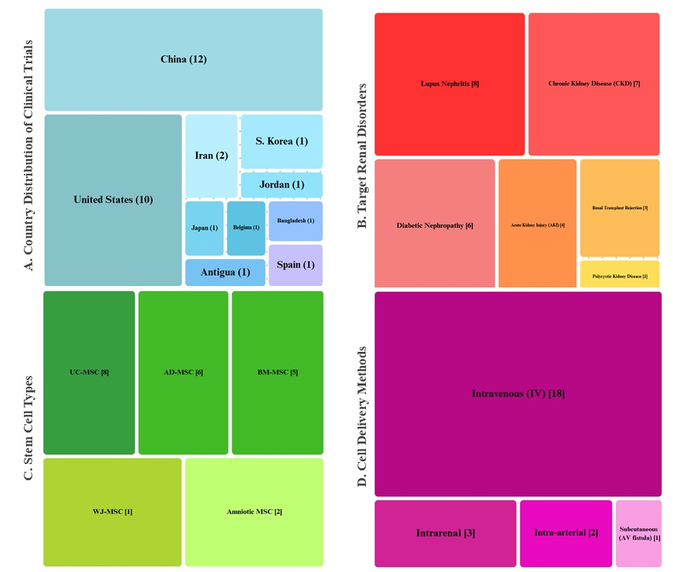

Figure 2- clinical trials analysis reveals China (40%) and the US (33%) lead in renal cell therapy trials (A). Lupus nephritis (27%) and diabetic nephropathy (20%) are primary targets (B). Umbilical cord (uc-mscs) and adipose-derived stem cells (ad-mscs) dominate (47% combined) (C). Intravenous delivery remains standard (60% of trials) (D).

Clinical Trials
In order to investigate the future of cell therapy in the treatment of kidney diseases, the website (https://clinicaltrials.gov/) was reviewed on March 2025. The results showed 52 studies, some with other goals and some for reasons such as exosome-based therapy and were excluded from the review process. Stem cell therapy trials for kidney disorders have been conducted globally, with notable studies in China, the US, Iran, and European countries (Figure 2). The most commonly used cell types were mesenchymal stem cells (MSCs) derived from umbilical cord (UC-MSCs), adipose tissue (AD-MSCs), bone marrow (BM-MSCs), and Wharton's jelly, typically administered at doses of 1-5×10⁶ cells/kg via intravenous infusion. Intrarenal and intra-arterial delivery methods were also employed in specific cases targeting renal vasculature. The primary indications included diabetic nephropathy (38% of reviewed trials) and chronic kidney disease (CKD, 29%), followed by lupus nephritis (18%) and acute kidney injury (12%). Comorbid conditions such as type 1/2 diabetes, hypertension, and systemic lupus erythematosus were frequently reported alongside renal pathologies. Therapeutic mechanisms focused on immunomodulation (particularly in autoimmune nephropathies) and tissue regeneration through paracrine signaling. Safety assessments predominantly monitored infusion-related reactions and tumorigenicity risks, while efficacy endpoints emphasized glomerular filtration rate (eGFR) improvements (67% of trials), proteinuria reduction (58%), and histopathological changes in biopsy-proven cases. Second-generation trials increasingly combined MSC therapy with conventional immunosuppressants, demonstrating synergistic effects in transplant rejection protocols. Despite promising phase I/II results, heterogeneity in cell sources, dosing protocols, and outcome measures underscores the need for standardized phase III trials. Current evidence positions MSC therapy as a viable adjunct treatment for refractory nephropathies, particularly where conventional therapies show limited efficacy. Further research should address long-term safety, optimal delivery routes, and biomarker-based patient stratification. Despite the limitations of existing studies, the development of innovative MSC-based therapies holds promise for addressing dysregulated immune responses in critical illnesses such as AKI and CKD.

Conflict of interests
The authors declare that they have no competing interests.
Authors’ contributions
All authors were involved in preparing the manuscript. The corresponding author designed the manuscript and was also involved in the writing and revisiting the text.
Funding
This research did not receive any specific grant from funding agencies in the public, commercial, or not-for-profit sectors. No funding was received.
Ethics approval and consent to participate
Not applicable.
Consent for publication
Not applicable.
Acknowledgments
We thank for the financial support of this study as a MD student dissertation by a grant from the Mashhad University of Medical Sciences (No. 4021642).
Abbreviations
MSCs: Mesenchymal Stem Cells, CKD: Chronic Kidney Disease, AKI: Acute Kidney Injury, HGF: Hepatocyte Growth Factor, VEGF: Vascular Endothelial Growth Factor, ECM: Extracellular Matrix, BMP: Bone Morphogenetic Protein, TGF-β: Transforming Growth Factor-Beta, EMT: Epithelial-Mesenchymal Transition, PDGF: Platelet-Derived Growth Factor, GFR: Glomerular Filtration Rate, ESRD: End-Stage Renal Disease, iPSCs Induced Pluripotent Stem Cells, hMSCs: Human Mesenchymal Stem Cells, ADSCs: Adipose-Derived Stem Cells, BM-MSCs: Bone Marrow Mesenchymal Stem Cells, UC-MSCs: Umbilical Cord Mesenchymal Stem Cells, EVs: Extracellular Vesicles, IL-6: Interleukin-6, TNF-α: Tumor Necrosis Factor-Alpha.

References
1. El Nahas AM, Bello AK. Chronic kidney disease: the global challenge. The lancet. 2005;365(9456):331-40.
2. Hill NR, Fatoba ST, Oke JL, Hirst JA, O’Callaghan CA, Lasserson DS, et al. Global prevalence of chronic kidney disease–a systematic review and meta-analysis. PloS one. 2016;11(7):e0158765.
3. Jha V, Garcia-Garcia G, Iseki K, Li Z, Naicker S, Plattner B, et al. Chronic kidney disease: global dimension and perspectives. The Lancet. 2013;382(9888):260-72.
4. Yan H, Xu J, Xu Z, Yang B, Luo P, He Q. Defining therapeutic targets for renal fibrosis: Exploiting the biology of pathogenesis. Biomedicine & Pharmacotherapy. 2021;143:112115.
5. Yuan Q, Tang B, Zhang C. Signaling pathways of chronic kidney diseases, implications for therapeutics. Signal transduction and targeted therapy. 2022;7(1):182.
6. López-Novoa JM, Martínez-Salgado C, Rodríguez-Peña AB, Hernández FJL. Common pathophysiological mechanisms of chronic kidney disease: therapeutic perspectives. Pharmacology & therapeutics. 2010;128(1):61-81.
7. Eirin A, Lerman LO. Mesenchymal stem cell treatment for chronic renal failure. Stem cell research & therapy. 2014;5:1-8.
8. Papazova DA, Oosterhuis NR, Gremmels H, Van Koppen A, Joles JA, Verhaar MC. Cell-based therapies for experimental chronic kidney disease: a systematic review and meta-analysis. Disease models & mechanisms. 2015;8(3):281-93.
9. Hickson LJ, Eirin A, Lerman LO. Challenges and opportunities for stem cell therapy in patients with chronic kidney disease. Kidney international. 2016;89(4):767-78.
10. Fleig SV, Humphreys BD. Rationale of mesenchymal stem cell therapy in kidney injury. Nephron Clinical Practice. 2014;127(1-4):75-80.
11. Pool M, Leuvenink H, Moers C. Reparative and Regenerative Effects of Mesenchymal Stromal Cells—Promising Potential for Kidney Transplantation? International Journal of Molecular Sciences. 2019;20(18):4614.
12. Perico N, Casiraghi F, Introna M, Gotti E, Todeschini M, Cavinato RA, et al. Autologous mesenchymal stromal cells and kidney transplantation: a pilot study of safety and clinical feasibility. Clinical journal of the American Society of Nephrology: CJASN. 2011;6(2):412.
13. EL‐ANSARY M, Saadi G, ABD EL‐HAMID SM. Mesenchymal stem cells are a rescue approach for recovery of deteriorating kidney function. Nephrology. 2012;17(7):650-7.
14. Reinders ME, de Fijter JW, Roelofs H, Bajema IM, de Vries DK, Schaapherder AF, et al. Autologous bone marrow-derived mesenchymal stromal cells for the treatment of allograft rejection after renal transplantation: results of a phase I study. Stem cells translational medicine. 2013;2(2):107-11.
15. Reinders ME, Bank JR, Dreyer GJ, Roelofs H, Heidt S, Roelen DL, et al. Autologous bone marrow derived mesenchymal stromal cell therapy in combination with everolimus to preserve renal structure and function in renal transplant recipients. Journal of translational medicine. 2014;12(1):1-12.
16. Zhang L, Lai X, Guo Y, Ma J, Fang J, Li G, et al. Autologous bone marrow-derived mesenchymal stem cells for interstitial fibrosis and tubular atrophy: a pilot study. Renal Failure. 2021;43(1):1266-75.
17. Stavas J, Silva AL, Wooldridge TD, Aqeel A, Saad T, Prakash R, et al. Rilparencel (Renal Autologous Cell Therapy-REACT®) for Chronic Kidney Disease and Type 1 and Type 2 Diabetes: Phase 2 Trial Design Evaluating Bilateral Kidney Dosing and Redosing Triggers. Am J Nephrol. 2024;55(3):389-98.
18. Stavas J, Thajudeen B, Coca S, Silva A, Butler E, Detwiler R, et al. Renal Autologous Cell Therapy in Type 2 Diabetes with Late Stage 4 Diabetes-Related Chronic Kidney Disease: Trial Design and Early Analysis. Blood Purif. 2023;52(2):114-21.
19. Carstens MH, García N, Mandayam S, Workeneh B, Pastora I, Calderón C, et al. Safety of Stromal Vascular Fraction Cell Therapy for Chronic Kidney Disease of Unknown Cause (Mesoamerican Nephropathy). Stem Cells Transl Med. 2023;12(1):7-16.
20. Stavas J, Filler G, Jain D, Ludlow J, Basu J, Payne R, et al. Renal Autologous Cell Therapy to Stabilize Function in Diabetes-Related Chronic Kidney Disease: Corroboration of Mechanistic Action With Cell Marker Analysis. Kidney Int Rep. 2022;7(7):1619-29.
21. Riordan NH, Ambrozic RA, Paz-Rodríguez J. Case report: effect of umbilical cord mesenchymal stem cells on immunoglobulin A nephropathy after acute renal failure. Am J Transl Res. 2022;14(7):4855-9.
22. Stavas J, Diaz-Gonzalez de Ferris M, Johns A, Jain D, Bertram T. Protocol and Baseline Data on Renal Autologous Cell Therapy Injection in Adults with Chronic Kidney Disease Secondary to Congenital Anomalies of the Kidney and Urinary Tract. Blood Purif. 2021;50(4-5):678-83.
23. Shao Z, Meng X, Meng F. Efficacy and safety of mesenchymal stem cell in Chinese patients with chronic renal failure: A pilot study in Shandong province, China. Pakistan Journal of Pharmaceutical Sciences. 2021;34.
24. Swaminathan M, Kopyt N, Atta MG, Radhakrishnan J, Umanath K, Nguyen S, et al. Pharmacological effects of ex vivo mesenchymal stem cell immunotherapy in patients with acute kidney injury and underlying systemic inflammation. Stem cells translational medicine. 2021;10(12):1588-601.
25. Villanueva S, González F, Lorca E, Tapia A, López VG, Strodthoff R, et al. Adipose tissue-derived mesenchymal stromal cells for treating chronic kidney disease: A pilot study assessing safety and clinical feasibility. Kidney Res Clin Pract. 2019;38(2):176-85.
26. Makhlough A, Shekarchian S, Moghadasali R, Einollahi B, Dastgheib M, Janbabaee G, et al. Bone marrow–mesenchymal stromal cell infusion in patients with chronic kidney disease: A safety study with 18 months of follow-up. Cytotherapy. 2018;20(5):660-9.
27. Rahyussalim AJ, Saleh I, Kurniawati T, Lutfi APWY. Improvement of renal function after human umbilical cord mesenchymal stem cell treatment on chronic renal failure and thoracic spinal cord entrapment: a case report. Journal of Medical Case Reports. 2017;11(1):1-7.
28. Kim JS, Lee JH, Kwon O, Cho JH, Choi JY, Park SH, et al. Rapid deterioration of preexisting renal insufficiency after autologous mesenchymal stem cell therapy. Kidney Res Clin Pract. 2017;36(2):200-4.
29. Packham DK, Fraser IR, Kerr PG, Segal KR. Allogeneic mesenchymal precursor cells (MPC) in diabetic nephropathy: a randomized, placebo-controlled, dose escalation study. EBioMedicine. 2016;12:263-9.
30. Wang D, Li J, Zhang Y, Zhang M, Chen J, Li X, et al. Umbilical cord mesenchymal stem cell transplantation in active and refractory systemic lupus erythematosus: a multicenter clinical study. Arthritis research & therapy. 2014;16(2):1-14.
31. Humes HD, Weitzel WF, Bartlett RH, Swaniker FC, Paganini EP. Renal cell therapy is associated with dynamic and individualized responses in patients with acute renal failure. Blood Purif. 2003;21(1):64-71.
32. Tumlin J, Wali R, Williams W, Murray P, Tolwani AJ, Vinnikova AK, et al. Efficacy and safety of renal tubule cell therapy for acute renal failure. J Am Soc Nephrol. 2008;19(5):1034-40.
33. Kalantar-Zadeh K, Jafar TH, Nitsch D, Neuen BL, Perkovic V. Chronic kidney disease. The lancet. 2021;398(10302):786-802.
34. Li Y, Ricardo SD, Samuel CS. Enhancing the therapeutic potential of mesenchymal stromal cell-based therapies with an anti-fibrotic agent for the treatment of chronic kidney disease. International Journal of Molecular Sciences. 2022;23(11):6035.
35. Park BD, Faubel S. Acute kidney injury and acute respiratory distress syndrome. Critical Care Clinics. 2021;37(4):835-49.

