Hypoxia-induced expression of miR424 and miR155 and target CD47 and PDL-1 genes in a gastric cancer cell line (MKN-45)

Abstract
Background and objectives: Hypoxia (pO2, <5-10 mmHg) is one of the most important conditions of the tumor environment that causes genetic and epigenetic changes. This study aimed to evaluate the effect of hypoxia on the expression of immune checkpoint genes (CD39, CD47, PD-L1) and their regulatory miRNAs (miR-155, miR-424, miR-133, miR-142) in the gastric cancer cell line MKN-45.
Methods: MKN-45 cells were cultured in RPMI-1640 medium supplemented with FBS and antibiotics and treated with 25µM CoCl2 for 24 hours to induce hypoxic conditions. In the next step, mRNA expression levels of CD39, CD47, PD-L1 and miR-155, miR-424, miR-133, miR-142 were quantified relatively in the MKN-45 cells under hypoxia versus normoxia conditions. Also, protein levels of PD-L1 were assessed by western blot analysis.
Results: Hypoxia was confirmed by increased HIF-1α expression in MKN-45 cells treated with CoCl2. Under hypoxic conditions, CD47 and PD-L1 (P=0.005 and P=0.01, respectively) as well as miR-424 and miR-155 (P=0.001 and P=0.01, respectively) showed significantly higher expression levels in hypoxia compared to normoxia conditions. Also, western blot analysis corroborated the increased PD-L1 expression in hypoxia. CD39, miR-133, and miR-142 didn’t show statistical differences between the two conditions.
Conclusions: Our in vitro findings indicate that CD47 expression in the hypoxic conditions may be influenced by other miRNAs (miR-424) or the duration of hypoxia. Also relationship between PD-L1 and miR-155 expression suggesting that PD-L1 can be regulated by other miRNAs and hypoxia enhances its expression. These results indicate that targeting hypoxia in tumor microenvironment may improve cancer immunotherapy strategies.
Keywords: Gastric cancer, Hypoxia, microRNA, expression, tumor

1. Introduction
Gastric cancer is the fifth most frequent cancer and the third main cause of cancer death globally(1). The incidence of gastric cancer increases with age, and its prevalence is two to three times higher in men than in women(2). Environmental factors and lifestyles play a major role in disease etiology and the most important risk factor for this disease is Helicobacter pylori (H. pylori) infection. However, the contribution of other factors such as dietary factors, cigarette smoking, obesity, alcohol consumption, medications, genetics, and Epstein-Barr virus are also effective in the incidence of gastric cancer (3, 4).
One of the molecular mechanisms for cancer progression is the expression of specific ligands for inhibitory checkpoints in the infiltrating immune cells and subsequent immune responses. Immune system checkpoints are the regulators of the immune system and play an important role in inhibiting the anti-tumor response and subsequently in the tumor escaping from the immune system (5). Some of the most important immune checkpoints are CTLA4 / B7; PD1 / PD-L1; CD47 / SIRP1a; TIGIT / PVR; LAG3 / MHC-II; BTLA / HVEM; CD200 / CD200R; B7-H3 (CD276); B7-H4 (VTCN1, B7X); VISTA; CD39 / CD38 / CD73 / CD203a / CD157 / ADOR; TIM-3 / Galectin9 (6, 7).
Among the suppressor molecules of the immune system, CD39 is an ectoenzyme that along with CD73 facilitates the conversion of adenosine triphosphate into adenosine diphosphate and cyclic adenosine monophosphate, resulting in the release of an immunosuppressive form of adenosine within the tumor microenvironment (TME) (8, 9). Also, CD47, a cell surface protein expressed in various cell types, such as cancer cells, is a crucial regulator of the TME. The interaction of CD47 on tumor cells and signal regulatory protein alpha (SIRPα) on myeloid cells creates a signal that inhibits immune detection and phagocytosis of the tumor cells, facilitating their evasion of immune response and uncontrolled proliferation (10). PD-L1 in combination with PD-1 also prevents the proliferation of PD-1-positive cells, inhibiting cytokine secretion and inducing apoptosis, attenuating anti-tumor immunity (11).
Alternatively, microRNAs (miRNAs) are a group of non-coding RNAs that play an important role in the regulation of gene expression and thus, can be involved in various cellular processes and consequently different pathological conditions including various types of cancer (12). Many studies investigated miRNAs expression in different types of cancer and discovered that miRNA profiles varied between healthy and malignant cells or tissues. Therefore, it is speculative that each type of tumor has a specific expression pattern of miRNAs, and heterogeneous microRNA expression is significantly related to tumor stage, lymph node metastasis, poor prognosis, and response to different treatments(13).
Recent studies have accentuated that there are many correlations between the hypoxia pathway and improper miRNA expression index because both of them are involved in cancer cell metastasis, proliferation, signalling pathways, and differentiation. Further studies have documented that the hypoxia pathway impacts miRNAs expression profile and more attractively miRNAs also affect the hypoxia pathway (12). miRNAs indirectly or directly control immune checkpoint proteins in numerous cancers such as glioma, colorectal cancer, melanoma, and acute myeloid leukemia to impede the anti-cancer capacity of immune cells (14-19). This present study aimed to investigate the effect of hypoxia on the expression of CD39, CD47, and PD-L1 genes and miRNAs that control their expressions in the MKN-45 gastric cancer cell line.

2. Materials and methods

2.1. Cell culture and treatment
The human Gastric cancer cell line MKN-45 was obtained from the National Cell Bank of Iran (Pasture Institute, Tehran, Iran). The cells were cultured in complete Roswell Park Memorial Institute (RPMI) 1640 medium (Gibco Inc., El Paso, TX) supplemented with 10% fetal bovine serum (FBS; Gibco Inc.), 100 unit/ml penicillin, and 100 unit/ml streptomycin. These cells were kept in a 95% humidified incubator at 37 °C and 5% CO2. Cells were treated with 25 µM CoCl2 for 24 h to induce hypoxic condition.

2.2. miRNA target prediction
miRNAs were chosen based on targeting 3′UTR of CD39, CD47, and PD-L1 by online programs including TargetScan (http://www.targetscan.org/), miRbase (http://www.mirbase.org/), PicTar (http://pictar.mdc-berlin.de/) and MicroCosm Targets version 5 (http://www.ebi.ac.uk/enright-srv/microcosm/htdocs/targets/v5/). The strength of the bindings was checked by IBM Research (http://cbcsrv.watson.ibm.com/rna22_targets.html) and BiBiServe (http://bibiserv.techfak.uni-bielefeld.de/rnahybrid/submission.html).

2.3. Total RNA Isolation
Total RNA was isolated from the cells by using RiboEX reagent (GeneAll Biotechnology, Seoul, South Korea) according to the manufacturer's protocol. The RNA concentration was determined using a NanoDrop spectrophotometer (NanoDrop Technologies, Wilmington, DE, USA) and then stored at −80 °C until expression assessment.

2.4. Complementary DNA (cDNA) synthesis and real-time PCR
cDNA was synthesized by Bio-Tech (Seoul, South Korea) using a Bio-Rad T100 Thermal cycler for mRNA statement analysis. Also, cDNA for microRNA expression was synthesized by Bio-Tech cDNA Synthesis Kit (Seoul, South Korea) based on the manufacturer’s protocol. For assessment of the expression levels of mRNAs and miRNAs, quantitative Real-time PCR was performed using SYBER Green master mix on Light cycler 96 system (Roche Diagnostics, Mannheim, Germany). The expression patterns of mRNAs for target genes were normalized and examined using GAPDH as a housekeeping gene (Table 1). Specific primers were designed by Primer Express 3.0 (Applied Biosystems, Foster City, CA, USA).

2.5. Western blot analysis
To examine PD-L1 protein content, MKN-45 cells in both normal and hypoxic conditions were harvested and lysed by lysis buffer (500 μl Tris [pH 8.0], 0.003 g ethylenediaminetetraacetic acid [EDTA], 0.08 g NaCl, 1% NP-40, 0.025 g Sodium Deoxycholate, 1 tablet protease inhibitor cocktail). Equal levels of protein (12 µl) were loaded. For western blotting, anti-PD-L1 (Santa Cruz Biotechnology) or antiβ-actin (Santa Cruz Biotechnology) was added for 16-18 hours. Blots were washed, and species-matched peroxidase-intermixed secondary antibody was added (1:1000). Labeled bands from washed blots were discovered by elevated chemiluminescence (ECL; Amersham). However, assessment of the CD39 and CD47 proteins was not performed due to the unavailability of monoclonal antibodies for both markers.
This research was conducted to be preceded by the approval of our institutional ethics committee (IR.UMSHA.REC.1399.524) in compliance with the principles of the Helsinki Declaration.

2.6. Statistical analysis
The normality of variables was checked by Kolmogorov-Smirnov test. Continuous variables are defined as the mean ± standard deviation (SD). The comparison of data between two groups was determined by t-test and between more than two groups was determined by Kruskal-Wallis and One-Way ANOVA tests. All graphs were drawn by GraphPad Prism 6.0.1 software. P values less than 0.05 were considered significant. SPSS version 25.0 (Chicago, IL, USA) was used for all statistical analyses.

3. Results

3.1. Confirmation of hypoxia
HIF-1α is a gene that induces transcription in hypoxic conditions. The expression of HIF-1α was measured by Real-Time PCR in normoxia and hypoxia conditions to confirm the development of hypoxia conditions with COCL2 in cultured cells. The results of HIF-1α expression changes are shown in figure 1.

3.2. Evaluation of the expression levels of CD39, CD47, and PD-L1 genes under the hypoxia and normoxia conditions
We observed significantly increased expressions for both CD47 and PDL-1 in the hypoxia compared to the normoxia condition (P=0.005 and P=0.01, respectively). In addition, the expression of CD39 was increased in hypoxia compared to normoxia, but it was not statistically significant (Figure 2a-c).

3.3. Evaluation of expression level of miRNAs studied in hypoxia and normoxia conditions
The significantly increased expression of miR-424 and miR-155 were found in the hypoxia compared to normoxia conditions. But miR133 and miR142 did not show statistical differences between two conditions (Figure 3a-d).

3.4. Western blot analysis
Western blot analysis also confirmed an increased expression of PD-L1 in the hypoxia condition compared to the normoxia condition in the MKN-45 cell line (Figure 4).

4. Discussion
Studies have shown that hypoxia occurs in most tumors by reducing normal tissue oxygen levels (20). In addition, hypoxia frequently changes the metabolism of tumor cells by inducing cell inactivity, as well as altering the transport and/or distribution of chemotherapy, immunotherapy, and radiotherapy, resulting in resistance to these therapies (21). Also, depending on its severity, hypoxia stimulates an adaptive response to apoptosis, cell death, and tumor growth (22, 23). As a regulatory mechanism for gene expression, miRNAs are involved in many cellular processes, including cell division, cell differentiation, angiogenesis, migration, apoptosis and oncogenesis. Furthermore, the expression patterns of these small non-coding regulatory RNAs can change in response to chemotherapeutic agents or other anticancer treatments (24, 25).
In the present study, an increased expression of CD47 mRNA and non-significantly decreased expression of miR133 were found in hypoxia compared to normoxia conditions. Studies have shown the relationship between increased expression of miR-133 and inhibition of proliferation and migration, as well as induction of apoptosis by targeting the CD47 molecule (26). Zhang et al. demonstrated a high expression level of CD47 in breast cancer under hypoxic conditions and highlighted that hypoxia initiates HIF-dependent expression of CD47, which causes tumor growth and increases the mortality of patients (27). Suzuki et al. demonstrated that a high expression level of CD47 was associated with lymph node metastasis and miR133 expression in cancerous tissues was significantly lower than in adjacent non-cancerous tissues. They also depicted that miR133 is a direct regulator of CD47 that significantly inhibits tumorigenesis and tumor growth in vivo (28). Another study also documented that CD47 expression in metastatic tumors was higher than in primary tumors in melanoma patients (29). Furthermore, Honglin Yan et al. demonstrated that CD47 is upregulated and miR-133a is downregulated in triple-negative breast cancer (TNBC), identifying CD47 as a direct target of miR-133a for the first time. The expressions of CD47 and miR-133a are found to be inversely correlated in TNBC. Through its association with CD47, miR-133a functions as a tumor suppressor, preventing cell migration and proliferation while promoting apoptosis. Furthermore, it has been demonstrated that overexpression of miR-133a, which targets CD47, inhibits tumor growth in an animal model of TNBC xenograft (30). A decreased level of miR-133 expression even non-significantly in our in vitro study, might be due to long-term exposure to hypoxia. While the expression of CD47 in our experiment under hypoxic conditions could be consistent with studies showing the higher expression of CD47 in metastatic tumors compared to primary tumors. However, our in vitro findings should be interpreted with caution in comparison to similar preclinical or clinical studies. Increased expression of CD47 in hypoxic conditions causes the spread of the disease by its effect on tumor escape from phagocytosis.
Also, we observed a significant increase in PD-L1 gene expression in hypoxia compared to normoxia conditions. Various studies show the role of PD-L1 as one of the biomarkers involved in immune evasion and metastasis of tumor cells (11). For example, Aziz et al. study on colorectal cancer showed that PD-L1 expression was significantly associated with advanced cancer or lymph node invasion in patients undergoing postoperative surgery (31). In addition, studies show that hypoxia and PD-L1 molecule are two important factors in the progression and metastasis of various cancers. Zhou et al. demonstrated that PD-L1 expression was significantly increased under hypoxia and correlated with clinical characteristics of follicular thyroid cancer such as tumor size, metastasis, and disease stage (32). Also, Ruf et al. found that PD-L1 expression is increased by hypoxia-inducing factors in kidney cancer, and targeting PD-L1 along with preventing hypoxia can be effective in the treatment of this cancer (15). Moreover, Vicky Smith et al. reported that, in patient-derived bladder cancer cells, tumor hypoxia is correlated with elevated expression of PD-L1(33).
One study reported that miR-424 expression was inversely correlated to PD-L1 expression in ovarian cancer (34). Besides, Dastmalchi et al. demonstrated that miR-424 can reduce survival of breast cancer cells by modulating apoptosis and autophagy pathways in breast cancer. Also, they showed that miR-424 can exert its antiproliferative effect through the PETEN/PI3K/AKT/mTOR pathway, and the suppression of PD-L1 by miR-424 might be involved in the regulation of cytokines expression in T cells (35). Shaohua Xu et al. found that hypoxia suppressed the PDCD4 protein, a tumor suppressor involved in apoptosis, by inducing the expression of miR-424 in various cancer cells. In contrast, inhibition of miR-424 increases apoptosis and increases the sensitivity of cancer cells to chemotherapy (34). Also, Zhang et al. demonstrated that overexpression of miR-424 via targeting LATS1 transcript caused the development and invasiveness of gastric cancer cells (36). Moreover, Wei et al. indicated that upregulation of miR-424 might cause the growth of gastric cancer cells (37). In the present study, an increased expression of miR-424 in hypoxia condition could be indicative of the predominant effect of hypoxia on MKN-45 gastric cancer cells. In light of this, the level of miR-424 expression may serve as a potential biomarker for the stage and prognosis of this cancer.
Of note, other miRNAs, such as miR-146 and miR-155, may upregulate the expression of the PD-L1 gene (11). In our study, the expression of miR-155 was significantly increased in hypoxia compared to normoxia conditions. In a study by Zheng et al. on B-cell lymphoma, miR-155 overexpression was associated with decreased peripheral blood CD8+ T cells by inducing FAS expression and inhibiting T cell receptor signaling by inactivating AKT and ERK (11). Bayraktar et al. found that miR-155 acts as an onco-miRNA by overexpression in various malignant tumors and also makes them resistant to chemo- and radiotherapy (38). Furthermore, Imran et al. demonstrated that hypoxia induces miR-155 expression in lung cancer cells. Also, they identified a significant therapeutic link between miR-155, hypoxia, and radiation (39). Moreover, Elena Golovina et al. confirmed the combined impact of hypoxia and deletion of miR-155 on the proliferation rate of MEC-1 cells, where the deletion of miR-155 strongly suppresses cell growth in normoxia and hypoxia condition (40). Our results indicated that the increased expression of miR-155 might be related to an increase in PD-L1 expression, which, in turn, can be indicative of the downregulation of the anti-tumor immune responses and induction of the apoptosis of activated T cells in favour of disease progression. According to our in vitro findings and other studies, PD-L1 and miR-155 may be used as therapeutic targets in the treatment of gastric cancer although, further studies are needed to clarify this relationship.
CD39 is another molecule involved in immune system checkpoints that promotes tumor escape from the immune system. Dying cells in the acutely hypoxic tumor microenvironment release ATP which is then metabolized to adenosine by the ectonucleotidases CD39 and CD73 and suppresses T-cell functions in the extracellular matrix (41, 42). Teodoraki et al. found that patients with advanced cervical cancer have high levels of CD39 expression (43). Jie Wu et al. reported that CD39 is a potent prognostic marker for clear cell renal cell carcinoma (ccRCC) patients. Elevated tumor expression of CD39 mRNA is substantially associated with increasing levels of tumor-infiltrating lymphocytes (TILs), and improved efficacy of immune checkpoint therapy (ICT) for ccRCC (44). Moreover, Zhao et al. depicted that an increased expression of CD39 occurs in Treg cells by decreasing the expression of miR-142 (45). In our study, the expression of the CD39 gene was not significantly increased in hypoxia compared to normoxia conditions. Likewise, the expression of miR-142 in hypoxia conditions did not decrease significantly compared to normoxia conditions. A study by Lu et al. on pancreatic cancer showed that the expression of miR-142 could be significantly suppressed in pancreatic samples compared with normal pancreatic tissue and normal cells. Their findings identified miR-142 as a therapeutic target for pancreatic cancer (46). In addition, Fatah et al. found that hypoxia has an increasing effect on the expression of CD39 in breast cancer cells, and it also causes the spread and metastasis of the disease (41). Also, Xu-Chen et al. showed that the high expression of miR-142 inhibited the growth and development of cancer cells, while its underexpression increased the number of cancer cells (47). A study by Jermy et al. on the inhibition of CD39 enzyme activity in tumor cells showed that CD39 expression in different types of human cancer was significantly higher than in normal tissues, and it is expressed by infiltrating tumor-stromal lymphocytes and tumor cells. They showed that CD39 promotes cancer by inhibiting the activity of CD8 and CD4 and reducing the cytotoxicity of NK and CTL cells (48). Our in vitro findings indicate that longer incubation with CoCl2, an inducer of hypoxia, might change the expression level of CD39 and miR-142, though it needs to be examined by further studies.

5. Conclusion

In this study, we investigated the effects of hypoxia on the expression of immunosuppressive genes (CD39, CD47, PD-L1) and the miRNAs (miR-155, miR-424, miR-133, miR-142) that regulate these genes. Our in vitro findings indicate that the expression of CD47 under hypoxic conditions may be influenced by other miRNAs or the duration of hypoxia, potentially enabling tumor survival by evading phagocytosis. This suggests a potential target for therapeutic intervention. Additionally, the simultaneous increase in PD-L1 and miR-155 expressions suggests that PD-L1 might be regulated by different miRNAs and that hypoxia could enhance its expression. Variability in the expression level of miR-424 in MKN-45 cells and across disease stages indicates its potential as a diagnostic indicator. Although CD39 showed a direct association with miR-142 during hypoxia, the changes were not significant compared to normoxic conditions, suggesting a need for further investigation. Overall, targeting hypoxia in tumors has the potential to improve cancer immunotherapy approaches.

Acknowledgments
This study has received financial support from Hamadan University of Medical Sciences (Grant No. 139910279119).

References
1. Smyth EC, Nilsson M, Grabsch HI, van Grieken NC, Lordick F. Gastric cancer. The Lancet. 2020;396(10251):635-48.
2. Thrift AP, El-Serag HB. Burden of gastric cancer. Clinical gastroenterology and hepatology. 2020;18(3):534-42.
3. Thrift AP, Nguyen TH. Gastric cancer epidemiology. Gastrointestinal Endoscopy Clinics. 2021;31(3):425-39.
4. Thrift AP, Wenker TN, El-Serag HB. Global burden of gastric cancer: epidemiological trends, risk factors, screening and prevention. Nature reviews Clinical oncology. 2023;20(5):338-49.
5. Shum B, Larkin J, Turajlic S, editors. Predictive biomarkers for response to immune checkpoint inhibition. Seminars in Cancer Biology; 2021: Elsevier.
6. Sharma P, Wagner K, Wolchok JD, Allison JP. Novel cancer immunotherapy agents with survival benefit: recent successes and next steps. Nature Reviews Cancer. 2011;11(11):805-12.
7. Rouas-Freiss N, LeMaoult J, Verine J, Tronik-Le Roux D, Culine S, Hennequin C, et al. Intratumor heterogeneity of immune checkpoints in primary renal cell cancer: focus on HLA-G/ILT2/ILT4. Oncoimmunology. 2017;6(9):e1342023.
8. Jiang X, Wu X, Xiao Y, Wang P, Zheng J, Wu X, et al. The ectonucleotidases CD39 and CD73 on T cells: The new pillar of hematological malignancy. Frontiers in immunology. 2023;14:1110325.
9. Timperi E, Barnaba V. CD39 regulation and functions in T cells. International journal of molecular sciences. 2021;22(15):8068.
10. Chen Q, Guo X, Ma W. Opportunities and challenges of CD47-targeted therapy in cancer immunotherapy. Oncology Research. 2024;32(1):49.
11. Han Y, Liu D, Li L. PD-1/PD-L1 pathway: current researches in cancer. American journal of cancer research. 2020;10(3):727.
12. Tapeh BE-G, Alivand MR, Solalii S. Potential interactions between miRNAs and hypoxia: a new layer in cancer hypoxia. Anti-Cancer Agents in Medicinal Chemistry (Formerly Current Medicinal Chemistry-Anti-Cancer Agents). 2021;21(17):2315-26.
13. Eslami M, Khazeni S, Khanaghah XM, Asadi MH, Ansari MA, Garjan JH, et al. MiRNA-related metastasis in oral cancer: moving and shaking. Cancer cell international. 2023;23(1):182.
14. Ting Koh Y, Luz García-Hernández M, Martin Kast W. Tumor immune escape mechanisms. Cancer drug resistance: Springer; 2006. p. 577-602.
15. Ruf M, Moch H, Schraml P. PD‐L1 expression is regulated by hypoxia inducible factor in clear cell renal cell carcinoma. International journal of cancer. 2016;139(2):396-403.
16. Zhou X, Mao Y, Zhu J, Meng F, Chen Q, Tao L, et al. TGF-β1 promotes colorectal cancer immune escape by elevating B7-H3 and B7-H4 via the miR-155/miR-143 axis. Oncotarget. 2016;7(41):67196.
17. Yang J, Liu R, Deng Y, Qian J, Lu Z, Wang Y, et al. MiR‐15a/16 deficiency enhances anti‐tumor immunity of glioma‐infiltrating CD8+ T cells through targeting mTOR. International journal of cancer. 2017;141(10):2082-92.
18. Maeda A, Yamamoto K, Yamashita K, Asagoe K, Nohgawa M, Kita K, et al. The expression of co-stimulatory molecules and their relationship to the prognosis of human acute myeloid leukaemia: poor prognosis of B7-2-positive leukaemia. Br J Haematol. 1998 Sep;102(5):1257-62.
19. Wang J, Chong KK, Nakamura Y, Nguyen L, Huang SK, Kuo C, et al. B7-H3 associated with tumor progression and epigenetic regulatory activity in cutaneous melanoma. Journal of Investigative Dermatology. 2013;133(8):2050-8.
20. Xie F, Ling L, van Dam H, Zhou F, Zhang L. TGF-β signaling in cancer metastasis. Acta biochimica et biophysica Sinica. 2018;50(1):121-32.
21. Boulefour W, Rowinski E, Louati S, Sotton S, Wozny A-S, Moreno-Acosta P, et al. A review of the role of hypoxia in radioresistance in cancer therapy. Medical science monitor: International medical journal of experimental and clinical research. 2021;27:e934116-1.
22. Ruan K, Song G, Ouyang G. Role of hypoxia in the hallmarks of human cancer. Journal of cellular biochemistry. 2009;107(6):1053-62.

23. Kim J-w, Gao P, Dang CV. Effects of hypoxia on tumor metabolism. Cancer and Metastasis Reviews. 2007;26(2):291-8.
24. Zhu S, Wu H, Wu F, Nie D, Sheng S, Mo Y-Y. Mirna-21 targets tumor suppressor genes in invasion and metastasis. AACR; 2008.
25. Smolarz B, Durczyński A, Romanowicz H, Szyłło K, Hogendorf P. miRNAs in cancer (review of literature). International journal of molecular sciences. 2022;23(5):2805.
26. Li H, Wang Y, Li Y-Z. MicroRNA-133a suppresses the proliferation, migration, and invasion of laryngeal carcinoma cells by targeting CD47. Tumor Biology. 2016;37(12):16103-13.
27. Zhang H, Lu H, Xiang L, Bullen JW, Zhang C, Samanta D, et al. HIF-1 regulates CD47 expression in breast cancer cells to promote evasion of phagocytosis and maintenance of cancer stem cells. Proceedings of the National Academy of Sciences. 2015;112(45):E6215-E23.
28. Suzuki S, Yokobori T, Tanaka N, Sakai M, Sano A, Inose T, et al. CD47 expression regulated by the miR-133a tumor suppressor is a novel prognostic marker in esophageal squamous cell carcinoma. Oncology reports. 2012;28(2):465-72.
29. Ngo M, Han A, Lakatos A, Sahoo D, Hachey SJ, Weiskopf K, et al. Antibody therapy targeting CD47 and CD271 effectively suppresses melanoma metastasis in patient-derived xenografts. Cell reports. 2016;16(6):1701-16.
30. Yan H, Huang W, Chen C, Zhang X, Zhu K, Yuan J. MiR-133a/CD47 axis is a novel prognostic biomarker to promote triple negative breast cancer progression. Pathology-Research and Practice. 2023;244:154400.
31. Aziz ZW, Mahmood AM, Yahiya ZO, Al–Nuaimy WMT. Correlation Between Programmed Cell Death Ligand1 (PD-L1) Expression and Clinical Parameters in Colorectal Carcinoma. Journal of Contemporary Medical Sciences. 2020;6(4).
32. Zhou L, Cha G, Chen L, Yang C, Xu D, Ge M. HIF1α/PD-L1 axis mediates hypoxia-induced cell apoptosis and tumor progression in follicular thyroid carcinoma. OncoTargets and therapy. 2019;12:6461.
33. Smith V, Mukherjee D, Lunj S, Choudhury A, Hoskin P, West C, et al. The effect of hypoxia on PD-L1 expression in bladder cancer. BMC cancer. 2021;21:1-11.
34. Xu S, Tao Z, Hai B, Liang H, Shi Y, Wang T, et al. miR-424 (322) reverses chemoresistance via T-cell immune response activation by blocking the PD-L1 immune checkpoint. Nature communications. 2016;7(1):1-13.
35. Dastmalchi N, Hosseinpourfeizi MA, Khojasteh SMB, Baradaran B, Safaralizadeh R. Tumor suppressive activity of miR-424-5p in breast cancer cells through targeting PD-L1 and modulating PTEN/PI3K/AKT/mTOR signaling pathway. Life Sciences. 2020;259:118239.
36. Zhang J, Liu H, Hou L, Wang G, Zhang R, Huang Y, et al. Circular RNA_LARP4 inhibits cell proliferation and invasion of gastric cancer by sponging miR-424-5p and regulating LATS1 expression. Molecular cancer. 2017;16(1):1-16.
37. Wei S, Li Q, Li Z, Wang L, Zhang L, Xu Z. miR-424-5p promotes proliferation of gastric cancer by targeting Smad3 through TGF-β signaling pathway. Oncotarget. 2016;7(46):75185.
38. Bayraktar R, Van Roosbroeck K. miR-155 in cancer drug resistance and as target for miRNA-based therapeutics. Cancer and Metastasis Reviews. 2018;37(1):33-44.
39. Babar IA, Czochor J, Steinmetz A, Weidhaas JB, Glazer PM, Slack FJ. Inhibition of hypoxia-induced miR-155 radiosensitizes hypoxic lung cancer cells. Cancer biology & therapy. 2011;12(10):908-14.
40. Golovina E, Heizer T, Daumova L, Bajecny M, Fontana S, Griggio V, et al. MiR-155 deficiency and hypoxia results in metabolism switch in the leukemic B-cells. Cancer Cell International. 2024;24(1):251.
41. Sek K, Mølck C, Stewart GD, Kats L, Darcy PK, Beavis PA. Targeting adenosine receptor signaling in cancer immunotherapy. International journal of molecular sciences. 2018;19(12):3837.
42. Clayton A, Al-Taei S, Webber J, Mason MD, Tabi Z. Cancer exosomes express CD39 and CD73, which suppress T cells through adenosine production. The Journal of Immunology. 2011;187(2):676-83.
43. Theodoraki MN, Hoffmann TK, Jackson EK, Whiteside TL. Exosomes in HNSCC plasma as surrogate markers of tumour progression and immune competence. Clinical & Experimental Immunology. 2018;194(1):67-78.
44. Wu J, Wang Y-C, Xu W-H, Luo W-J, Wan F-N, Zhang H-L, et al. High expression of CD39 is associated with poor prognosis and immune infiltrates in clear cell renal cell carcinoma. OncoTargets and therapy. 2020:10453-64.
45. Zhao J, Cao Y, Lei Z, Yang Z, Zhang B, Huang B. Selective depletion of CD4+ CD25+ Foxp3+ regulatory T cells by low-dose cyclophosphamide is explained by reduced intracellular ATP levels. Cancer research. 2010;70(12):4850-8.
46. Lu Y, Ji N, Wei W, Sun W, Gong X, Wang X. MiR-142 modulates human pancreatic cancer proliferation and invasion by targeting hypoxia-inducible factor 1 (HIF-1α) in the tumor microenvironments. Biology open. 2017;6(2):252-9.
47. Cao XC, Yu Y, Hou LK, Sun XH, Ge J, Zhang B, et al. miR‐142‐3p inhibits cancer cell proliferation by targeting CDC 25C. Cell proliferation. 2016;49(1):58-68.
48. Bastid J, Regairaz A, Bonnefoy N, Déjou C, Giustiniani J, Laheurte C, et al. Inhibition of CD39 enzymatic function at the surface of tumor cells alleviates their immunosuppressive activity. Cancer immunology research. 2015;3(3):254-65.

Figures

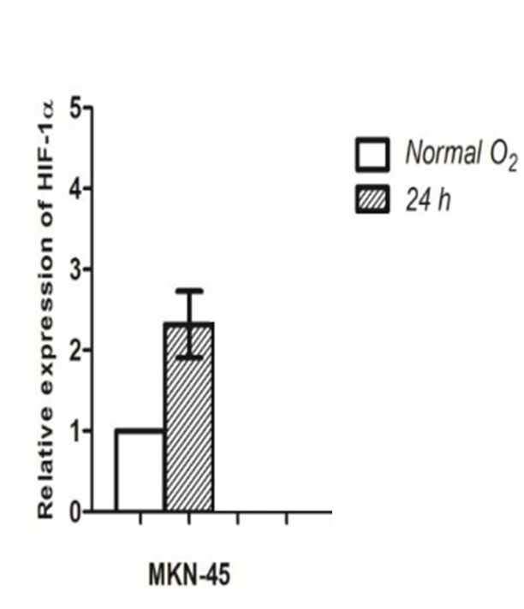

Figure 1. HIF-1α gene expression in hypoxia versus normoxia. HIF-1α expression increased (P= 0.04) within 24 hours.

a) 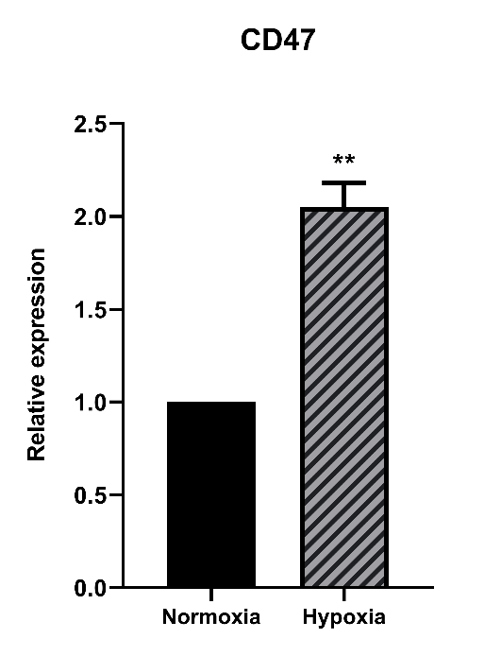 b) 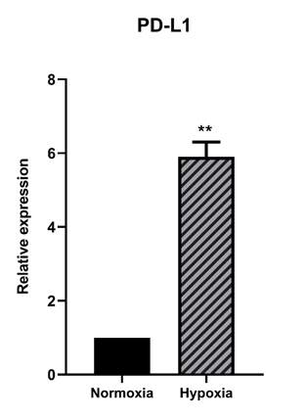 c)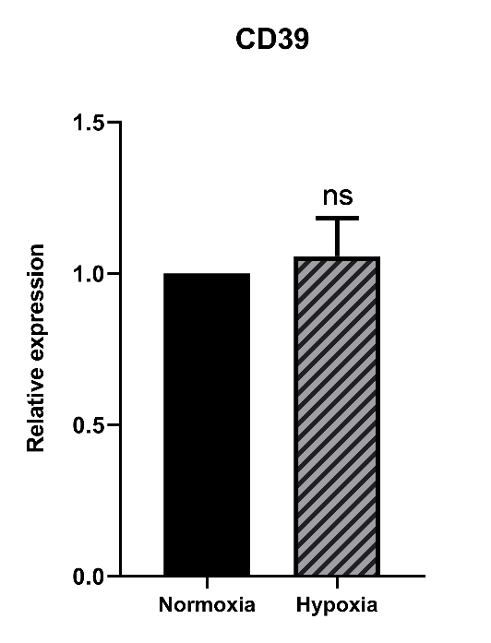
Figure 2. a) The expression analysis of CD47, PD-L1, and CD39 genes in the MKN-45 cell line in hypoxia condition compared to normoxia. ns = non-significant,*≤0.05 and **≤0.01

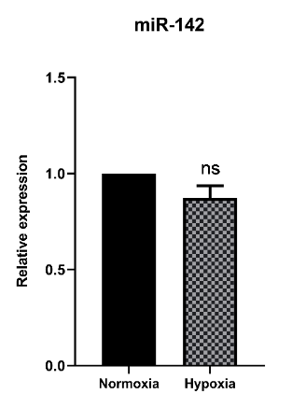
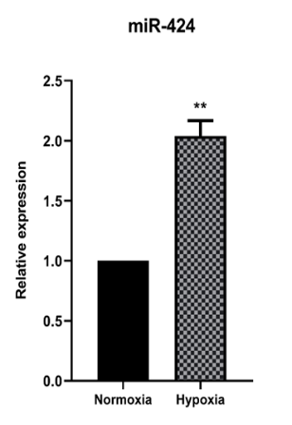b) 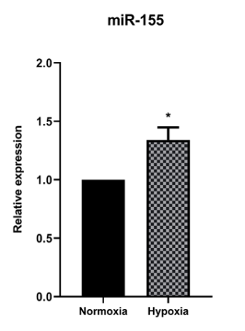c) 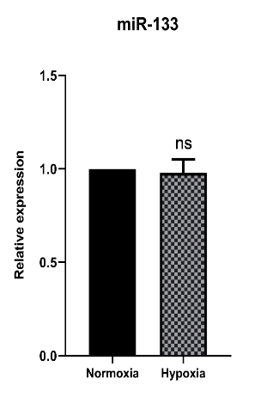 d)
Figure 3. a) The expression level of miR-424, miR155, miR133 and miR142 in the MKN-45 cell line in the hypoxia compared to normoxia condition. ns = non-significant, *=0.01, **=0.001

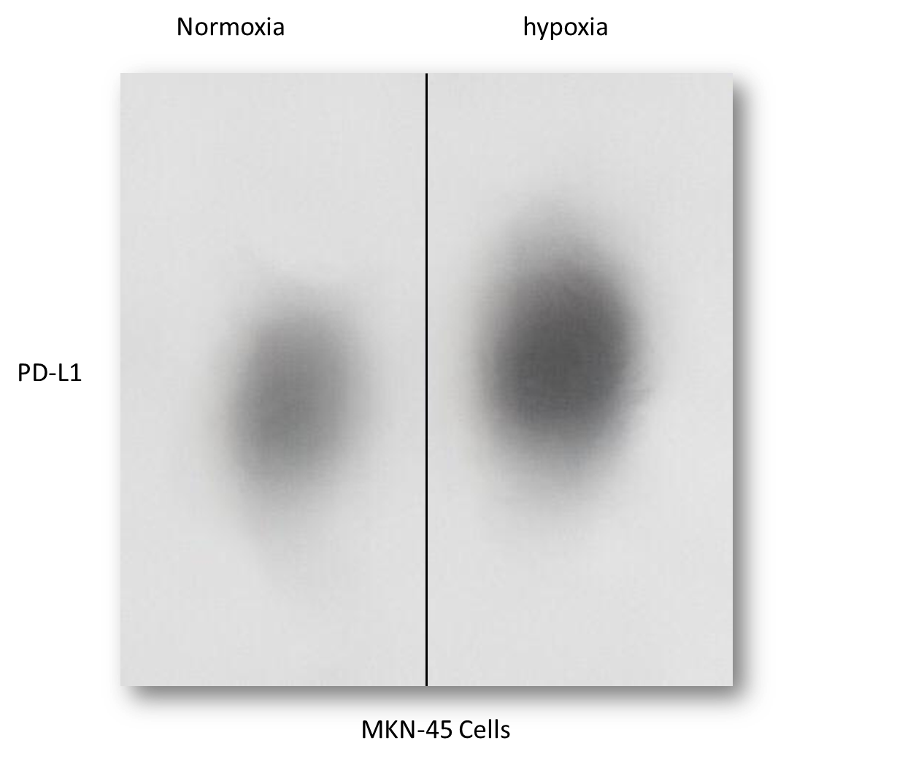
Figure 4. Increased expression of PD-L1 protein in hypoxic conditions of MKN-45 cancer cells.

Tables
Table 1. Primer sequences for the studied genes by RT-PCR.
Primer | Sequences
HIF-1 α | F: 5'-TGACCTGCTTGGTGCTGATT-3'  R: 5'-AGCGGCCTAAAAGTTCTTCTG-3'
CD39 | F: 5'-AGTGATTCCAAGGTCCCAGCA-3'  R: 5'-CTGGCACCCTGGAAGTCAAAG-3'
CD47 | F: 5'-GCCTTGTCCCTATTGTGGCTT-3'  R: 5'-CTTGGTTTGTGACTGCCCCAT-3'
PD-L1 | F: 5'-CTGCAGGGCATTCCAGAAAGA-3'  R: 5'-TGCGTTCAGCAAATGCCAGTA-3'
GAPDH | F: 5'- CAAGATCATCAGCAATGCCTCC -3'  R: 5'- GCCATCACGCCACAGTTTCC -3'

